Tuesday 30th June 2020
Eagles Literacy and SPAG

https://www.literacyshed.com/takingflight.html

Re-watch the video from the link above.
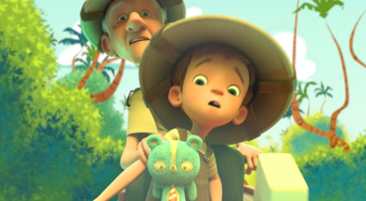

Below is a paragraph of writing - but it is missing all of the commas. These commas could be missing from either separating fronted adverbials or separating subordinate clauses and main clauses. We have already covered these during home-learning, but if you need reminding about these just check out the PowerPoints on the school website. See the additional resources if you need help with these. Re-write the paragraph and add the missing commas.

Cautiously Sam stepped into the vibrant red cart and sat down on the solid base. After he was settled Grandpa Nono handed him an old helmet which perfectly matched the colour of the cart. Once he had placed his own explorer-style hat onto his balding head they were off. Grandpa slowly pulled the cart along the paved street as Sam looked left and right. Suddenly Sam caught a shadow in the corner of his eye. Looking again the shadow was gone and he gasped. Grandpa Nono grinned and began a tale of escaped monkeys. Whilst listening with excitement Sam looked around him once again.

If you’d like to check your answers, have a look at the answer sheet!

Remember to take a photograph of your work and ask a grown-up to either email it to the office for us or upload it to the Eagles unit of the Facebook page. We really want to see your work!

