Eagles SPAG task
Week commencing 11th May 2020
Task 3
Today we are going to focus on verbs, those essential words which are the main focus in a sentence.
Verbs – these are words tell us about being (are / is / am / was / will and so on) and doing (running / walking / shouting / sleeping and so on).
This video will help! https://www.youtube.com/watch?v=Q2gCrABrj_U
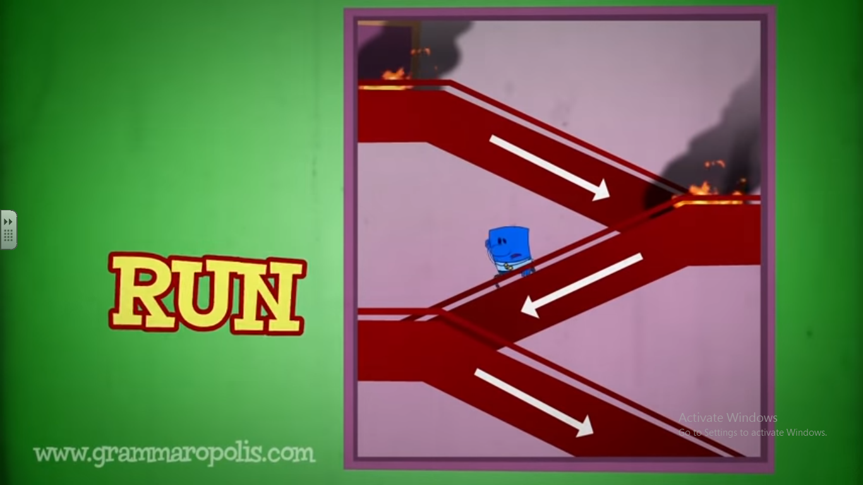

Verbs can be split in to past tense (what has already happened), present tense (happening now) and future tense (what will happen)
Past tense |  |  | Present tense |  |  | Future tense
Simple Past  I walked  We ate  He rode  She slept | Past progressive / past continuous  (was/were + ing)  I was walking  We were eating  He was riding  She was sleeping | Past perfect simple  (had + past tense)  I had walked  We had eaten  He had ridden  She had slept | Simple present  I walk  We eat  He rides  She sleeps | Present progressive / present continuous  (is/am/are + ing)  I am walking  We are eating  He is riding  She is sleeping | Present perfect simple (have / had + past tense)  I have walked  We have eaten  He had ridden  She has slept | Simple future  I will walk  We will eat  He will ride  She will sleep | Future progressive / future continuous (will + be + ing)  I will be walking  We will be eating  He will be riding  She will be sleeping | Future perfect simple  (will + been + past tense)  I will have been walking  We will have been eating  He will have been riding  She will have been sleeping
Have a go at writing a diary entry for today (it can be real or totally made-up, whichever is more appealing and exciting!) and play around with your verb tenses. Using different tenses is a sign of an excellent writer. You could do something like this….

Last night, we were walking (past continuous) to the magic castle when I saw (simple past) a three-horned unicorn. It was being chased (past continuous) by a fire-breathing dragon. Tomorrow, we will be visiting (future continuous) a haunted house and we will look (simple future) for signs of ghosts.

Add some of these verb tenses to your flip book!

