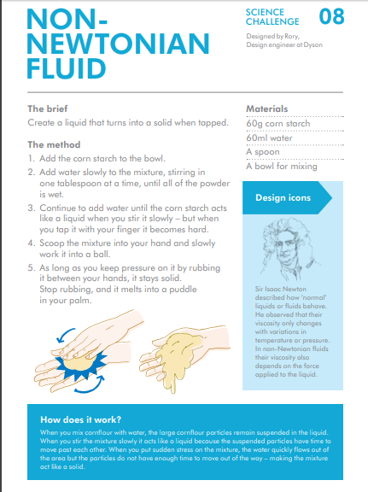

In the materials is says use corn starch – this is cornflour

