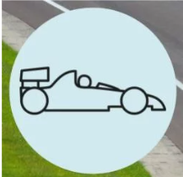 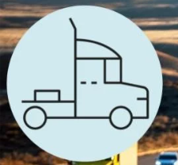 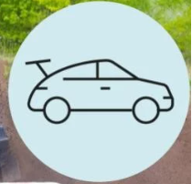 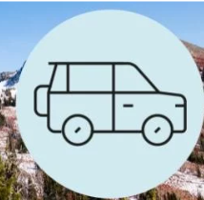 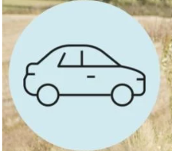

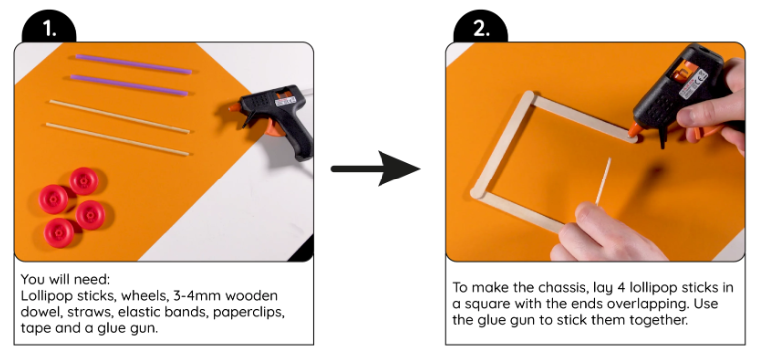 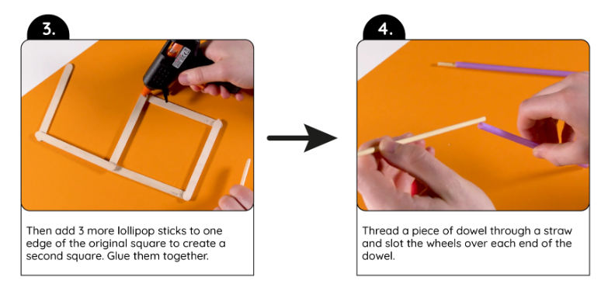 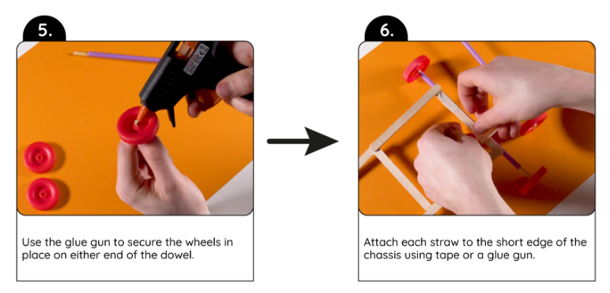 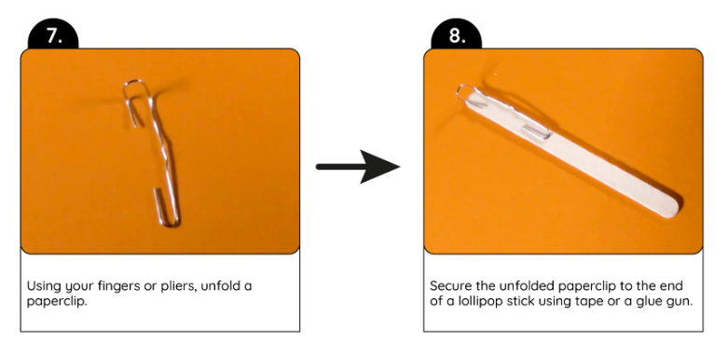 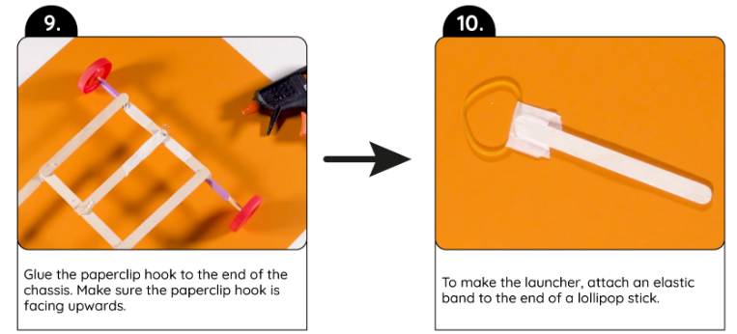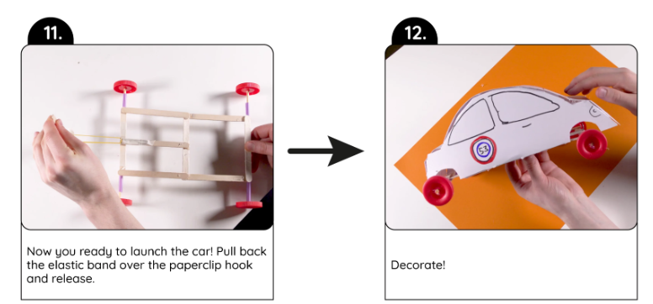

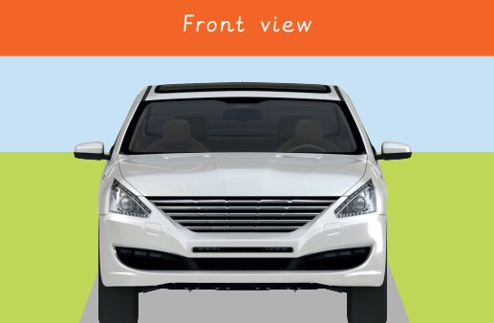 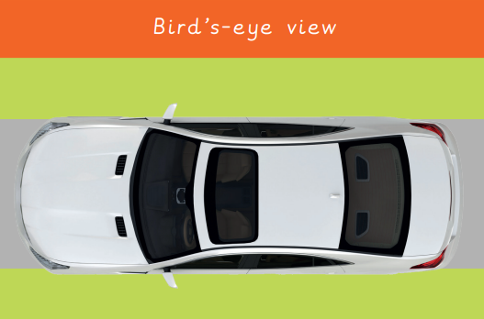 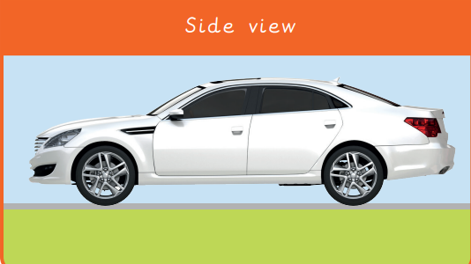

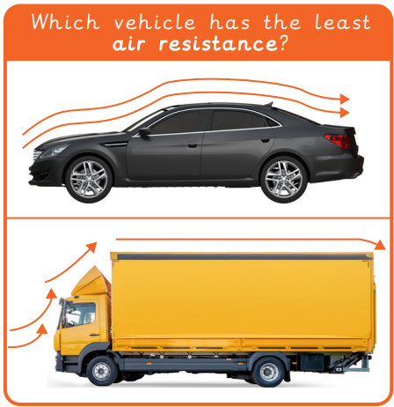

|  |
| --- |
| **Key Vocabulary** |

**Aesthetic** How an object or product looks.

**Air resistance** The level of drag on an object as it is forced through the air.

**Chassis** The body of a car.

**Design** To make, draw or write plans for something.

**Design criteria** A set of rules to help designers focus their ideas and test the success of them.

**Function** The purpose of an object (for example a chair needs to hold a person when sitting down); or how the product works (for example a torch needs to provide light in a dark space).

**Graphics** Images which are designed to explain or advertise something.

**Kinetic energy** The energy that causes an object to move.

**Mechanism** The parts of an object that move together as part of a machine.

**Net** A flat 2D shape, that can become a 3D shape once assembled.

**Structure** Something that has been made and put together and can usually stand on its own (eg a building, a bridge, a chair).

Mechanical systems- a slingshot car