Eagles SPAG task
Week commencing 11th May 2020
Task 5
Prepositions are the name of the game today!
Watch this Grammaropolis video https://www.youtube.com/watch?v=XlMxxK3hjbQ

Prepositions tell us the position of things in place or time; some examples are below…
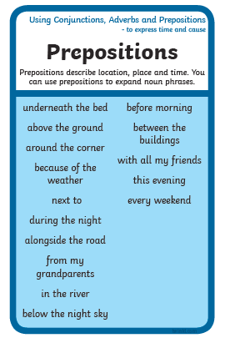
Grab a Lego figure or favourite toy and position them around your home. Write sentences to tell us where they are. It could they are “in the bread-bin” or “under the duvet” You can take photos if you’d like to!

Have a go at writing some different sentences which use prepositions of time. You may have been thinking that these sound suspiciously like adverbial phrases? Yep, they are similar. A preposition is a word such as “under”. It goes in an adverbial phrase when you write something like “The teddy bear is under the sofa”.

