KS2 Pop Art 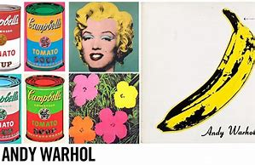
Exciting clips and lessons on you tube with arts most famous of all art styles- POP ART!!! Please have a parent or guardian guiding the you tube clips.
Equipment needed- A4 paper, pencils and colouring pencils.
Take a look at Tate Art for kids and find the links for Pop Art!
Type in the bold words into you tube search then scroll down for suggested clips to look at the famous Pop Artists work. Create Pop Art following the Pop Art lessons. Don’t forget to use bold saturated colours, dots, lines and simple shapes!
When using Pop Art words for art think of words that make a sound ( Onomatopoeia ) such a bang, wham etc. Don’t forget the exclamation mark|! Have fun!
Google You tube
- KS2 pop art lesson
Pop art lesson for kids and teens.
Pop Art Andy Warhol for kids.
- KS2 pop art tutorial lesson
How to draw Pop Art
Pop art donuts – free art lesson for kids
- Pop Art tutorial Easy
Pop art projects for kids
Pop art drawing
Pop Art words

