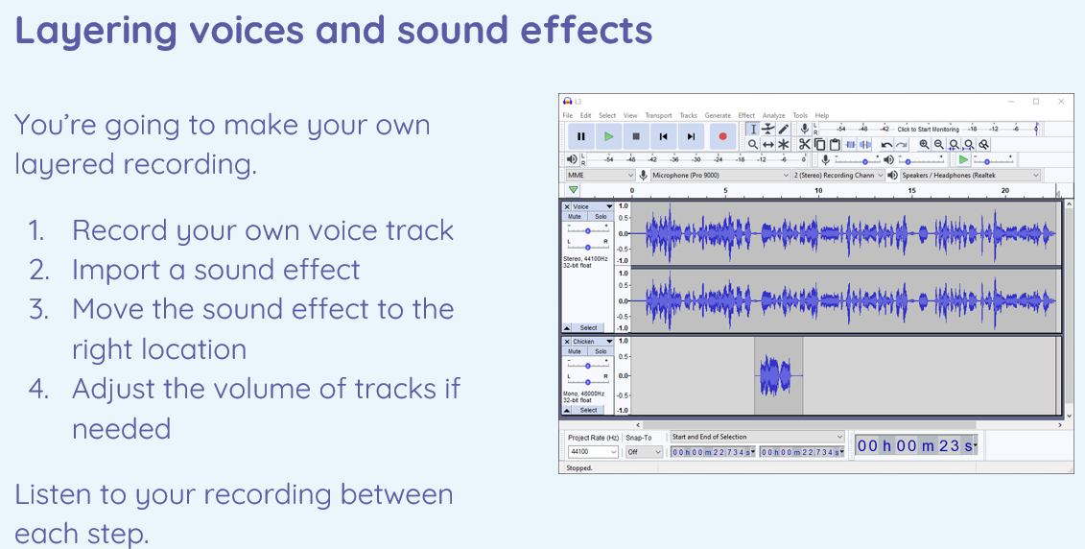

|  |  |
| --- | --- |
| **Key Vocabulary** | |
| Audio | Relating to hearing or sound |
| Record | To copy by use of a mechanical or electronic device for later hearing or viewing. |
| Playback | To play back audio or video recordings. |
| Feedback | In an audio system, a whistling or screeching noise made when the output signal is picked up at the input. |
| Evaluate | To judge the level or value of. |
| Editing | To correct, cut, add to, or change with the goal of producing a finished piece of writing or a film. |
| MP3 | An audio file |
| Export | The process of transferring or saving data from one software application or file format to another. |
| Mixing | Combining more than 1 thing together. |
| Open | To be able to see a saved file. |
| Selection | Something clicked on |
| Sound | Anything that can be heard |
| File | A place for keeping documents or other objects safe and in order. |
| Save | To keep something for future use. |
| Podcast | An audio file that users can stream or download and listen to. |
| Output | Information that a computer has processed that is being given back out. |
| Input | Information that a computer has processed that has been given or collected. |
| Headphones | An external device used to hear audio. |
| Speaker | An external device used to hear audio. |
| Microphone | An external device used to record audio. |

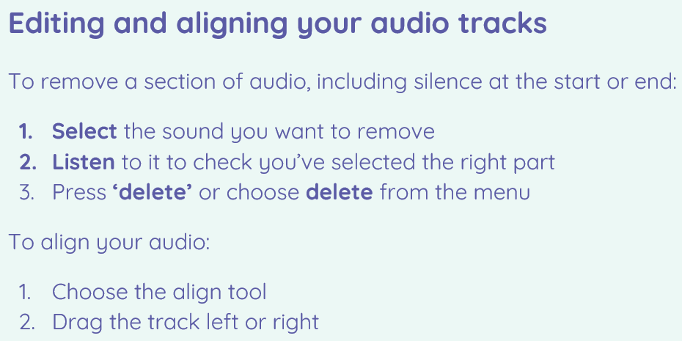

I can plan and write the content of a podcast

I can save a digital recording as a file

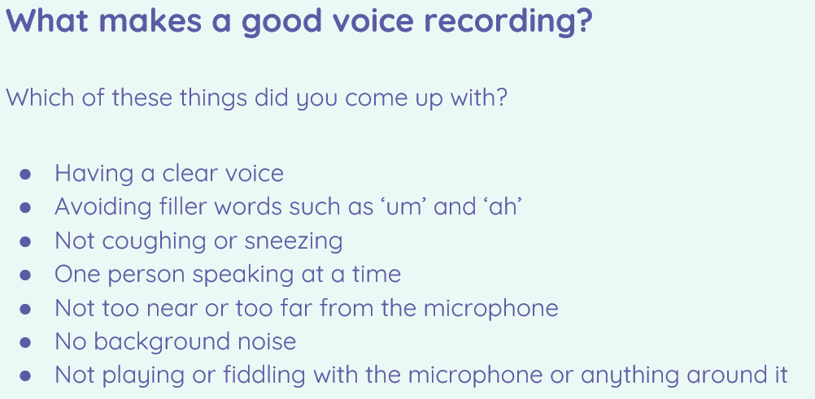

I can explain that digital recordings need to be exported to share them

I can discuss the features of a digital recording I like

I can identify digital devices that can play audio, record sound, or do both

I can identify important inputs and outputs of digital devices that can play audio, record sound, or do both

Audio production

I can open a digital recording from a file

I can edit sections of an audio recording

|  |
| --- |
| I can choose suitable sounds to include in a podcast  I can use editing tools to arrange sections of audio |

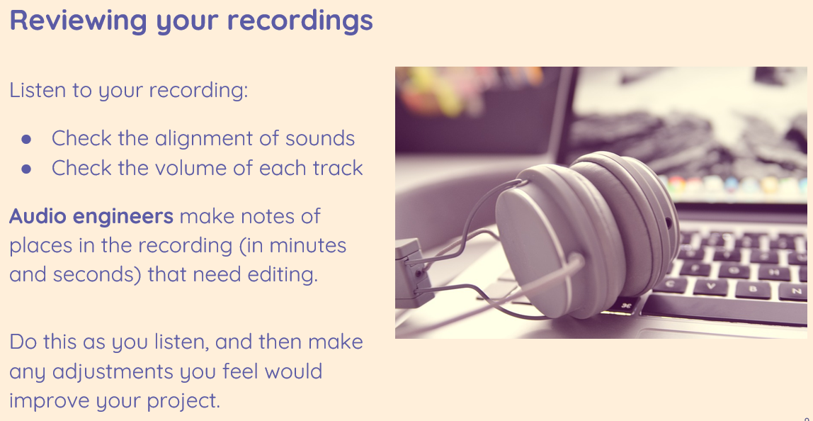

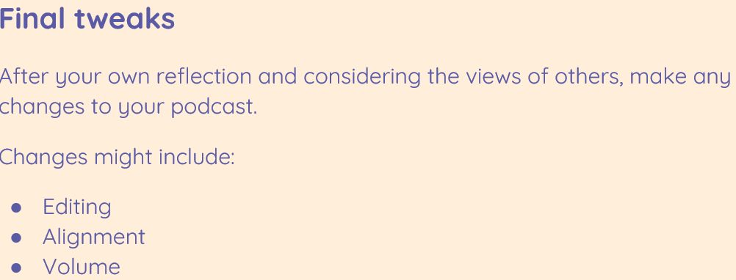

|  |
| --- |
| I can use a device to record audio and play back sound  I can suggest how to improve my recording |

