Wednesday 3rd June
Please find attached the work for today.
In school after we have registered we are going to be looking at our phonics sound; We will practice all of phase 3 and 5 sounds using the Flashcard speed trial on Phonics Play. Then we will be looking at our tricky words using tricky word trucks for phase 5. Below are the worksheets we will be working through as a class or doing similar activities.

After phonics we will be going out and doing 15 minutes of exercise either playing a game like simon says outside or super movers.
Then in maths we will be starting each lesson with using our number square to practice counting forwards and backwards from different numbers up to 100. We are then going to practice our number bonds to 20 again starting with making them. If your child can make them independently use these challenges to extend them.
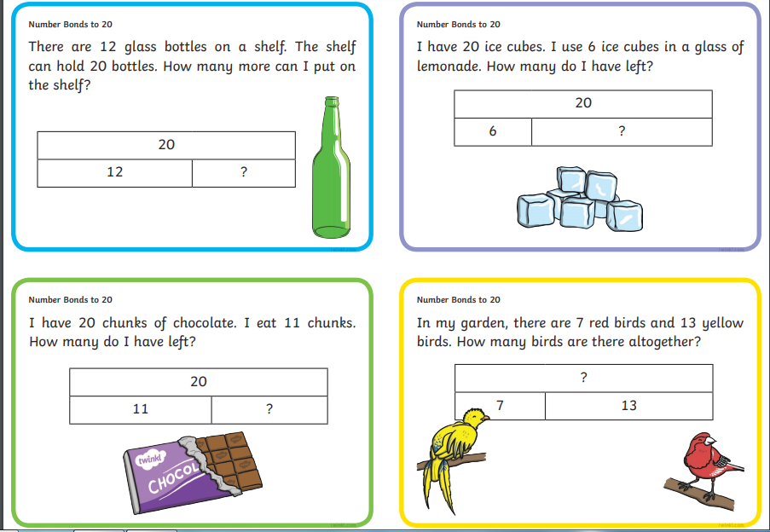
We will then have half an hour to eat a piece of fruit and go outside for some fresh air.
After break it will be literacy. This week we are focussing on The Magic Porridge Pot. Today we will retell the story and order the story using these sequencing cards:
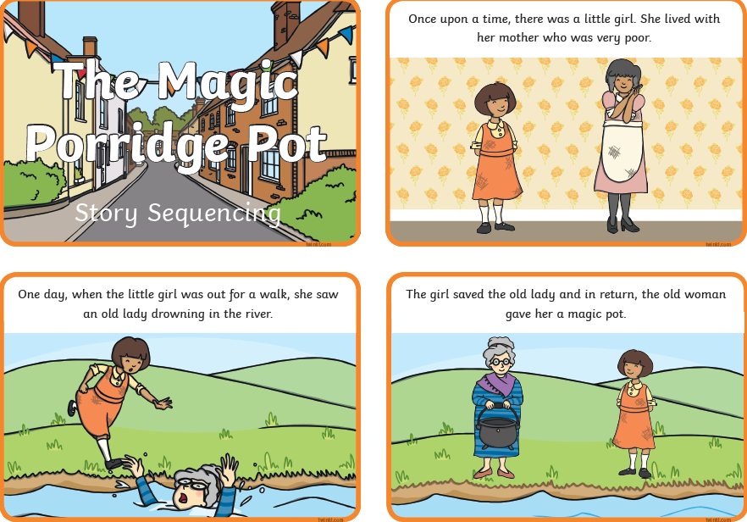
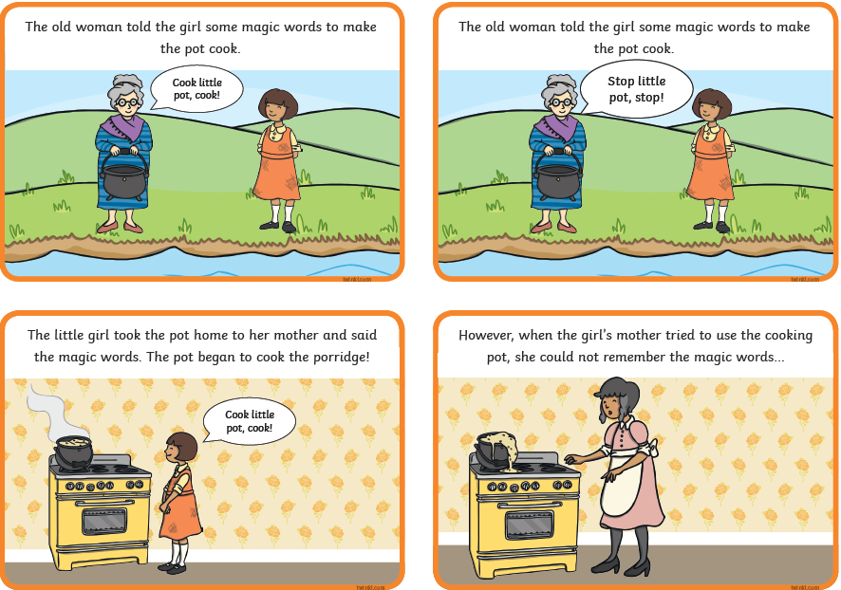
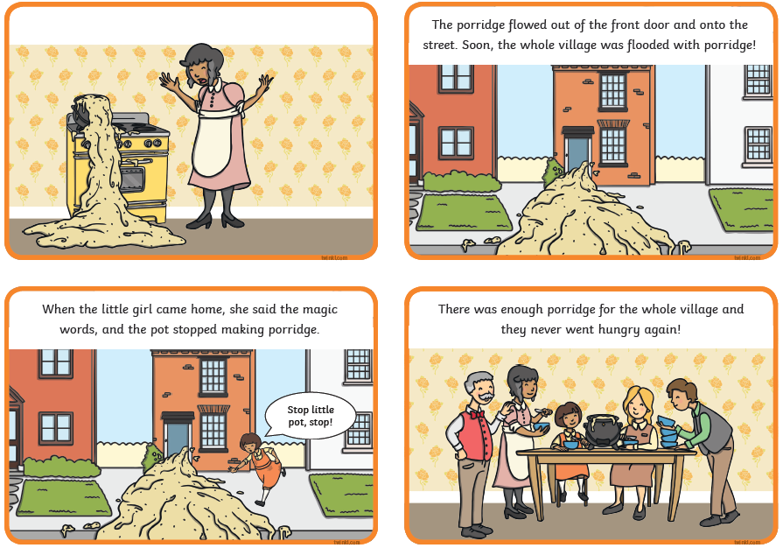
We will then create a story map. This is when the children draw pictures to help them remember what happens in the story. They may choose to write key words but they do not have to. In-between the pictures they draw an arrow to show which direction the pictures go in. it would look something like this:
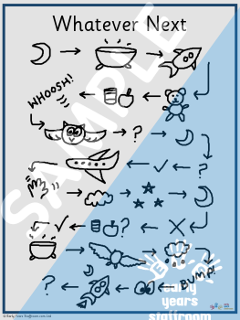
Following this we will do a go noodle or some super movers.
The children will then work through the following sheets so that we can prepare the classroom for lunch.

We will now have our packed lunch and fresh air outside.
After lunch the children will have handwriting practice. Today the children will be practicing: said, says and are.
Then they will have PE where they will practice their ball skills.
After this we will have our creative lesson which today is art. The children will be using different resources to learn how to draw different things. You can use this website or any other sources you can find to draw lots of different objects: http://www.robbiddulph.com/draw-with-rob
Finally, we will end the day with a story.

