To the

**Curriculum Newsletter**

You will find a copy of the curriculum newsletter in your child’s book bag this week. It gives you some information on what your child will be learning at school this term. Any updates on this will appear in this weekly newsletter. The curriculum newsletter is also on the website.

**Balancability**

We had our first lesson on our new balancability bikes this week. The children’s ability to sit patiently whilst adjusting helmets and listening to instructions whilst riding the bikes was outstanding. Mrs Foley and I were so impressed with how the children embraced the lesson. Well done Robins!

**Wow Moments on Tapestry**

Don’t forget that if your child has had a ‘wow’ moment at home, please record this on Tapestry. An example of a ‘wow’ moment could be riding a bike for the first time, being able to use a knife and fork properly, reading a book independently at home or taking part in a club in or out of school for the first time. I would love to see these moments on Tapestry. Thank you

**Don’t forget….**

* Gymnastics this week will be on Tuesday again, NOT on Wednesday. Please bring PE kit into school in a bag on Tuesday.
* PE kit needs to be worn on a Thursday.
* To hear your child read every evening. Children who are heard read daily at home make good progress with their reading.
* To bring in any materials suited to junk modelling.

**Have a wonderful weekend.**

**Mrs Burrough**

**Robin Class News**

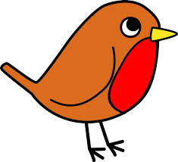

**Year Reception**

**How you can help your child with mathematics.**

This week we have been practising recognising, naming and sorting 2D shapes with the children, predominantly circle, square, triangle and oblong (rectangle) but they have also been introduced to pentagon and hexagon. We have been talking about their properties. For example how many sides/edges, how many corners (vertices) each shape has and whether their edges are curved or straight. The children have also been introduced to symmetry. To help learn this, the children have made kites, trying to place the shapes symmetrically before they were stuck down. The children used a mirror placed on the line of symmetry to see whether what was in the mirror was what they saw on the kite on the other side of the mirror. To help your child at home with shape you can point out everyday objects and talk about the shapes they can see. For example, many road signs are triangles or circles, house doors tend to be oblong in shape and dice have square faces.

**How you can help your child with English.**

* Please make time every day to hear your child read. Explain the meaning of unknown words.
* Practise writing the letters learnt so far.

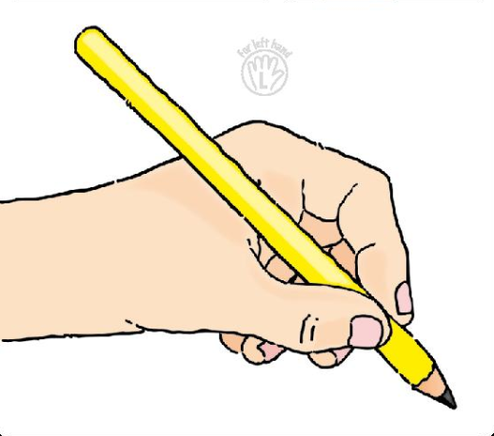 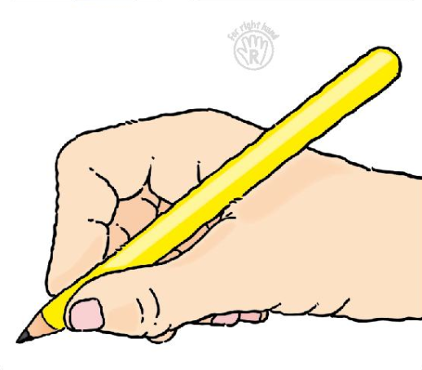

* Please help your child **practise writing their name** starting the lowercase letters from the line.
* Read a story every evening to your child.
* Visit your local library.

**Phonics work week beginning 28th January 2019.**

In phonics we are moving on to week 4 of phase 3 of letters and sounds. We will be learning the phonemes (sounds)

sh, th & ch

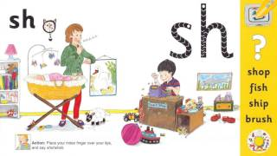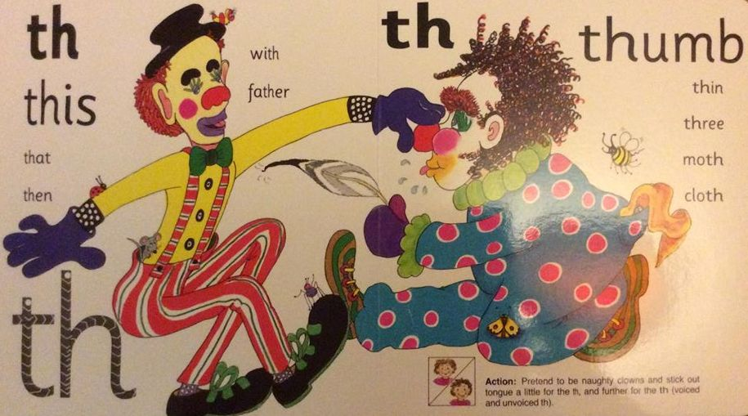

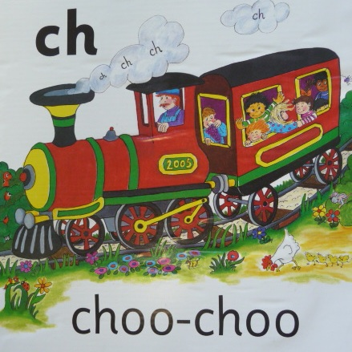

Words we will read:

shop, ship, fish, much, chick, check, chug, such, thick, thin, moth

We will practise reading high frequency words learned so far, read and write sentences using letters learned so far as well as the words so, no, go, the, and, to, I.

We will learn to read the high frequency words:

this, that, then, them, with and they