Graphite Sketches

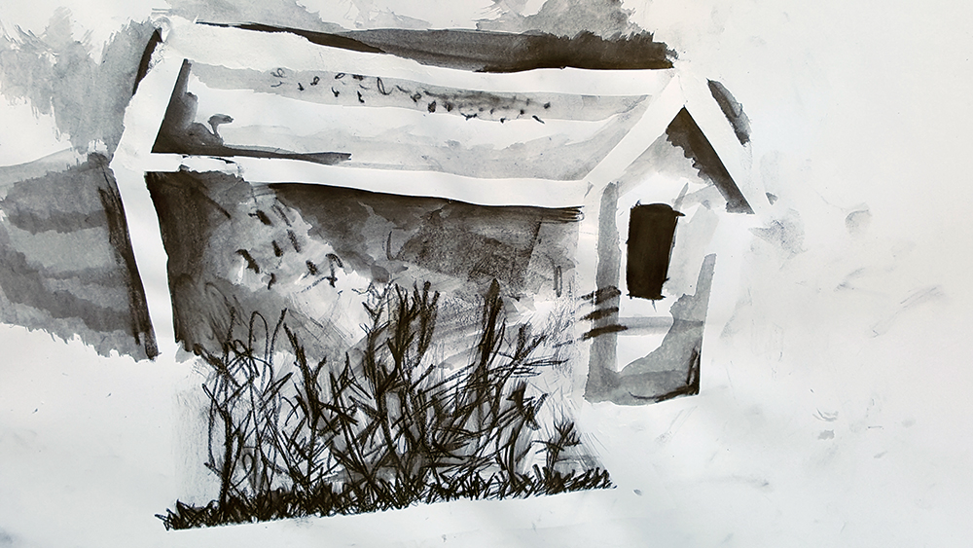

Share, Reflect, Discuss

Once you have made your work, even if it was just a 30 minute session, try to make time to appreciate what has been made, to reflect and focus your thoughts, and to listen to feedback from others. Learning how to talk about art, especially art you have made yourself, is all part of making art. This process can take place even if the work is unfinished. In art schools this would be called a Crit.

**Saoirse Morgan**

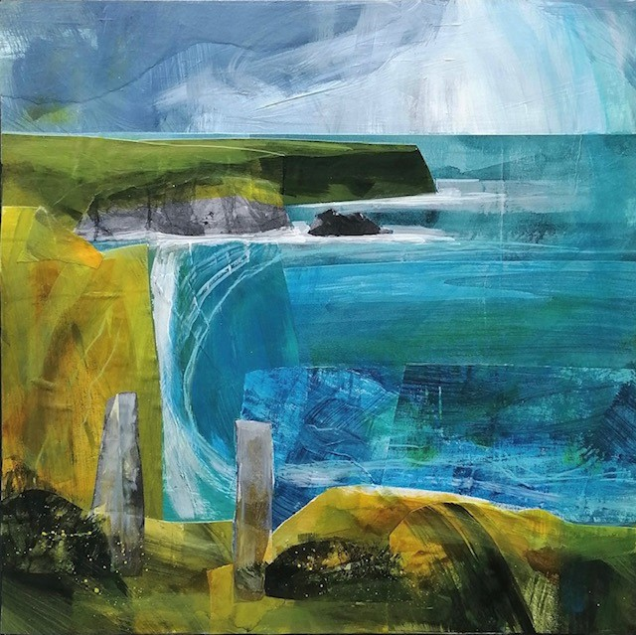

Exploring Mixed Media

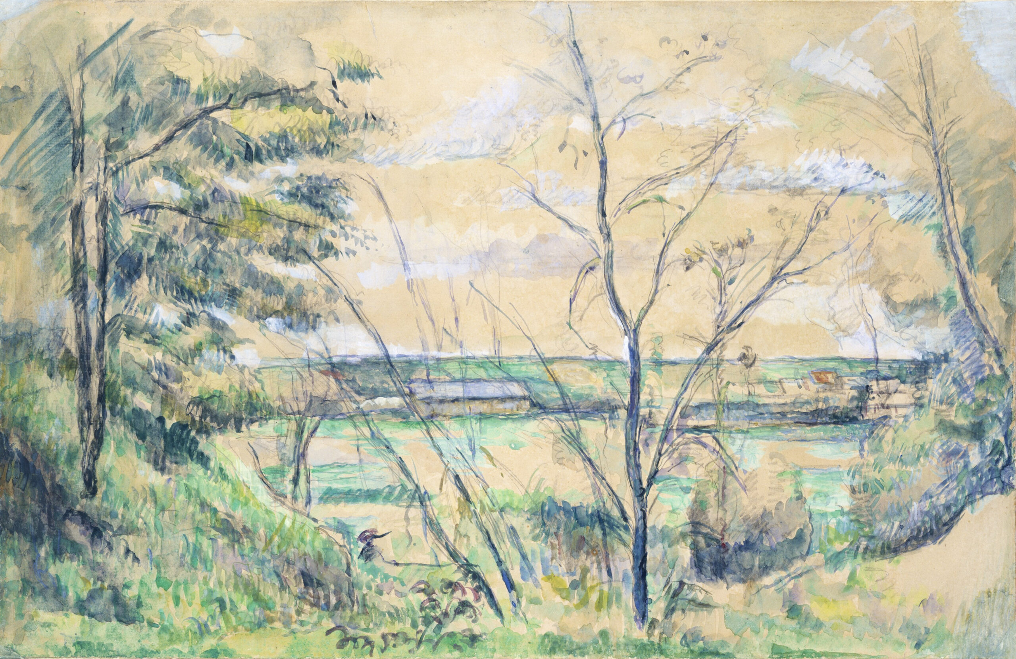

[Making Spaces & Places in a Sketchbook](https://www.accessart.org.uk/making-spaces-and-places/)

Vanessa Gardiner & The Shoreditch Sketcher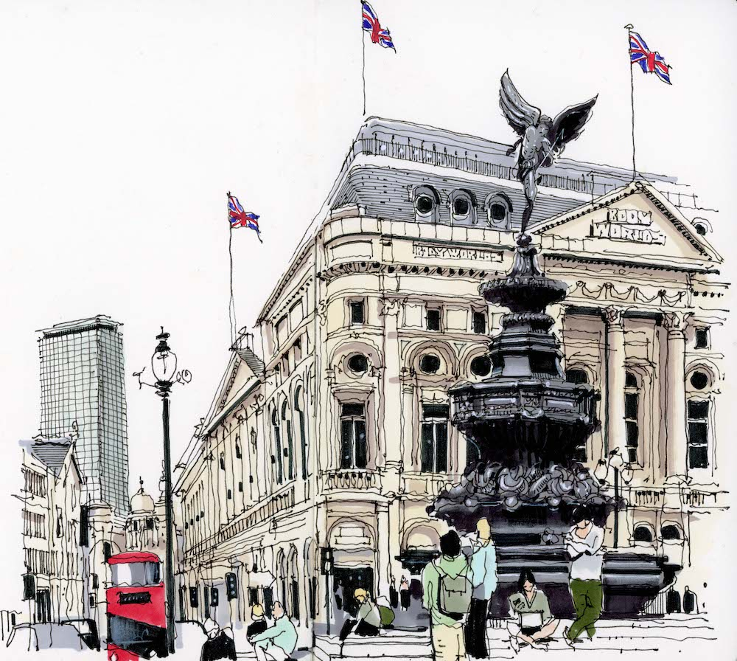

|  |
| --- |
| **Key Vocabulary** |

Landscape- all the visible features of an area of land

Cityscape- the visual appearance of a city or urban area

Working from Life- using real life to create art

Mixed Media- using a range of art skills

Senses- sight, taste, touch, smell and sound

Spirit- how an artist engages your creativity and imagination

Energy- how an artist makes the viewer feel

Capture- how the artist presents a moment, image or feeling

Composition- a piece of creative work

Format- the way in which something is arranged or set out

Present- to show off your work

Share- to show your work to others

Reflect- to think about your work in terms of its strengths and how you would change it in the future

Respond- to say something in reply

Articulate- to discuss using good vocabulary

Feedback- to share your thoughts about others work

Crit- a critical review of art

Similarities- things that are the same

Differences- things that are different

[Mixed Media Land And City Scapes](https://www.accessart.org.uk/mixed-media-land-and-city-scapes/)