Shape Discussion Cards

Always, Sometimes or Never?

Jerry says, “A square can have different length
sides.”

Always, Sometimes or Never?

A rectangle can be turned around to face any direction.

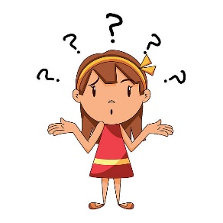
Always, Sometimes or Never?

Mary states, “When you fold a square in half you get a
triangle.”

Always, Sometimes or Never?

A pyramid has one square face.

Answers: Never, Always, Sometimes, Sometimes

