Rainbow Scavenger Hunt

- Find something red.
- Find something orange.
- Find something yellow.
- Find something green.
- Find something blue.
- Find something purple.
- Name a fruit that is red.
- Name an animal that is yellow.
- Name a vegetable that is orange.
- Name a plant that is green.
- Name a flower that is purple.
- Name something that is blue.

Spring Scavenger Hunt
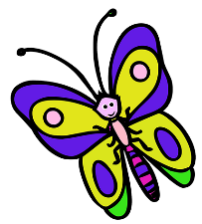

- Find a yellow flower.
- Find 3 different shaped leaves.
- Find something that is red.
- Find a spider web.
- Find something that flies.
- Name 2 things that you see in the sky.
- Find something long.
- Find something that grows that is green.
- Name 2 birds.
- Find some water.
- Find something purple.
- Find something that crawls.
Indoor Scavenger Hunt

- Find a fork.
- Find a ruler.
- Find a tissue box.
- Find 3 things that have wheels.
- Find an orange crayon.
- Find something that is very soft.
- Find a clothes hanger.
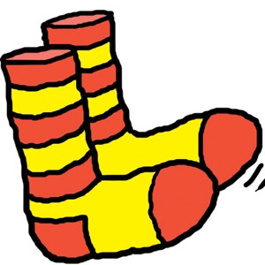
- Find a key.
- Find 2 socks that match.
- Find something round.
- Find a rubber band.
- Find a pair of gloves.
- Find an envelope.

