To the

**PE CHANGE TIME Week Beginning 21st January**

**Tuesday 22nd January – gymnastics lesson – please bring PE kit in a bag.**

**Wednesday 23rd January – DANCE FESTIVAL – please wear PE kit all day.**

**Thursday 24th January – multi-skills PE lesson – please wear PE kit all day.**

**Slowly, Slowy**

Slowly, slowly, very slowly,

creeps the garden snail,

Slowly, slowly, very slowly,

up the garden rail.

Faster, faster, so much faster,

runs the little mouse.

Faster, faster, so much faster,

round my little house.

**Don’t forget….**

* To hear your child read every evening. Children who are heard read daily at home make good progress with their reading.
* To bring in any materials suited to junk modelling.

**Have a wonderful weekend.**

**Mrs Burrough**

**Robin Class News**

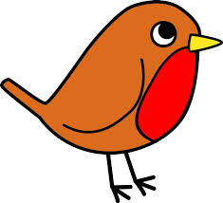

**Year Reception**

**How you can help your child with mathematics.**

**Counting, counting, counting**

**What’s in the box?**

**How you can help your child with English.**

* Please make time every day to hear your child read. Explain the meaning of unknown words.
* Practise writing the letters learnt so far.

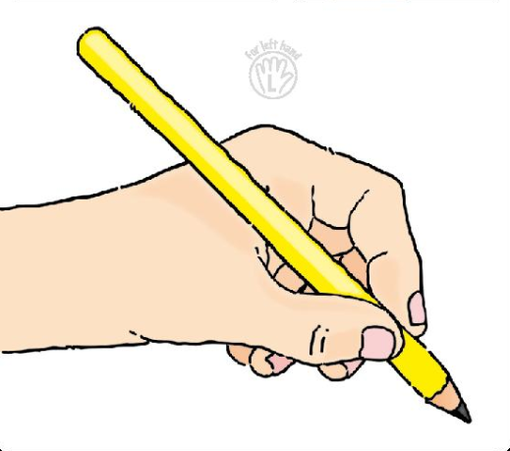 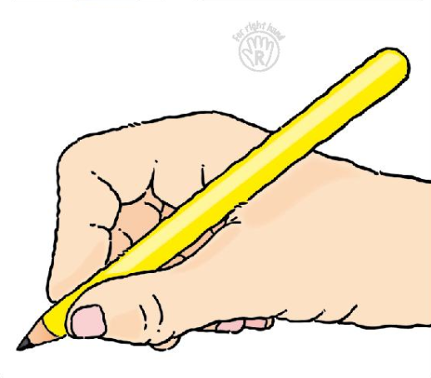

* Please help your child **practise writing their name** starting the lowercase letters from the line.
* Read a story every evening to your child.
* Visit your local library.

**Phonics work week beginning 21st January 2019.**

In phonics we will be learning that a digraph is two letters that together make one sound. We will be revising the digraphs ck, ff, ll, & ss as well as learning the qu digraph. Please look out for more words and more letter sounds on the treasury tags that you will need to practise at home with your child as from now on we will be learning new phonemes and high frequency words.

ck ll ss zz q(u)

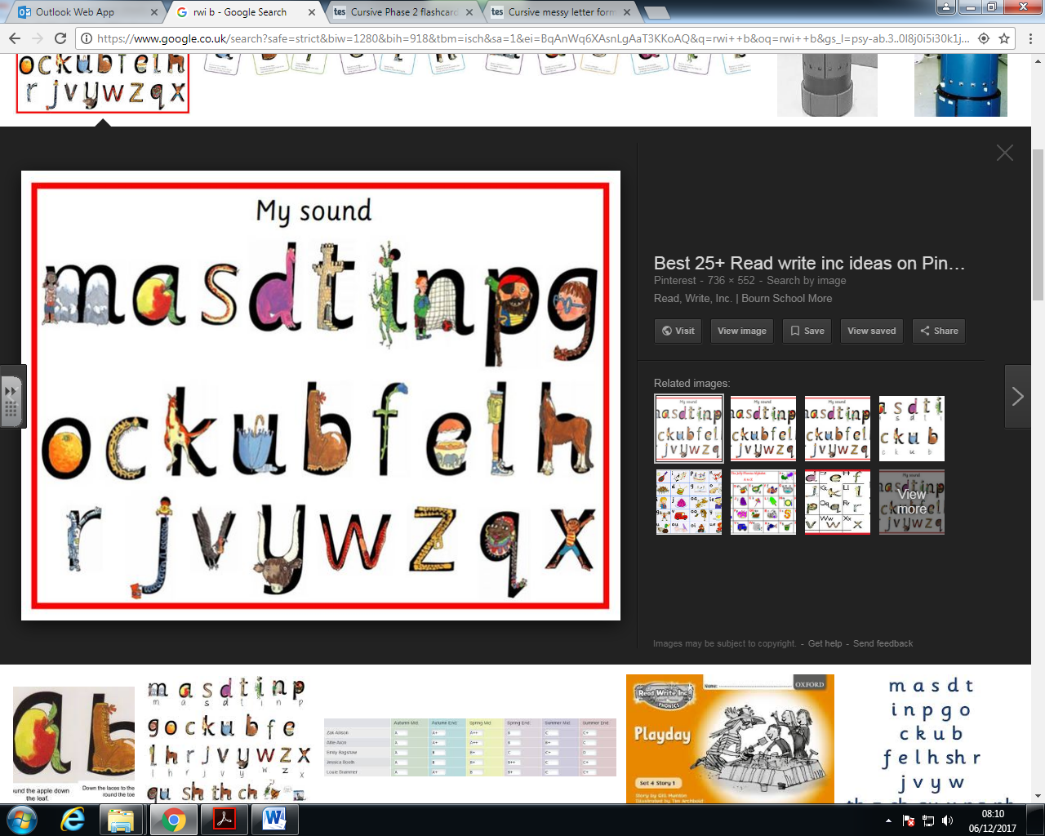 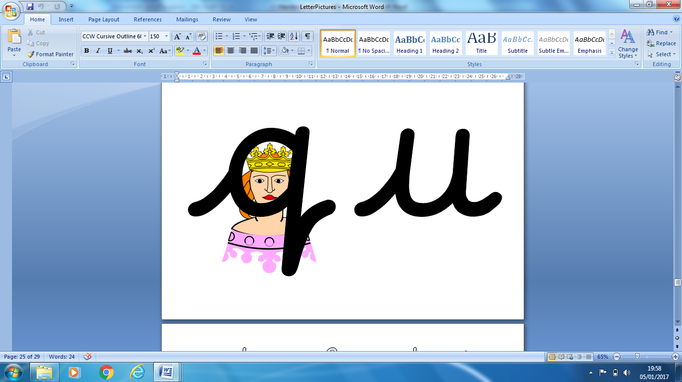

We have been learning some rhymes for each letter to help with formation, they are as follows:

* Up we go, zig zag, zig.
* (q) Up and over. Round her head. Up past her earrings. Down her hair.

Reading tricky words will, was, are & you.

Writing tricky words no, go, the, and, to, I, so, no & go.