Eagles English and SPAG – TASK 1
Monday 22nd June 2020

Speech will need to play a big part in your myth writing. It needs to be punctuated correctly and be used to advance the action. We did some speech work a while ago for home learning; you could always look at that to remind yourself! So, to practice, please complete the tasks below:
Part a
Look at these sentences and put the speech marks (also called inverted commas) in the right places.
- The boy said, I would like to go home now.
- The lady asked, why do you want to go home so soon?
- I don’t feel very well, the boy replied
- The lady whispered, are you missing your mum?
- The boy looked at her and muttered, you won’t tell anyone will you?
- She winked and answered comfortingly, no of course not

Part b
Write sentences using these words to replace the dreaded said…
- shouted
- cried
- yelled
- asked
- explained
- begged
- snapped
- boasted

Part c
And finally, Rewrite this passage to practise starting a new line for each new speaker. (I left the speech marks in for you )
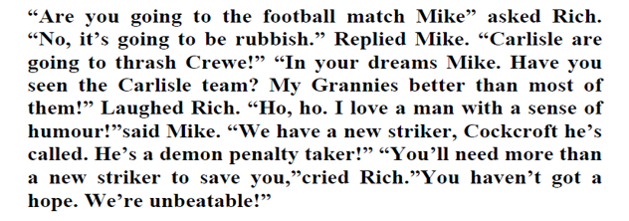

Remember to take a photograph of your work and ask a grown-up to either email it to the office for us or upload it to the Eagles unit of the Facebook page. We really want to see your work!

