To the

**Chickens**

We have welcomed some chickens to our school grounds. The children have enjoyed being farmers and learning to look after the chickens, bedding them up, feeding, watering them and collecting the eggs. We will be looking after the chickens until Easter.

**Frogspawn**

We have also had a delivery of frogspawn in our class and we are enjoying watching the tadpoles grow. The children will be encouraged to observe the changes in the tadpoles as they grow over the next few weeks.

**Spring time**

Spring is just around the corner and this is such a beautiful time of year where there are many opportunities to talk about the changes in nature and happenings of new life. Please encourage your children to be observant when out and about and talk about what they see.

**Don’t forget….**

* Please bring **PE kit into school in a bag** on **Wednesday.**
* PE kit needs to be worn on a Thursday.
* To hear your child read every evening. Children who are heard read daily at home make good progress with their reading.
* To bring in any materials suited to junk modelling.

**Have a wonderful weekend.**

**Mrs Burrough**

**Robin Class News**

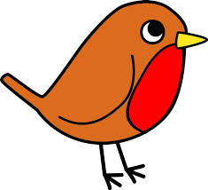

**Year Reception**

**How you can help your child with mathematics.**

This week we have been working on counting out objects to 20 accurately, finding one or two more than a number and writing numerals. Please keep practising reciting numbers in order to 20 and beyond. Count objects ensuring the children are saying one number for each object counted. Also, encourage the children to read numbers as they see them in the environment. Talk about their shape. Do they have curvy lines, straight lines or curvy and straight lines? We are now trying to read the teen’s numbers and are learning that teen’s numbers consist of a ten and another number. For example, 12 is a ten and a 2, 14 is a ten and a 4.

**How you can help your child with English.**

* Please make time every day to hear your child read. Explain the meaning of unknown words.
* Practise writing the letters learnt so far.

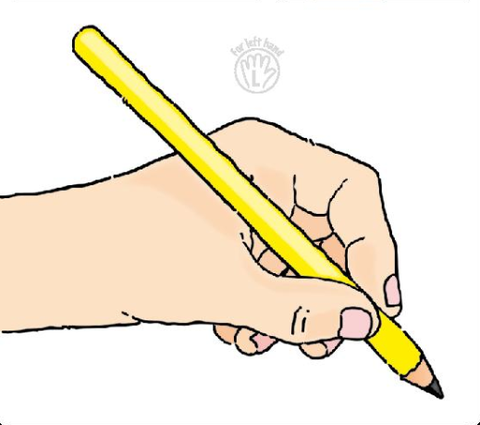 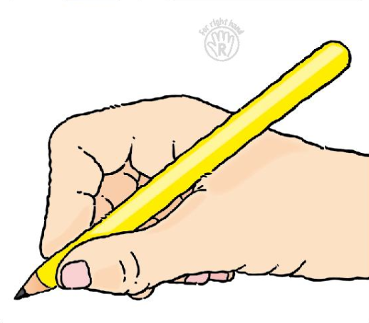

* Please help your child **practise writing their name** starting the lowercase letters from the line.
* Read a story every evening to your child.
* Visit your local library.

**Phonics work week beginning 4th March 2018.**

In phonics last week we covered sounds taught in week 7 of phase 3 of letters and sounds. This week we will learnt he sounds taught in week 8.

oo (short and long), ar, or

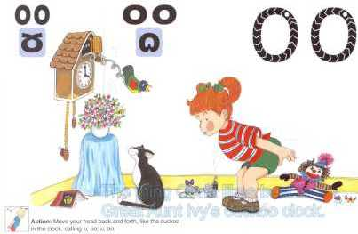 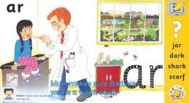 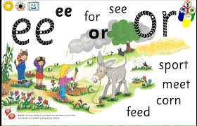

oo (long) too, zoom, boot, room, soon

oo(short) book, look, cook, good.

ar bar, park, card, jar, hard, part, cart

or cork, fork, cord, lord, sort.

igh, ur, ow, oi

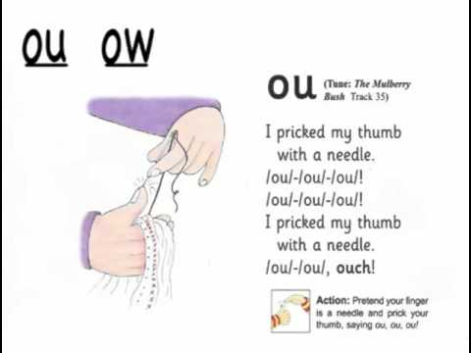 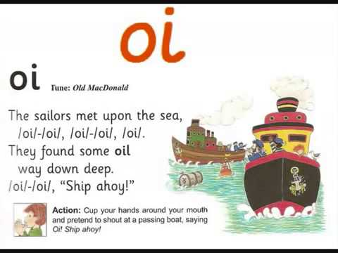

tight, might, right, sight

church, burn, fur, curl

owl, now, down, town

foil, join, toil, boil, coin, oil

We will learn to read the high frequency words: look, for, too, now, down