Thursday 2nd July 2020
Eagles Literacy and SPAG

https://www.literacyshed.com/takingflight.html
Re-watch the video from the link above.
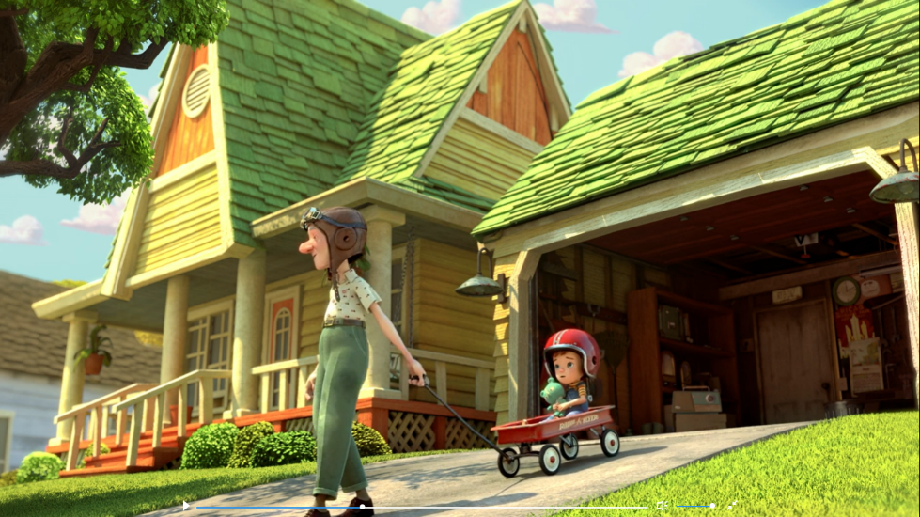

Write a descriptive paragraph for the image above. I would like to see a range of EXPANDED NOUN PHRASES and POWERFUL VOCABULARY used to up level your writing. Try using www.thesaurus.com to improve your vocabulary choices and make your writing more engaging. Remember to try and use your punctuation choices from earlier in the week.

EXPANDED NOUN PHRASES
We looked at these in detail when writing our ‘Ice Bear’ themed stories. Remember that you can both pre and post modify a noun by adding description before (pre) and after (post).
You can use:
determiner + adjective + noun = the vibrant cart
determiner + adjective + adjective + noun = the vibrant, crimson cart
determiner + noun + adjective + adjective = the cart, rickety and creaking,
determiner + noun + prepositional phrase = the cart at the top of the driveway
determiner + noun + relative clause = the cart which creaked with every movement
Remember that you can also add more adjectives into each of these and also up level your vocabulary to make it more detailed.
Remember to take a photograph of your work and ask a grown-up to either email it to the office for us or upload it to the Eagles unit of the Facebook page. We really want to see your work!

