|  |  |
| --- | --- |
|  | |
|  |  |
|  |  |
|  |  |
|  |  |
|  |  |
|  |  |
|  |  |
|  |  |

1st ½ Summer term 2024

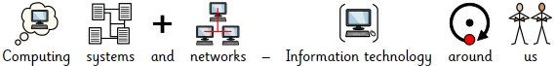

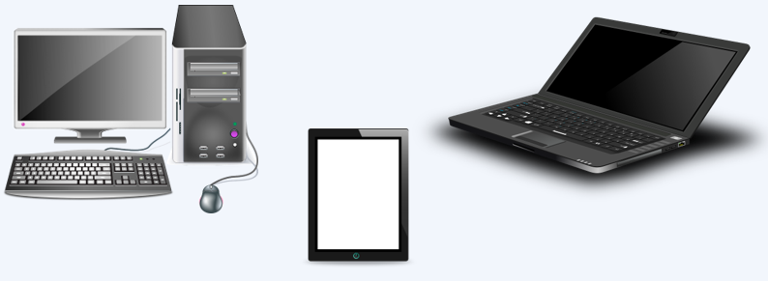

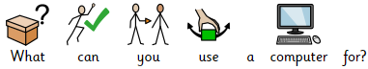

What devices have you seen or used in school?

**1**

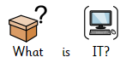



What do you use this technology for?

**2**

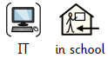

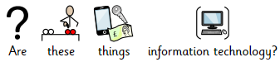

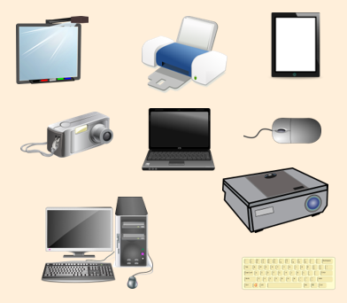

IT is very useful when you are shopping!

**4**

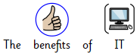



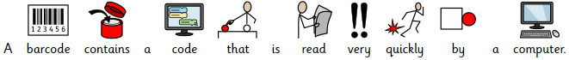

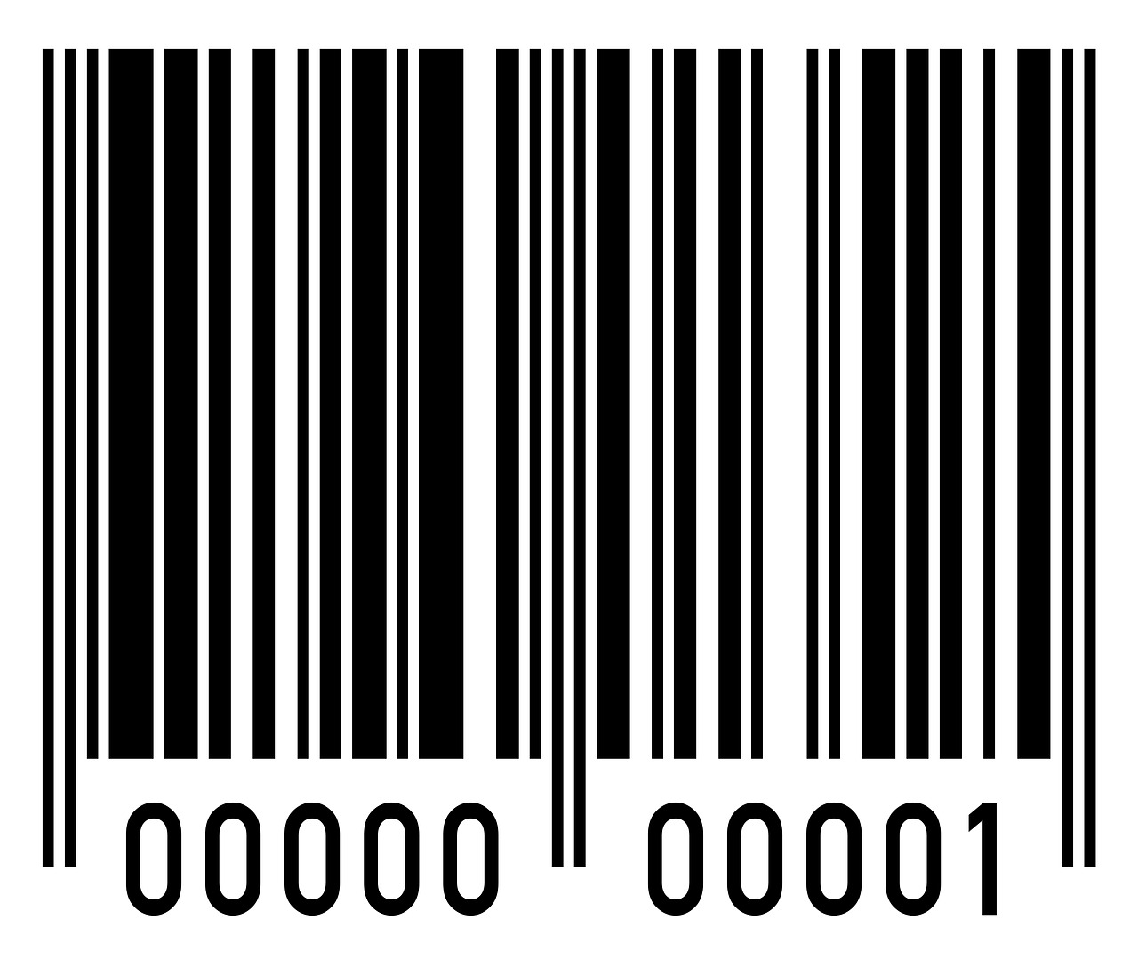

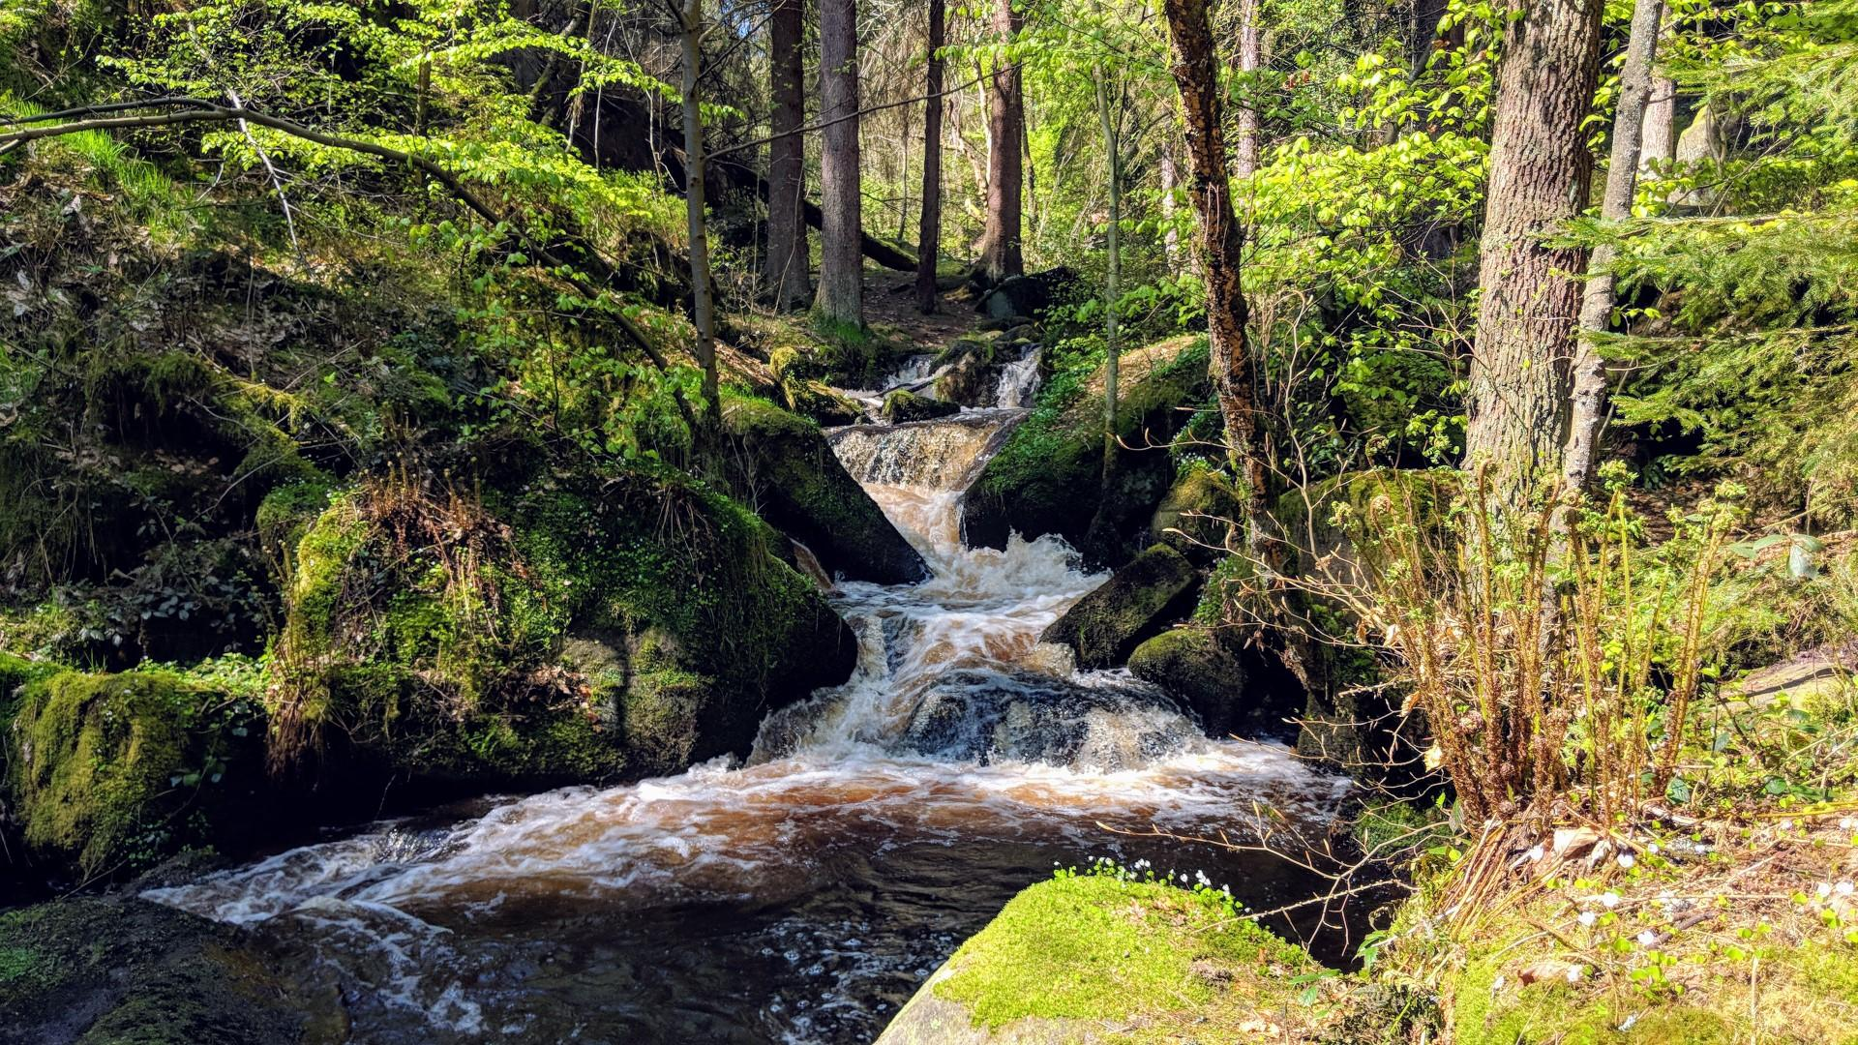 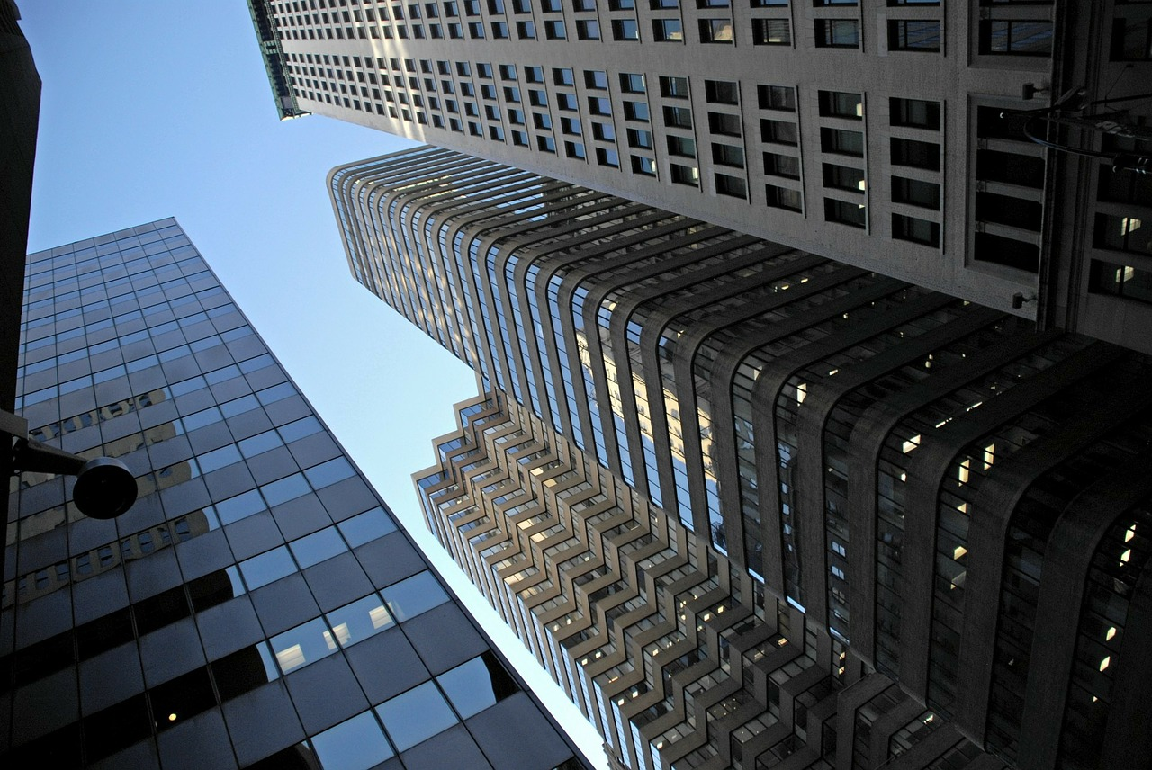  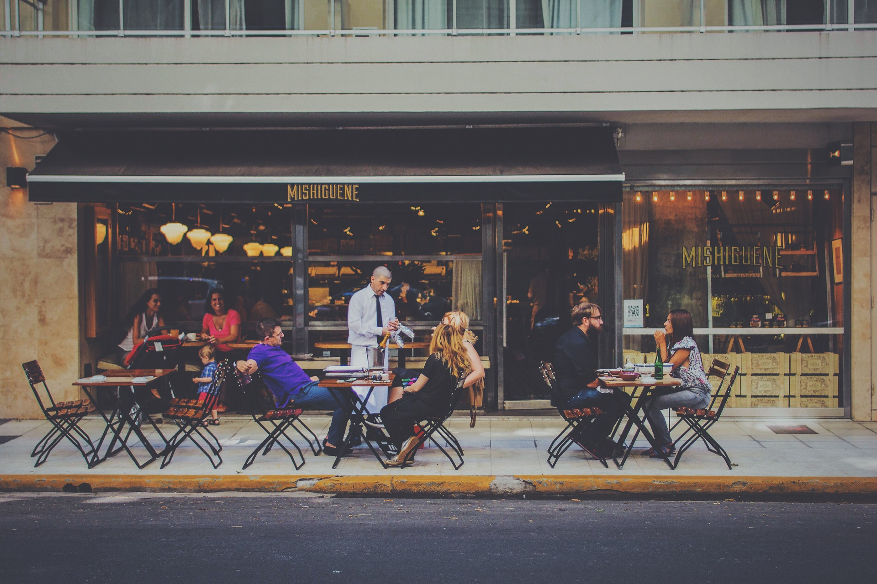 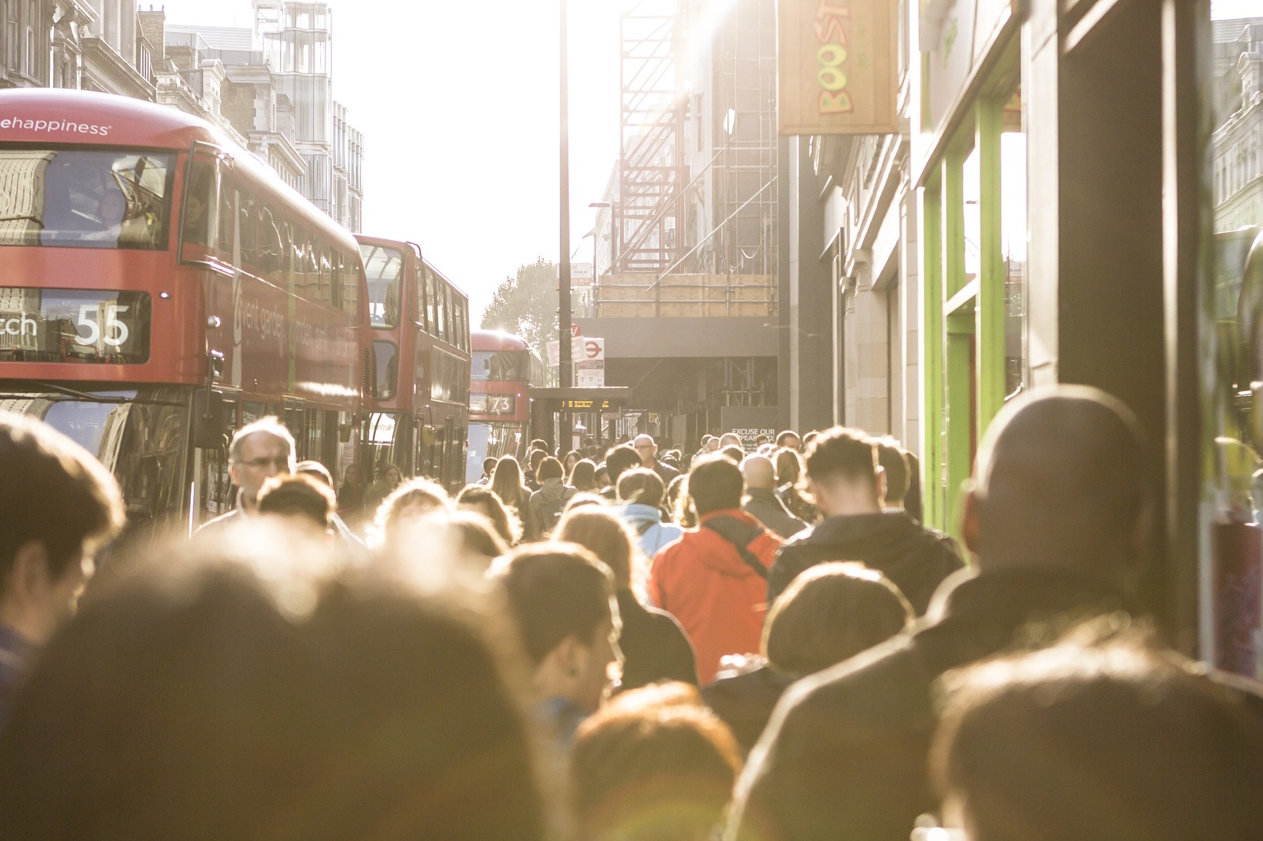

What are these IT objects? Where would you find them?

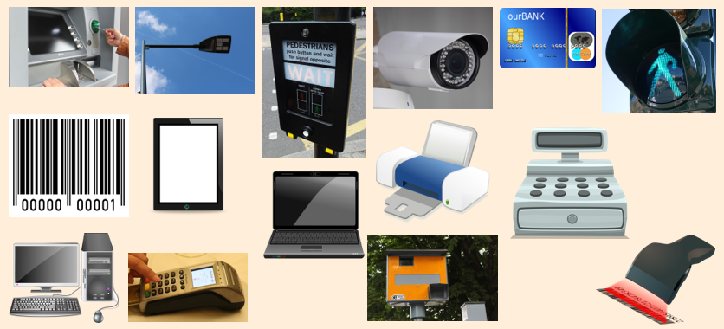

**3**

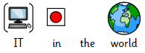

Would IT be used in these places?

There are rules we need to follow to use IT safely.

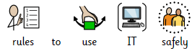





What IT do you use when you are not at school?

Do you play Roblox or talk to people online?

**5**

