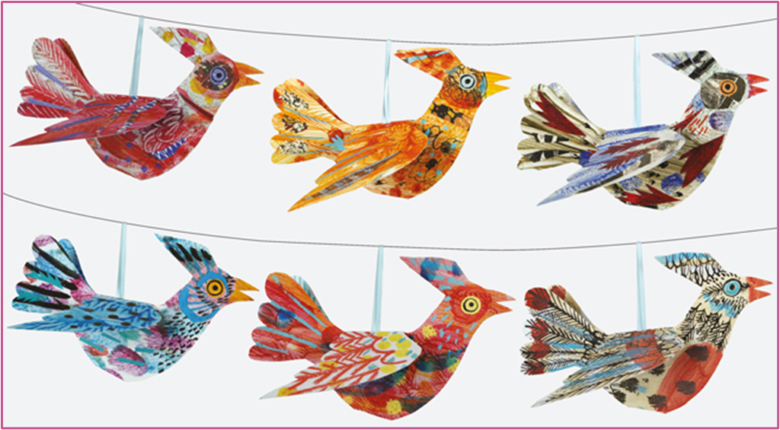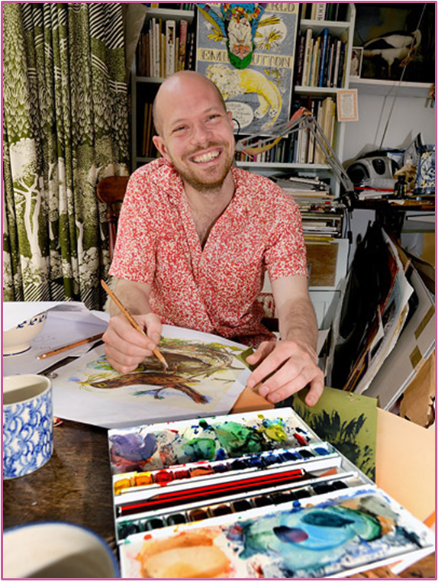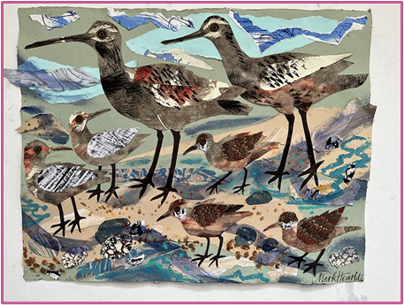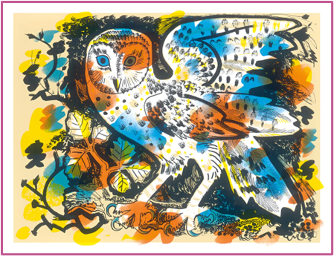

Mark Hearld

Mark Hearld is a contemporary artist from York. He works as a painter and printmaker and has illustrated books, designed fabrics and he has a range of affordable versions of his artwork, such as the small bird models we will be studying in this unit.

Hearld’s work is a celebration of nature, and teachers should draw attention to his focus on replicating patterns and textures from animals and birds.

Jackie Morris

Morris is a contemporary artist based in Wales. She works predominantly as a painter and illustrator, with a focus on the natural world.

Morris uses watercolour paints to represent birds and animals, often in motion. She makes exquisite use of the medium’s translucent quality, which will help pupils develop their understanding of the versatility of this type of paint.

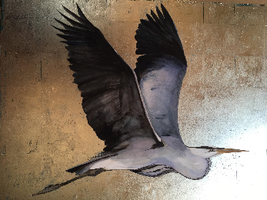 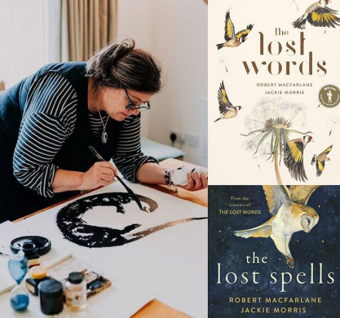 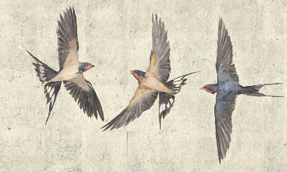

Watercolour brush strokes to try

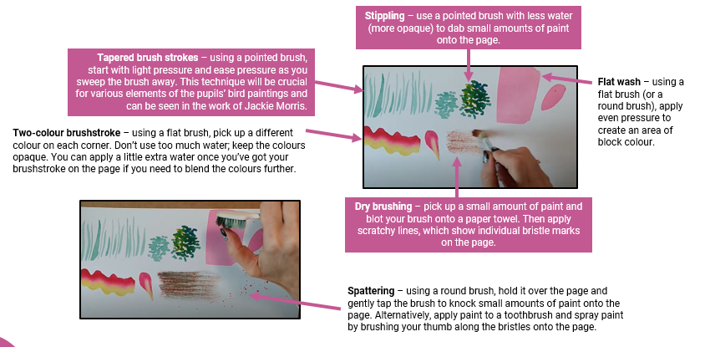 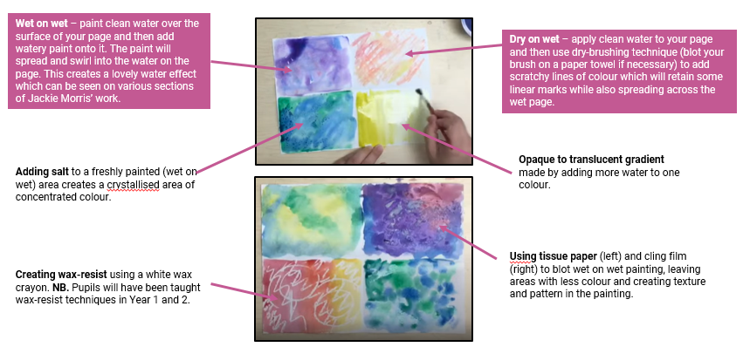

|  |
| --- |
| **Key Vocabulary** |

* **expressive:** (adjective) describing art that is focused on conveying emotions, feelings or experience rather than being strictly representational.
* **observation:** (noun) looking closely at something.
* **origami:** (noun) Japanese artform of folding a single piece of paper into a 3D model.
* **representational:** (adjective) describing art that attempts to show an object or scene in the most accurate way possible.
* **tone (1):** (noun) areas of light or dark in an artwork (‘Darker tones were used here’.)

Sculpture