**Geography – the Seasons - Year 2**

|  |  |
| --- | --- |
|  | The season before summer. New flowers grow. Lambs, rabbits and chicks are born are born. Animals come out of hibernation and it starts to get warmer |
|  | The season after spring and before autumn. It is hot in the summer and we don’t get as much rain. We have a big break from school. |
|  | The season before winte. Animals begin to hibernate. Leaves fall of the trees and it starts to get dark earlier. We ave Halloween in autumn. |
|  | The season before spring. Winter is cold. We get frosty mornings and need to wrap up very warm. Trees lose their leaves and not many flowrrs grow. |
|  | Thee are 4 seasons in a year, each with their own tpe of weath: spring (March, April and May), summer (June, July and August), autumn(September, October and November) and winter (December, January and February). |
|  | A hibernating animal sleeps throuh the winter – dormice, hedgehogs, and bats are examples of hiubernating animals. |
|  | How warm, cold, hot, wet, dry or windy it is outside. |

We will think about how the weather changes over the year.

**2**

How does the weather change across seasons?

**1**

What do we know about the weather and seasons?

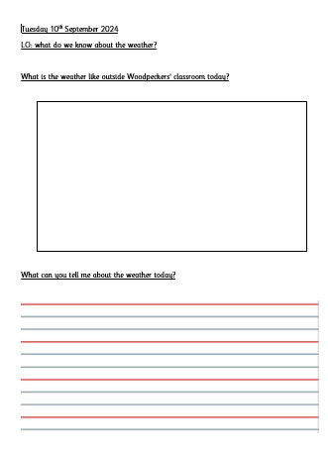

 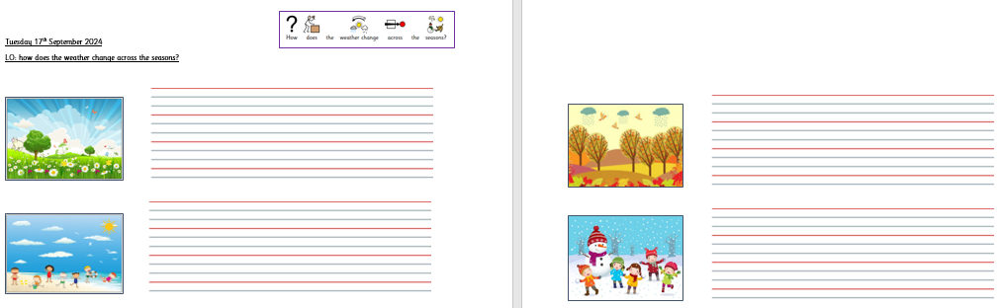

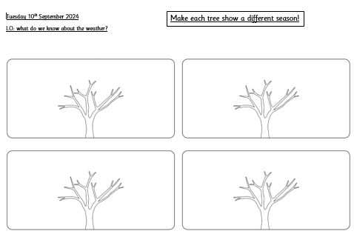

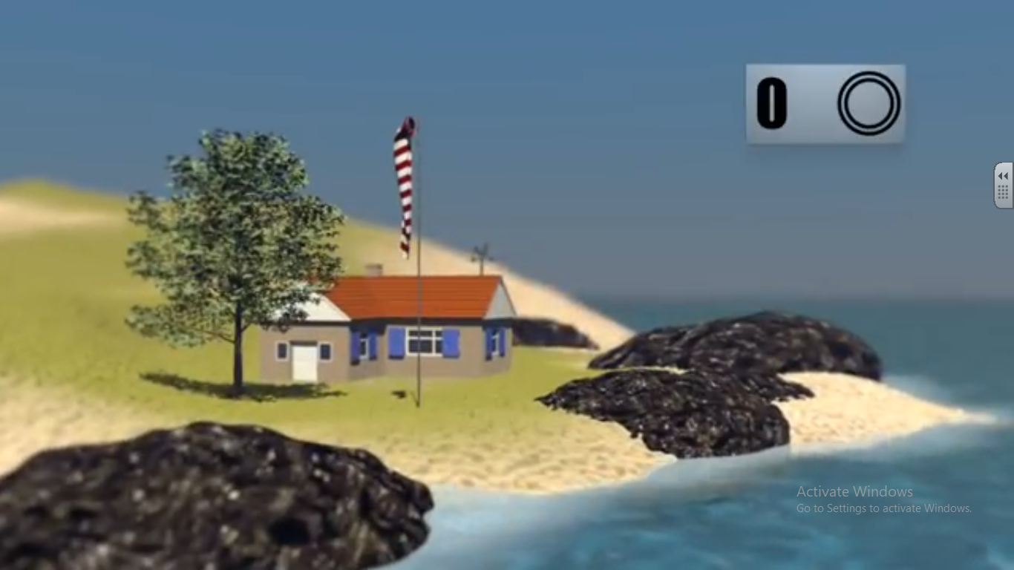



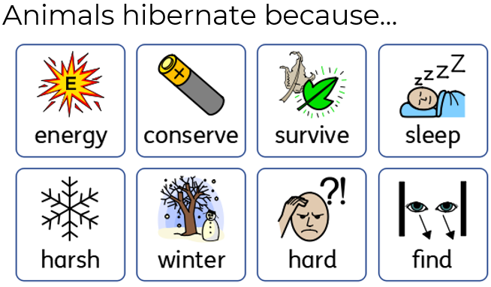

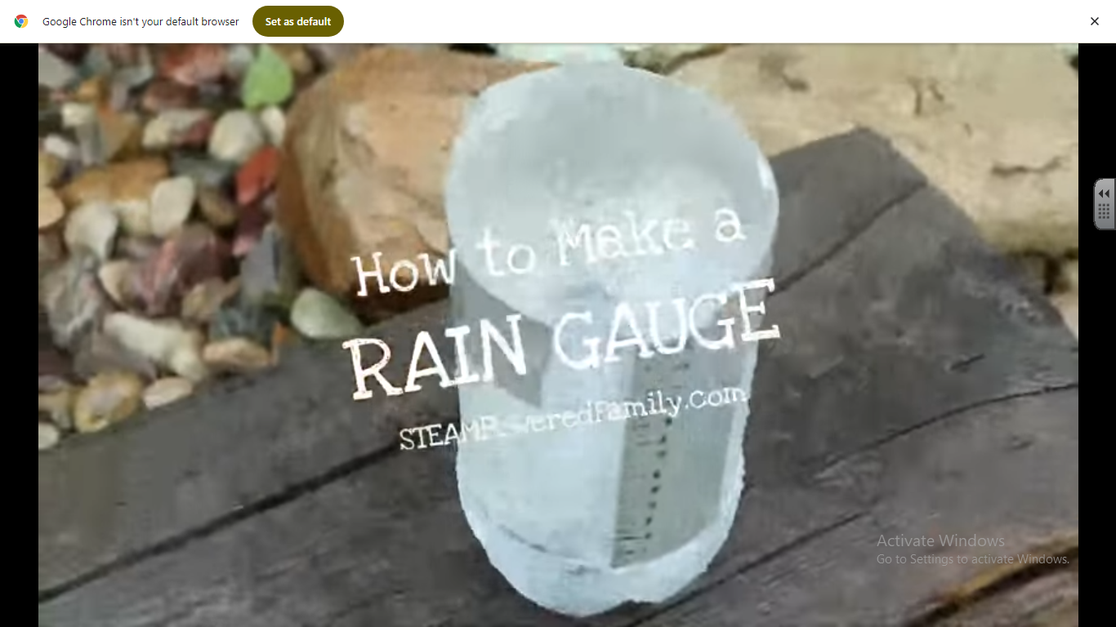

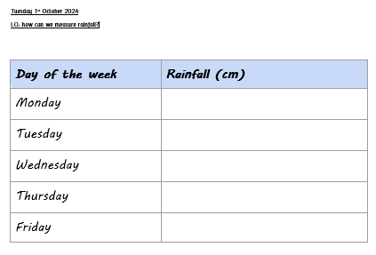

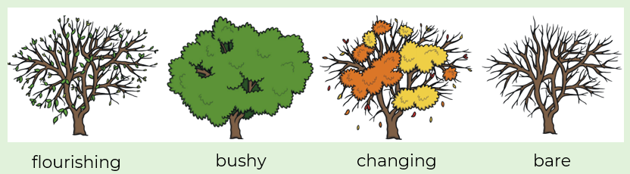

**3**

How do trees change across the seasons?

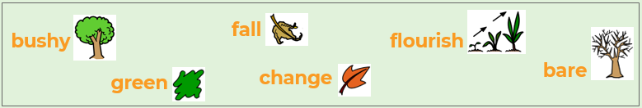



**6**

How can we record wind speed and direction?

**5**

What is hibernation?

**4**

How can we measure rainfall?

 