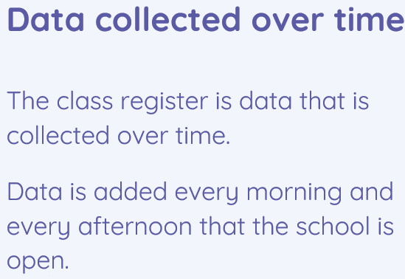 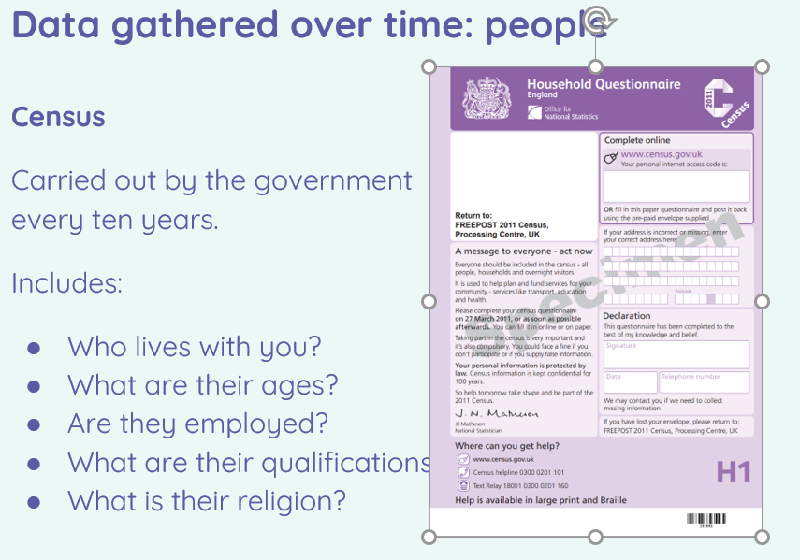

Data handling – data logging

•I can identify a suitable place to collect data

•I can identify the intervals used to collect data

•I can import a data set

•I can use a computer program to sort data

•I can interpret data that has been collected using a data logger

•I can draw conclusions from the data that I have collected

•I can choose a data set to answer a given question

•I can suggest questions that can be answered using a given data set

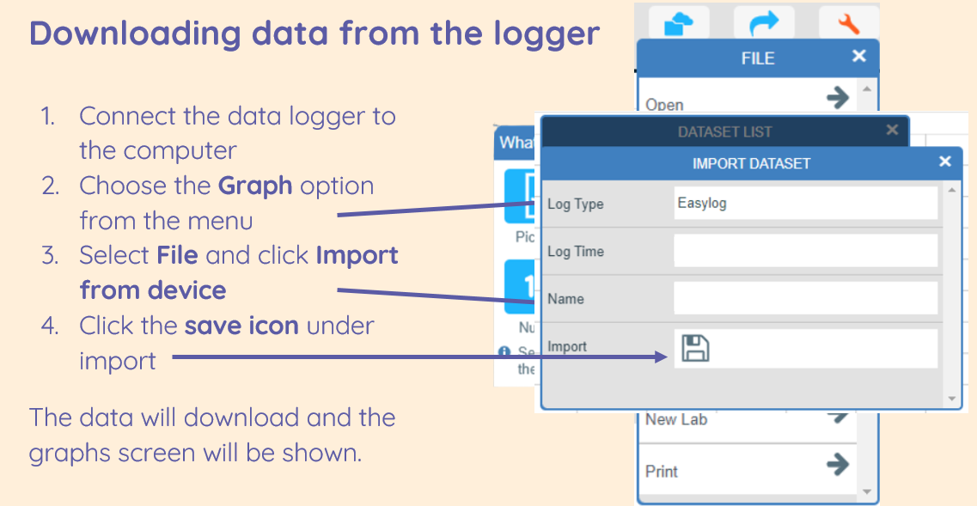

|  |
| --- |
| •I can propose a question that can be answered using logged data  •I can use a data logger to collect data |

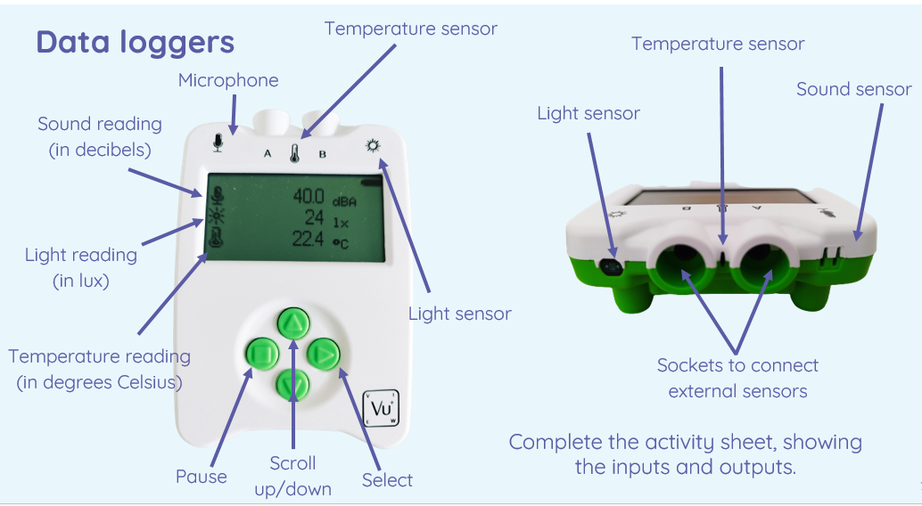

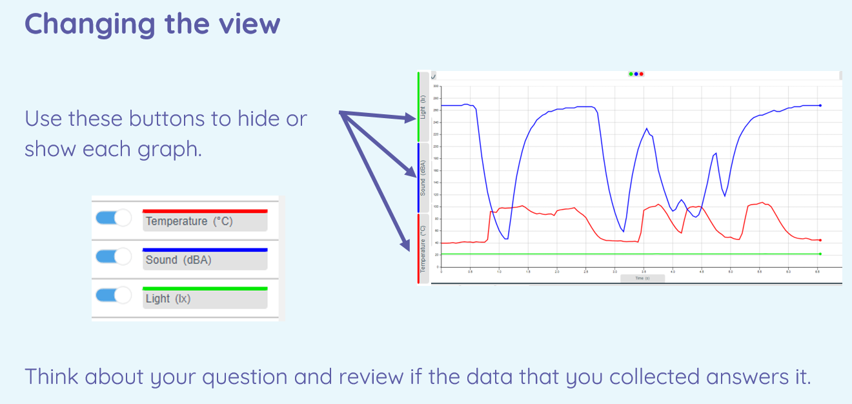

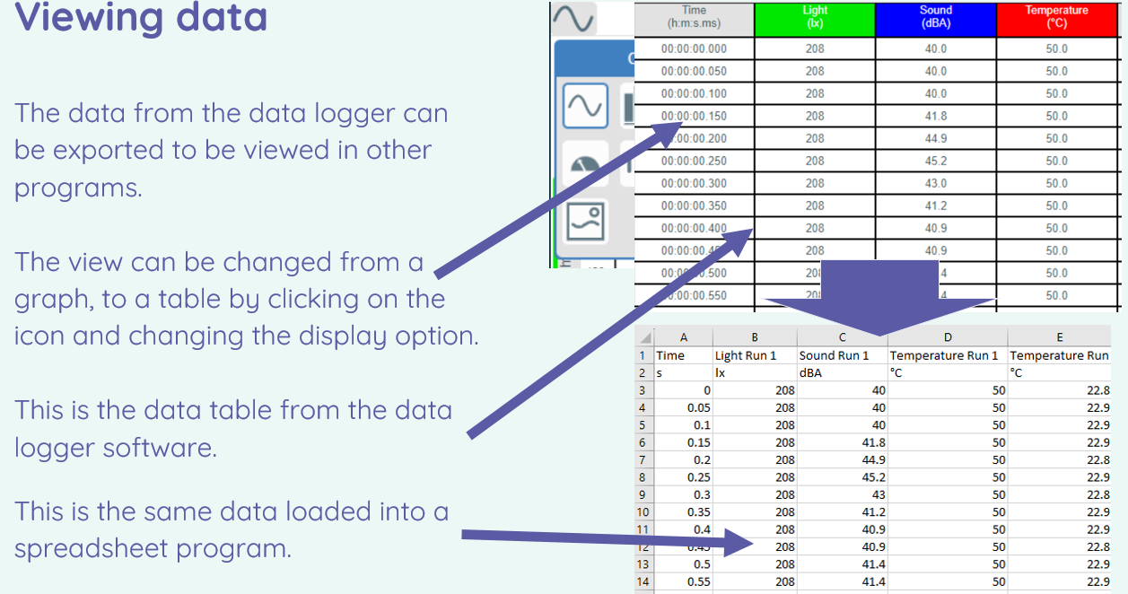

|  |  |
| --- | --- |
| **Key Vocabulary** | |
| Analyse | Examine (something) methodically and in detail, typically in order to explain and interpret it. |
| Collection | The action or process of collecting someone or something. |
| Conclusion | The last part of something, its end or result. |
| Data | Facts and statistics collected together for reference or analysis. |
| Data Logger | Electronic devices which automatically monitor and record environmental parameters over time. |
| Data Point | A discrete unit of information. |
| Data Set | A collection of data. |
| Export | You can transfer data to a file. |
| Import | You can bring data into a file you are editing. |
| Input Device | The process of providing information to the computer. |
| Layout | How something is presented. |
| Logged | Enter information. |
| Review | Look back over something. |
| Sensor | A device which detects or measures a physical property and records, indicates, or otherwise responds to it. |
| Table | A set of facts or figures systematically displayed, especially in columns. |

|  |
| --- |
| •I can explain that sensors are input devices  •I can use data from a sensor to answer a given question |

