To the

**THANK YOU**

Thank you so much to the parents who organised the cake sale and those of you who baked cakes and bought cakes. Fingers crossed we have made a significant amount of money to go towards our school trip to Magdalen Farm.

**Knowledge and Understanding of the World and Technology**

I have sent home two sheets entitled ‘Our World’ and ‘Technology’ with the children for you to fill out with your child over the next few weeks. Please return the sheets to school when they are completed so we can put them on Tapestry.

**Don’t forget….**

* Please bring PE kit into school in a bag on Wednesday.
* PE kit needs to be worn on a Thursday.
* To hear your child read every evening. Children who are heard read daily at home make good progress with their reading.
* To bring in any materials suited to junk modelling.

**Have a wonderful weekend.**

**Mrs Burrough**

**Robin Class News**

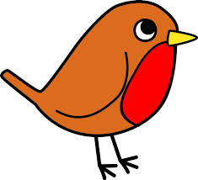

**Year Reception**

**How you can help your child with mathematics.**

This week we have been working on reciting numbers in order to 100 and working on pattern. The children have been working on making repeating patterns as well as symmetrical patterns. They have been making repeating patterns with more than two colours, shapes or sounds. I have been really pleased with the children’s creativity.

There is a good game on Topmarks that helps the children learn about repeating patterns. There are also some games that help the children to learn about symmetry.

<https://www.topmarks.co.uk/ordering-and-sequencing/shape-patterns>

<https://www.topmarks.co.uk/symmetry/symmetry-matching>

**How you can help your child with English.**

* Please make time every day to hear your child read. Explain the meaning of unknown words.
* Practise writing the letters learnt so far.

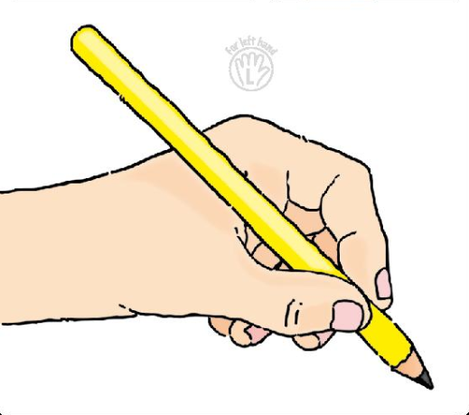 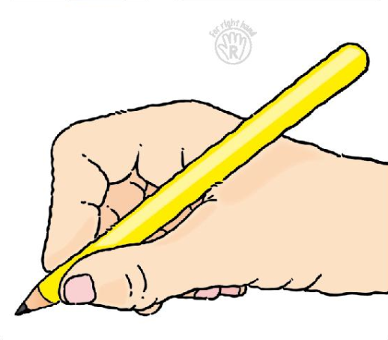

* Please help your child **practise writing their name** starting the lowercase letters from the line.
* Read a story every evening to your child.
* Visit your local library.

**Phonics work week beginning 11th February 2018.**

In phonics we are moving on to week 6 of phase3 of letters and sounds. We will be learning the phonemes (sounds):

ai, ee, oa

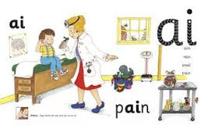 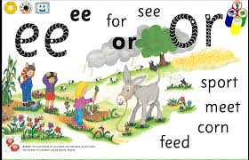

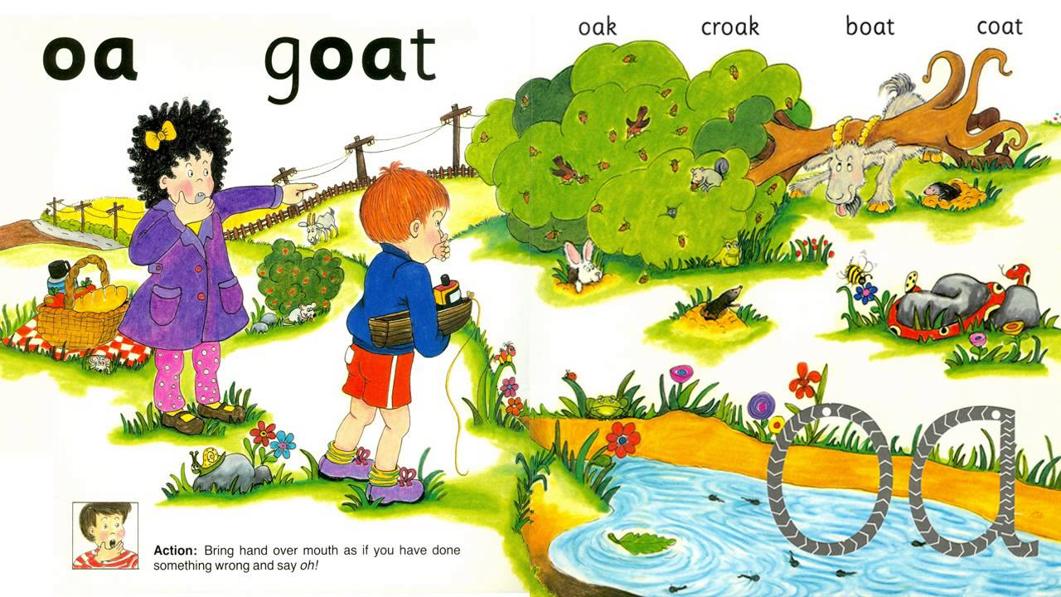

wait, pain, bait, rain, aim,

see, tree, feet, weep, meet,

coat, boat, toad, loaf

We will practise reading high frequency words learned so far, read and write sentences using letters learned so far as well as the words so, no, go, the, and, to, I.

We will learn to read the high frequency words:

she, all