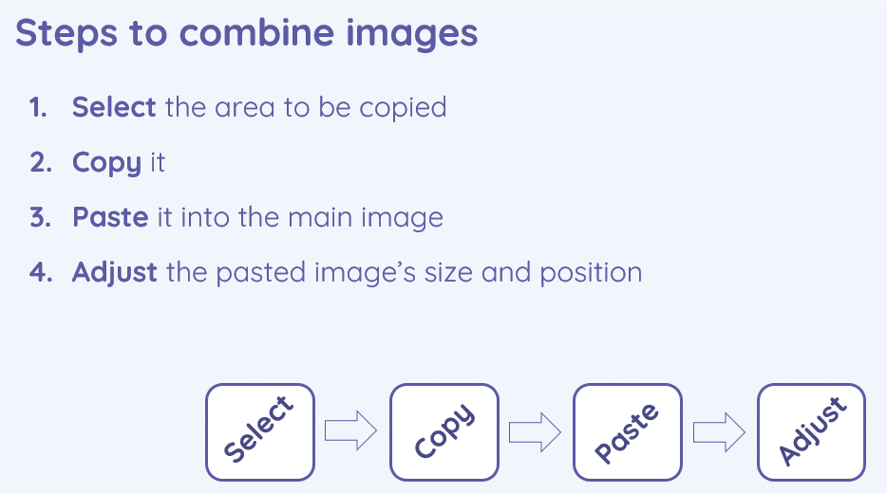 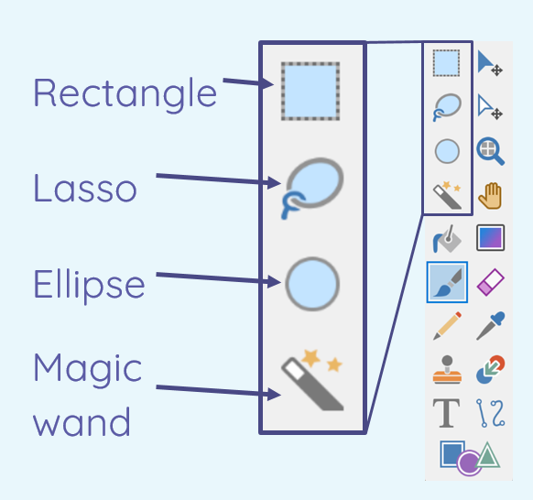

* I can give examples of positive and negative effects that retouching can have on an image
* I can choose appropriate tools to retouch an image

|  |
| --- |
| * I can consider the effect of adding other elements to my work * I can compare the original image with my completed publication |

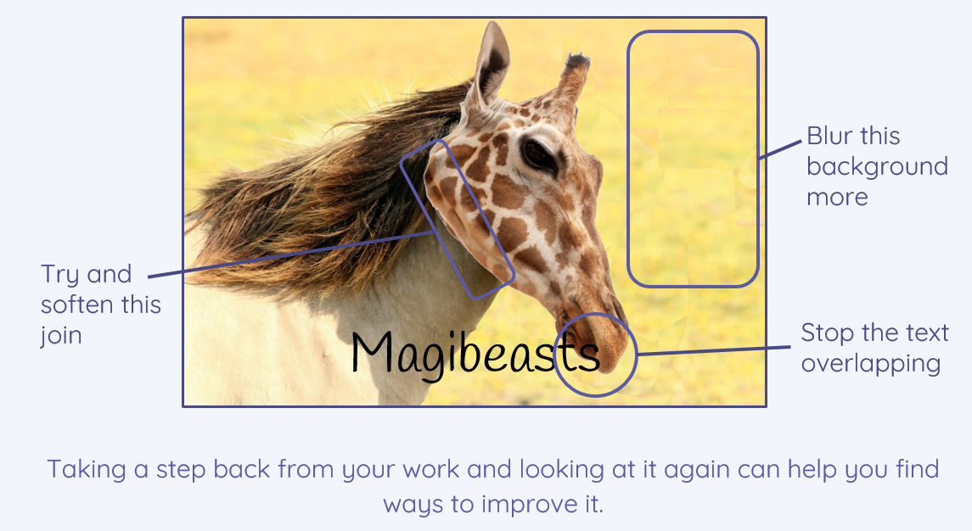

* I can sort images into ‘fake’ or ‘real’ and explain my choices
* I can combine parts of images to create new images

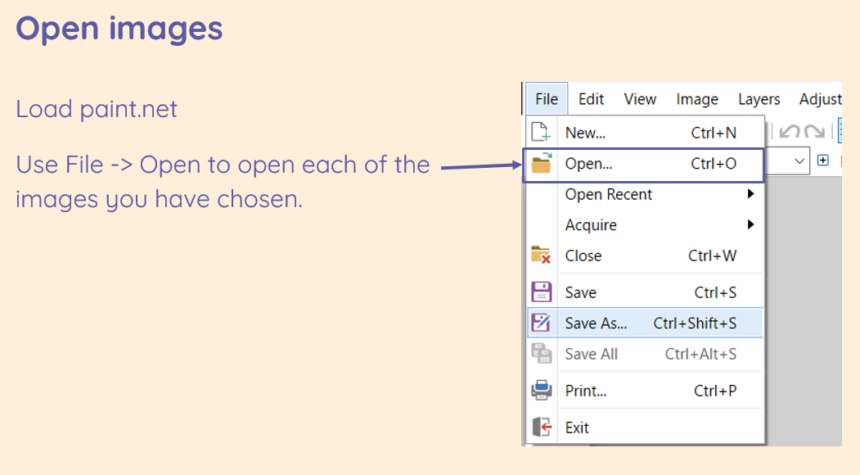

|  |
| --- |
| **Key Vocabulary** |

Image- the photo

Edit- to change something to improve it

Retouch- to change something slightly

Clone- to make a copy of it

Recolour- to change the colour

Magic wand- a tool in paint.net

Adjust/ alter- to change

Sharpen- make the edges clearer

Brighten- make the picture lighter

Composite- something that is made of many parts/ elements

Cut- to remove something from somewhere

Copy- to copy something

Paste- to place the object you have cut/ copied in another place

Elements- parts

Original- the first copy

Font style- how the text looks

Border- the part around the outside

Layer- things that are put on each other

**Photo editing**