To spread the good news

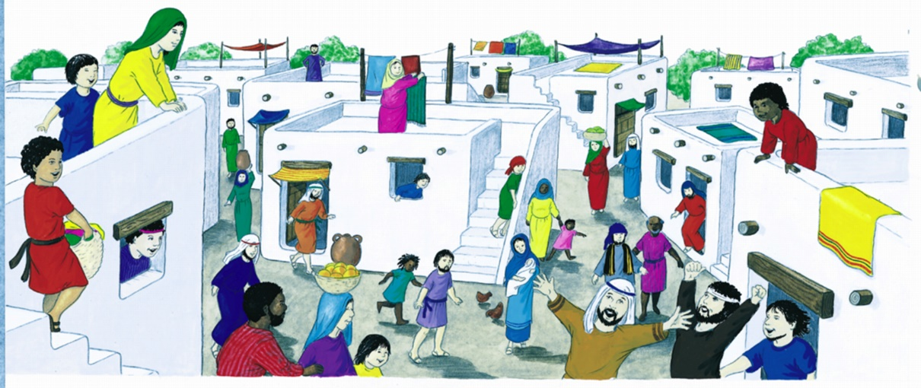

Holy days, like holidays, are times for celebrating and enjoyment. We relax from ordinary life and think about other things. Holy days are special times for thinking about the life of Jesus and about God the Creator’s love and care for us. This is Good News. The Holy Spirit guides us and gives us strength and courage to share that Good News with others.

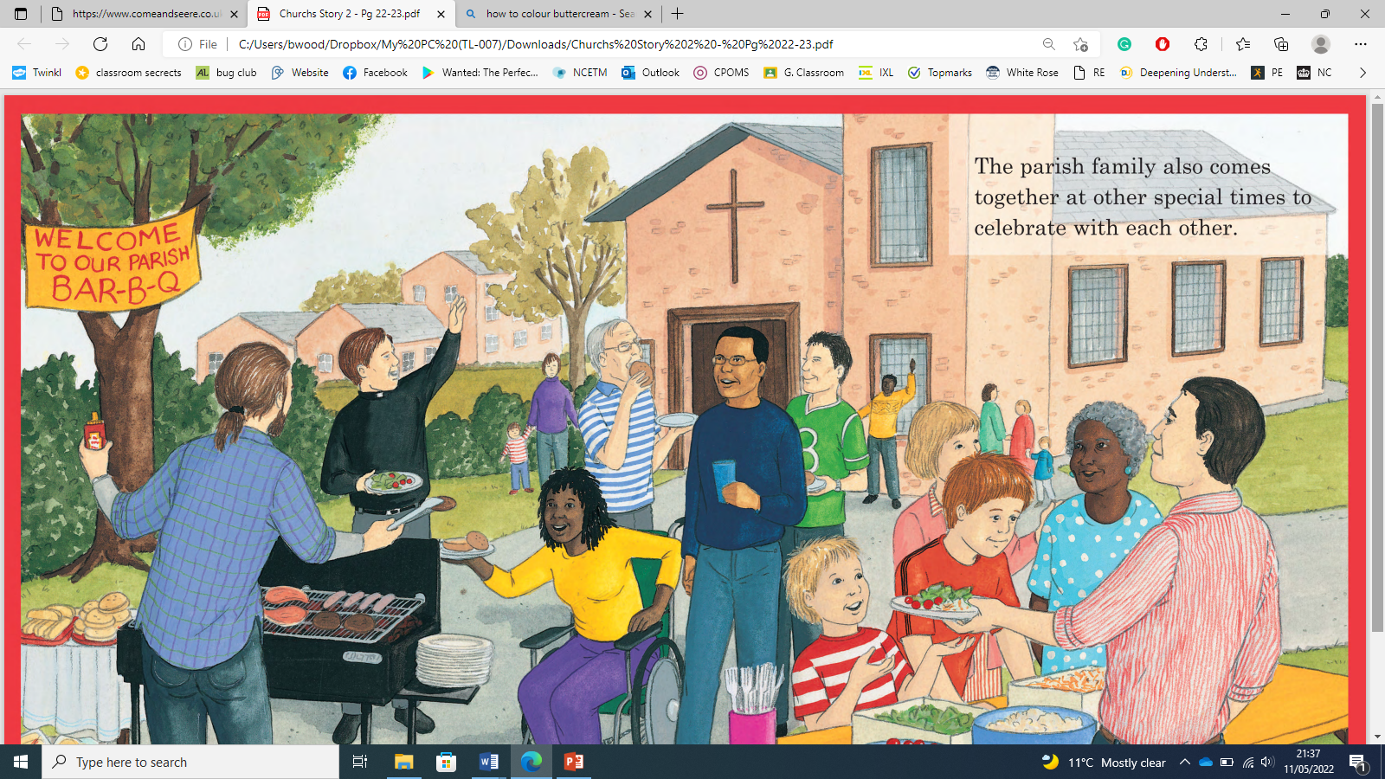

To know that Pentecost is the start of the church

|  |
| --- |
| To understand Pentecost day |

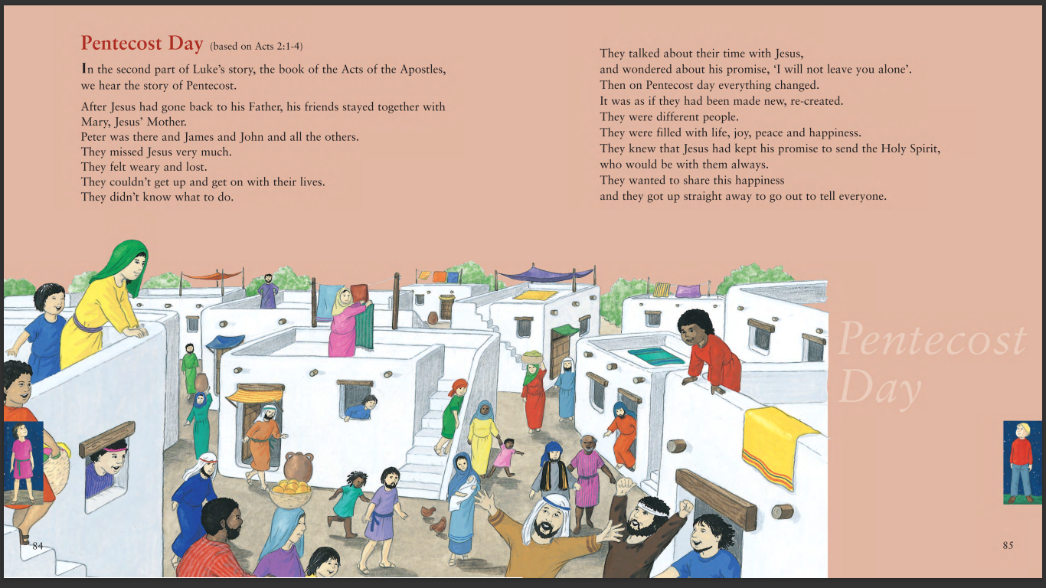

To know about the Holy day Pentecost

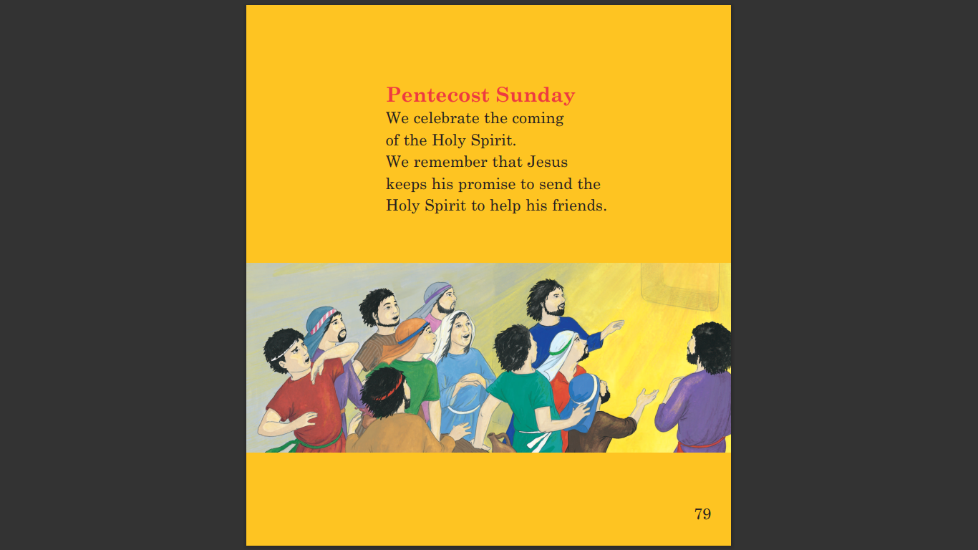

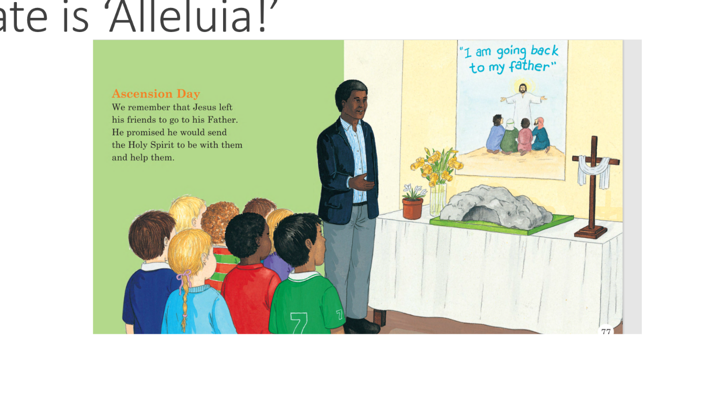

|  |
| --- |
| To know that the Ascension Day is when Jesus goes back to his Father. |

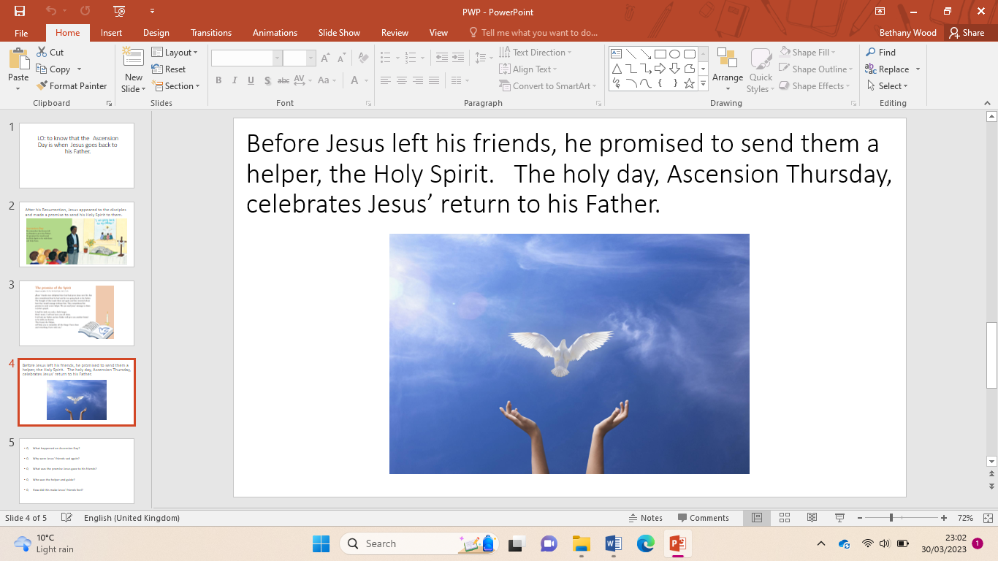

To know what a Holyday is

|  |
| --- |
| **Key Vocabulary** |

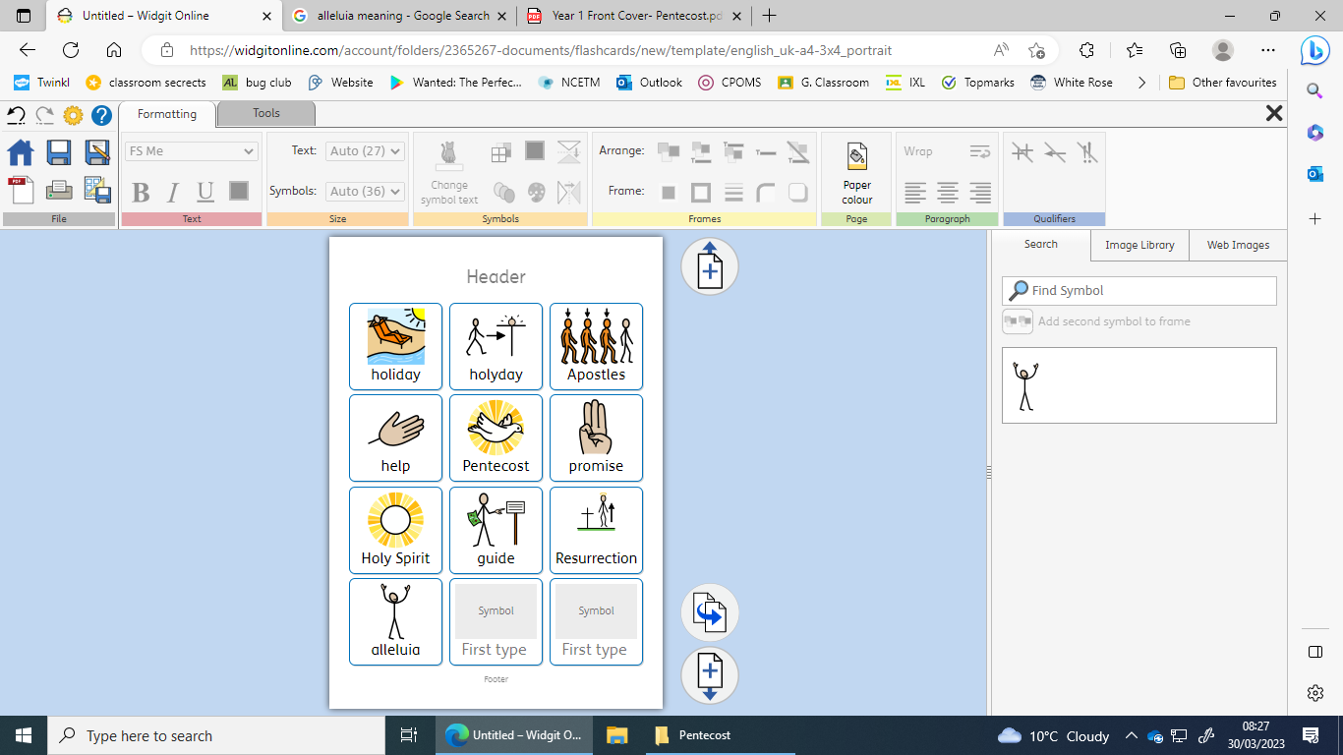

Pentecost