**Poem from the Poetry Basket**

**Falling Apples**

Here is the tree with its leaves so green.

Here are the apples that hang between.

When the wind blows, the apples will fall.

And this is the basket to catch them all.

**PE DAYS –** Our PE days are Monday and Wednesday. Please make sure your child come to school dressed in PE kit on those days.

**Reading Records** – Please try to hear your child read each day. Write in the reading record to say how they got on. Thank you

**Library Books –** School library books get changed on a Friday.

**AXMINSTER LIBRARY VISIT-**We are going to the library on Tuesday 15th October. Please make sure your child has their card in on this day and that they are in school by 8:45am so we can leave promptly.

**Wellies**- Please bring in a pair of named wellies for your child to keep in school.

**Water Bottles –** please bring in a named water bottle each day for your child.

**Have a lovely weekend from Mrs Burrough and Mrs Slade**

**Robin Class News**

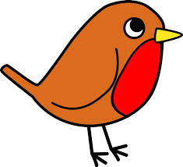

**Year Reception**

**Maths**

In maths this week, we have been focussing on the number 5. We have been counting drum beats, cubes and autumn treasures. We noticed that when we show five on a five frame it is full. We have also noticed that we can see five by seeing a 2 and a 3 or a 4 and a 1. As well as this, we used blocks to make lots of different shapes to show the number five – five monsters! When we were counting five we had to make sure we stopped counting when we had counted out five blocks as well as saying one number for each object counted. Please practise reciting numbers in order, counting forwards and backwards as well as counting objects and moving them as they count each one.

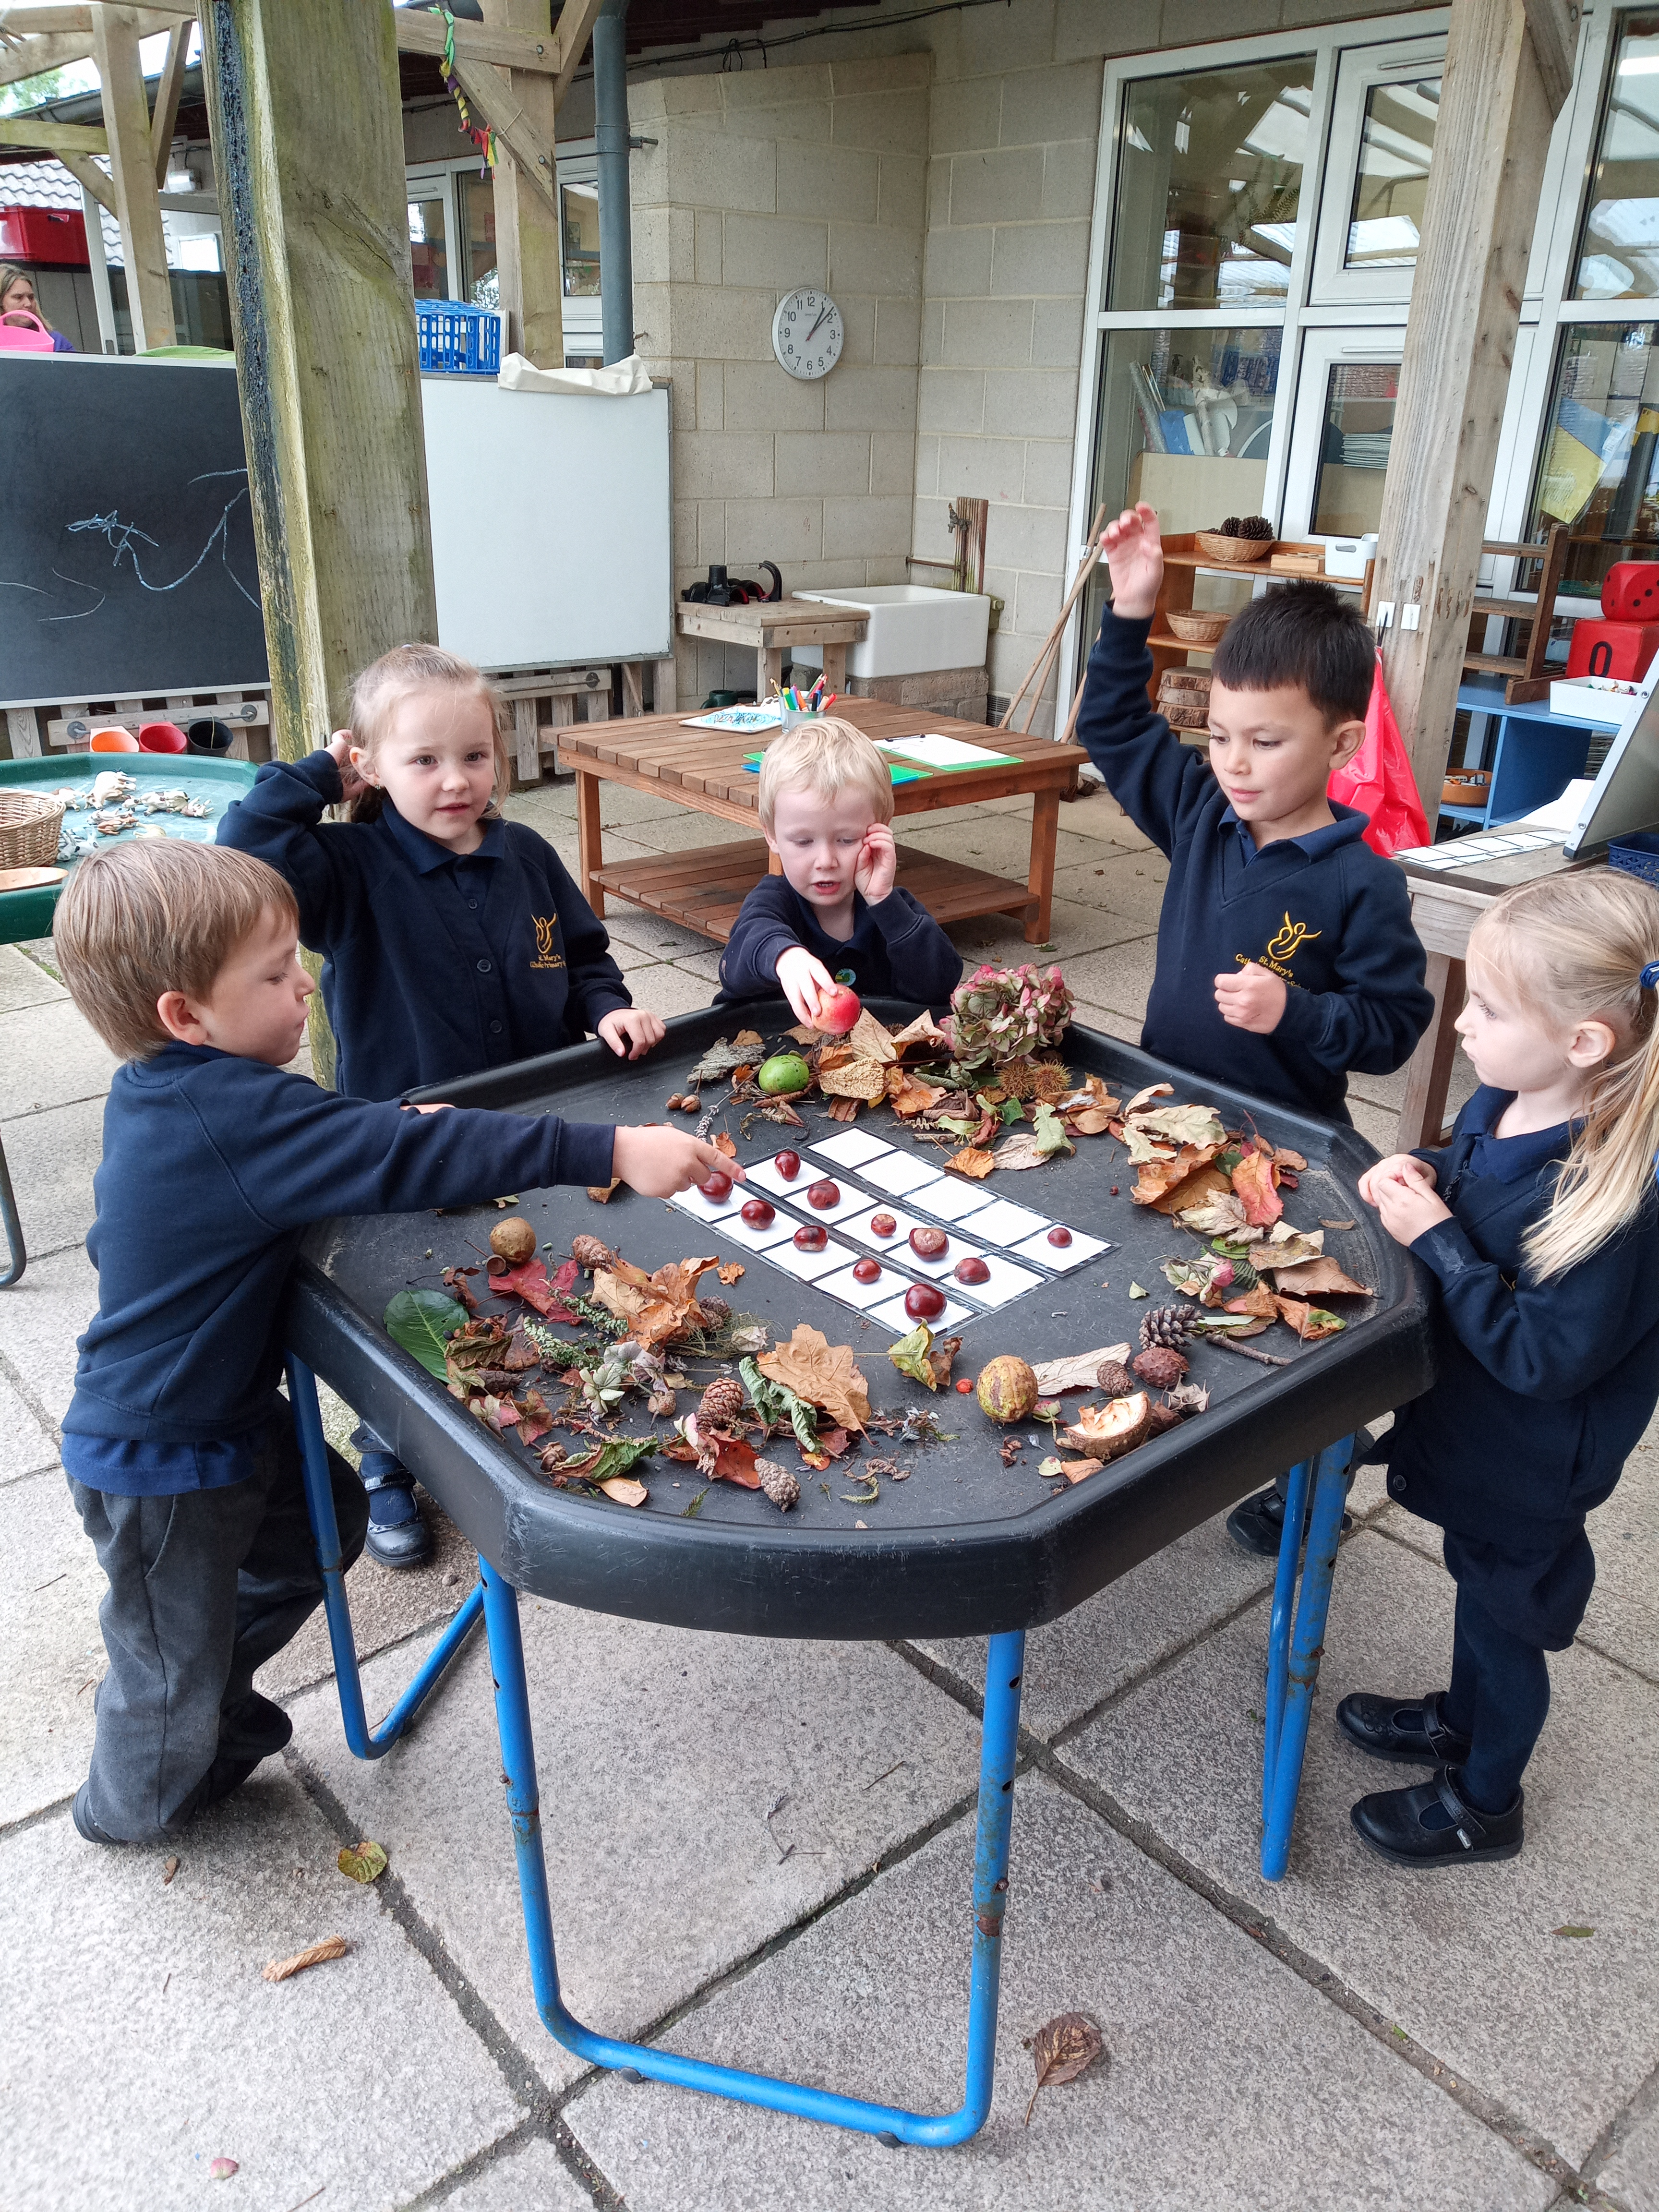

**Drawing Club**

In Drawing Club this week we have listened to the story We’re Going on a Bear Hunt. On the first day we drew a picture of the Bear, then we drew a picture of the setting, which was the bear’s cave, and then we drew an adventure. In our adventure, the family escaped but when they got to the river it was flooded. How could they get across? The children had some wonderful ideas. Our vocabulary that we have learnt this week from Drawing Club was - wandering, joyful, obstacle, courageous, tiptoe, panic, flee, hide. Why not use these words in your everyday interactions with the children?

**Phonics - week beginning 30th September 2024**

In phonics this week, the children have learnt the letter sounds i and n. They have learnt their names and have learnt the sound they make (the phoneme). I have assigned a game with the letter sounds on Bug Club for your child to practise.

We have listened to the sounds the letters i and n make and we have practised writing the letters. I have sent home the flash cards for you to practise at home. You could stick them onto cereal box card so you can use them as flash cards. Why not rearrange the sound cards to make words and practise reading words?

As well as this, I have sent home words with sound buttons underneath. Encourage your child to point to the sound buttons and say each individual sound then put their finger back to the beginning and slide it across as they blend the sounds to read the word. This is demonstrated on Bug Club if you want to look.

**Tapestry** – Please let me know if you can’t get on. It is really beneficial for your child’s learning to be actively involved in their learning journey.

**Autumn Treasures –** thank you so much for bringing in some beautiful autumn treasures. Please bring in more if you are able. Thank you.

**Little Red Hen –** We have started learning the story of The Little Red Hen. I have sent home the version we have learnt in school to practise with your child.

**KUW – Mrs Slade**

On Friday morning we continued talking about the lifecycle of a human being, focussing on babies and toddlers. The children played with the babies and explored different artefacts relating to babies and talked about how we look after them.

On Friday afternoon, the children learnt about harvest. We explored pumpkins and painted them from observation. We also harvested the potatoes in our garden.