Water in the liquid state can change into water in the gas state (water vapour).

In gas state, water is invisible, can flow, has no fixed volume and takes the shape of the whole of its container.

The process in which a liquid changes to a gas is called evaporation.

Water can be observed changing from a liquid to a gas.

We can change the state of a liquid to a gas by changing its temperature.

Water vapour (water in the gas state) turns into water in the liquid state when it is cooled.

The process in which water changes from the gas to the liquid state is called condensation.

We can change the state of a gas to a liquid by cooling.

Water can be observed changing from gas state to liquid state when cooled.

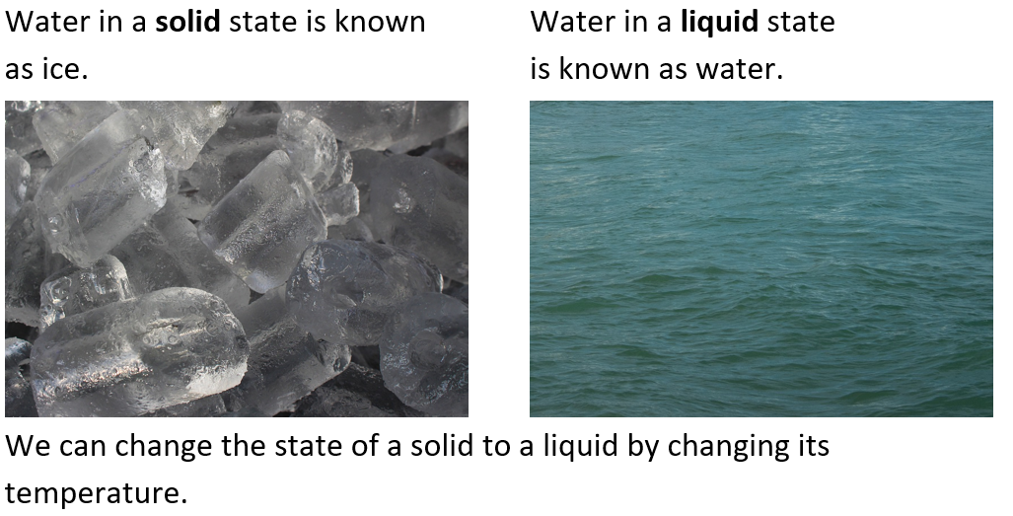

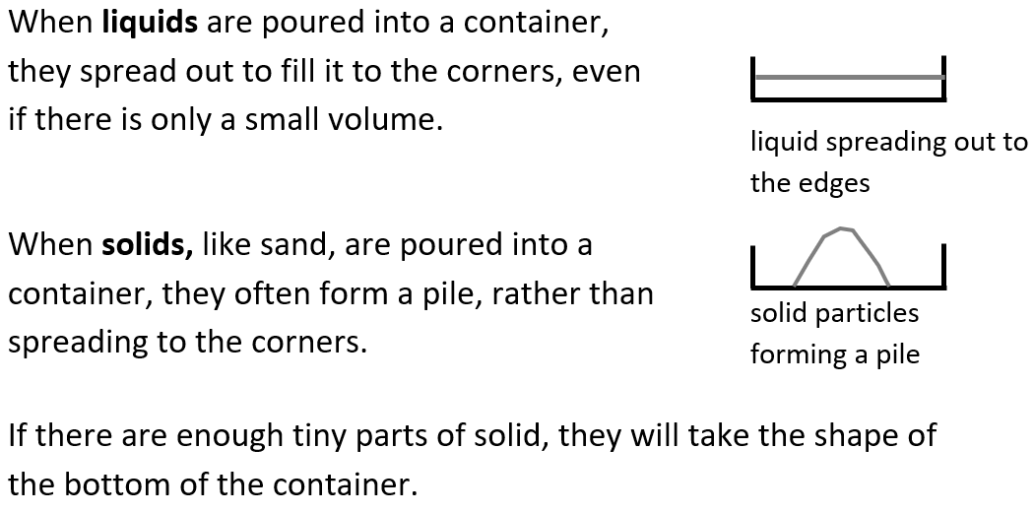

Substances can exist as different states of matter: solid, liquid and gas.

Solids, liquids and gases have different properties.

Liquids can be poured easily and take the shape of the bottom of the container that they are in.

A solid has a fixed shape and volume but some solids can change shape when a force is applied.

Gases are often invisible to the human eye. They escape from an unsealed container and have no fixed shape or volume.

|  |
| --- |
| **Key Vocabulary** |

States of matter - The three common states of matter are solid, liquid and gas.

Solid - A solid has a fixed shape and volume but some solids can change shape when a force is applied.

Liquid - A liquid can flow, has a fixed volume and takes the shape of the bottom of its container.

Gas - A gas can flow, has no fixed volume and takes the shape of the whole of its container.

Properties - The properties of a material or substance are its qualities or things it can do.

State - Materials can exist in three common states of matter: solid, liquid and gas.

Heat - To heat something is to increase its temperature.

Melt - To melt is to change from a solid state to a liquid state.

Freeze - To freeze is to change from a liquid state to a solid state.

Water vapour - Water is called water vapour when it is in the gas state.

Evaporation - Evaporation is the change of state from a liquid to a gas.

Condensation - Condensation is the change of state where a gas changes into a liquid.

Water cycle - The water cycle is the name of the journey water takes as it moves from the sea or land to the atmosphere and back again.

Precipitation - Precipitation is water, in the solid or liquid state, which falls from the atmosphere to Earth’s surface.

Properties of materials and states of matter