Eagles English and SPAG – TASK 5
Friday 26th June 2020

This has been quite a full on week of Literacy learning so I would like to make today a little more relaxed. As you have now, hopefully, finished your myths, todays task is to create an Ancient Greece style illustration to go with it. This could be a front cover, a key scene from your myth or the setting. Below are some examples of the art style we are aiming for. Good luck!
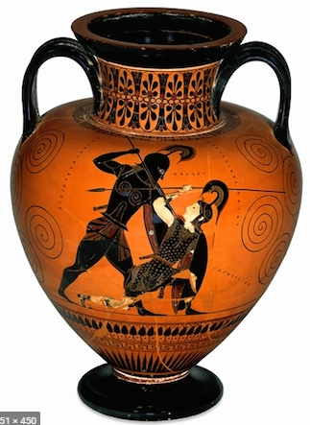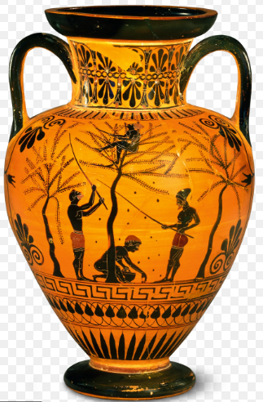
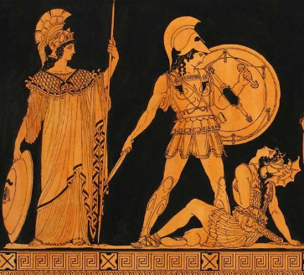
Remember to take a photograph of your work and ask a grown-up to either email it to the office for us or upload it to the Eagles unit of the Facebook page. We really want to see your work!

