Eagles English and SPAG Literacy – TASK 3
Wednesday 17th June 2020
As you may have noticed from the Greek Mythology you have read, the characters in these myths tend to be larger than life: scheming Gods, devious villains and dashing heroes! Pandora herself is a slightly more complicated character…
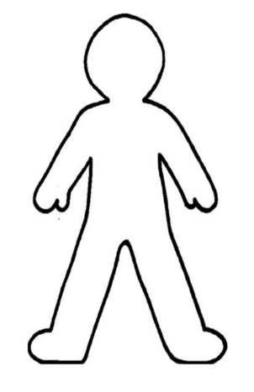
Step 1: Draw an outline of Pandora and think about what she is like as a character. On the inside of the outline, write down how she feels and what she thinks. On the outside of the outline, write down her actions and what she does in the story.

Step 2: It’s time to start thinking about your own Greek Myth. Can you design and create a character for your own myth? You can choose to create either a hero or villain / monster. Please draw and label your character and a write a short paragraph about what they are like and how they act.

Remember to take a photograph of your work and ask a grown-up to either email it to the office for us or upload it to the Eagles unit of the Facebook page. We really want to see your work!

