Monday 6th July
After we have registered we are going to be looking at our phonics sounds. We will practice all of phase 3 and 5 sounds using Flashcard speed trial. Then we will be looking at our tricky words using trick word trucks for phase 3. Below are then the worksheets we will be working through as a class or doing similar activities.
After phonics we will be going out and doing 15 minutes of exercise either playing a game like simon says outside or super movers.
In maths we will be starting each lesson with using our number square to practice counting forwards and backwards in 2,5 and 10 up to 100. We will then play a game involving finding and making 2digit numbers. We will also practice writing our number digits from 0-9 correctly. After this we will be working through the sheets below or doing similar activities using resources.
We will then have half an hour to eat a piece of fruit and have some fresh air outside.
After break it will be literacy. This week we are focussing on the little red hen. We will read the story then create a story map. This is when the children draw pictures to help them remember what happens in the story. They may choose to write key words but they do not have to. In-between the pictures they draw an arrow to show which direction the pictures go in. it would look something like this:
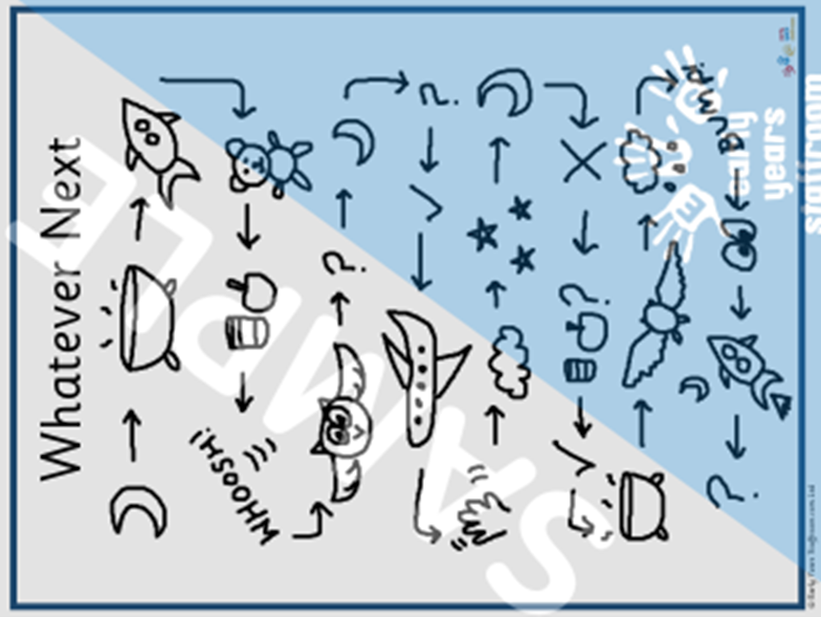
Following this we will do a go noodle or some super movers.
The children will then work through the following sheets so that we can prepare the classroom for lunch.
We will now have our lunch and fresh air outside. After lunch the children will have handwriting practice. The words today are: elephant, newt, toes
Then they will have PE. In PE today we will be practicing their skipping. We began to get good at it last week so we will be trying to beat our personal best.
After this we will have our creative lesson which is art. Today we will be doing colouring and drawing.
Finally, we will end the day with a story.

