**Factors that affect air and water resistance**

Surface area

The greater the surface area of the object, the greater the air resistance. This is because there are more air particles in contact with the object which results in increased fictional force.

Speed

As an objects speed increases, the air resistance increases.

**There are three components to any lever.**

a pivot – the point about which the arm can turn. This can be called a fulcrum.

an effort – the force you input.

a load – the thing you are trying to move.

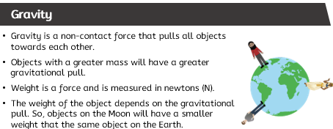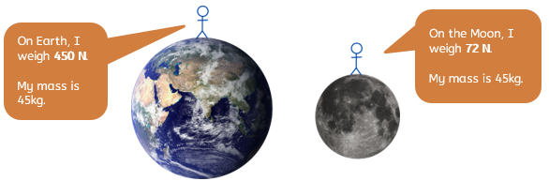

**What is the difference between mass and weight?**

All objects have a **mass**. This is the amount of matter that the object is made from, and it is measured in kilograms. All objects also have weight. Weight is the gravitational force of attraction on a mass. **Weight** is a force and is measured in **newtons** (N).

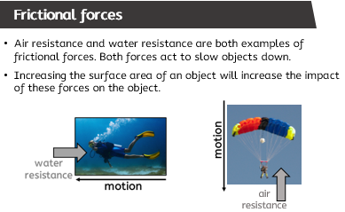

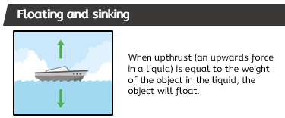 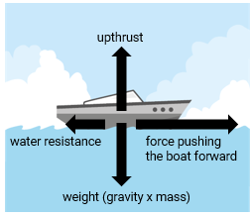

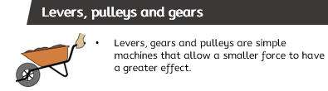

|  |
| --- |
| **Key Vocabulary** |

gears: (noun) gears are simple machines. They are a set of wheels with teeth that slot together. Gears can be used to increase a turning force.

lever: (noun) a mechanism that consists of an arm (bar or beam) on an fulcrum.

load: (noun) the weight (the force) that is being moved.

machine (noun) a piece of equipment that can change forces to make work easier.

pivot: (noun) the point at which something turns.

pulley: (noun) simple pulleys compose of a rope that passes around the edge of a wheel and is used to lift heavy objects.

streamlined: (adjective) describing a shape that results in less air or water resistance.

surface: (noun) the outside part of an object.  
surface area: (noun) the area of the outside part of an object.

weight: (noun) the force of gravity acting on an object. Weight is measured in Newtons.

Forces