Eagles SPAG – w/c Monday 13th July 2020

This week we are going to really focus on those Year 5/6 spellings which we will be using all the time in Year 6. The more you practise now, the easier it will be!
Please practise your spellings for at least half an hour every day. If you’d like another copy of your personal list, please contact the school and we will send a new one out to you. Here are some games you might want to try!
https://www.topmarks.co.uk/english-games/7-11-years/spelling-and-grammar
Spooky Spellings (pictured below) – click on the Yr 5/6 year group and then choose one of the books to click; each book has a different spelling list. It will give you the word to practise. Select the letters in the jars below; the word will disappear and you need to drag the correct letters up. Then check to see if you are correct.
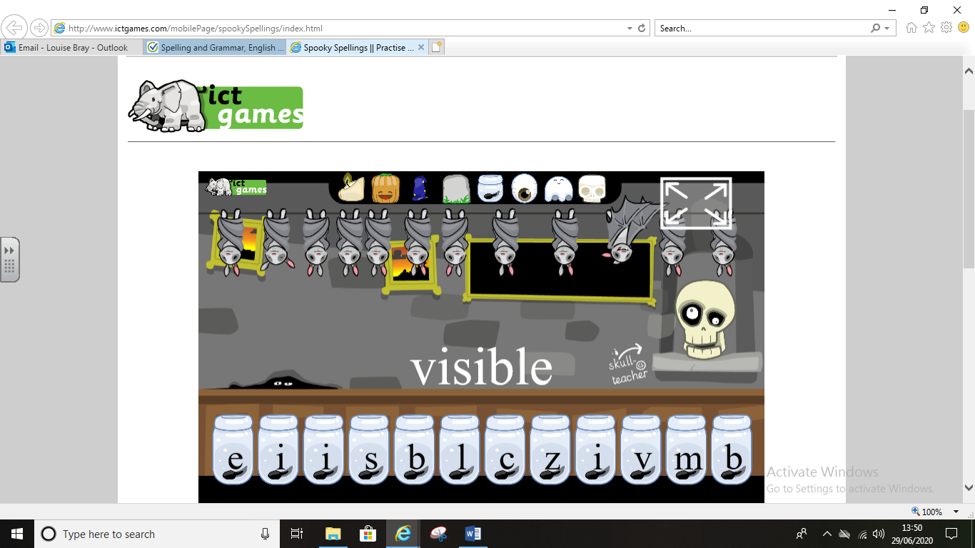

Coconut Vowels (pictured below) – not strictly Yr 5/6 words but a test on your knowledge of vowel sounds. Look at the vowels by the blaster and then see which of the falling coconuts have beginning and end letters which would make a word with the blasted-out vowels. Click on the falling coconuts and stop them from smashing open on the floor. You can choose your difficulty level and coconut-falling speed.
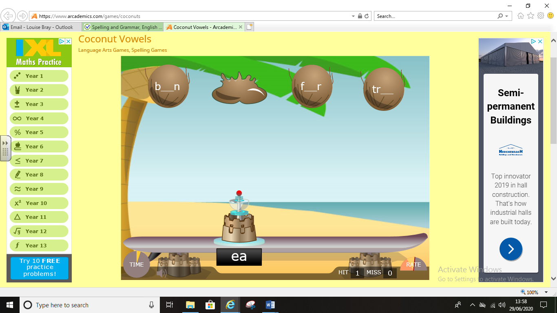
https://www.bbc.co.uk/bitesize/topics/zt62mnb
These games (pictured below) let you focus on a particular spelling pattern. Look at your personal list and see if any of your words use this pattern; if they do, have a go at some of the Bitesize games!
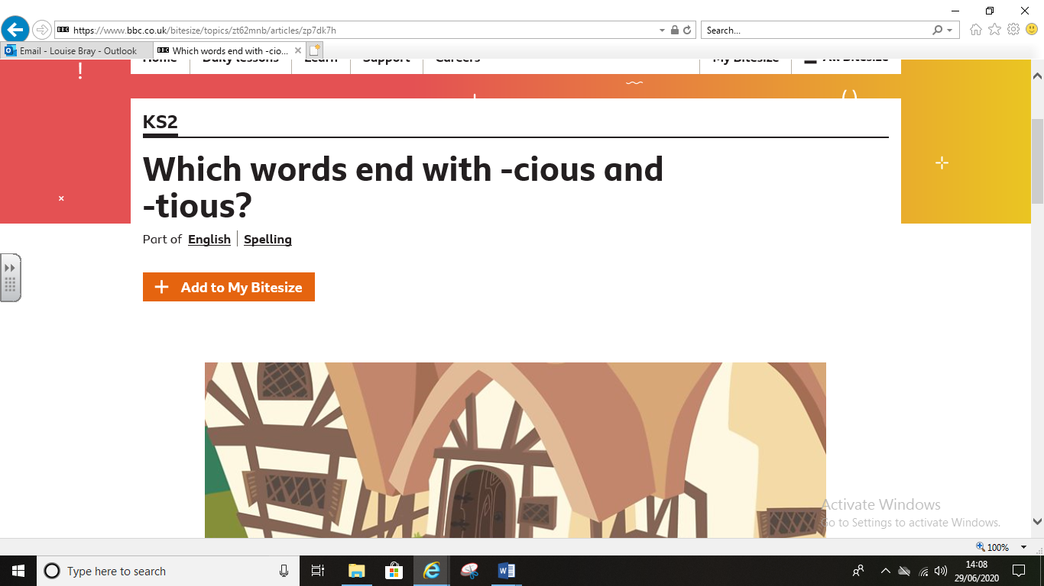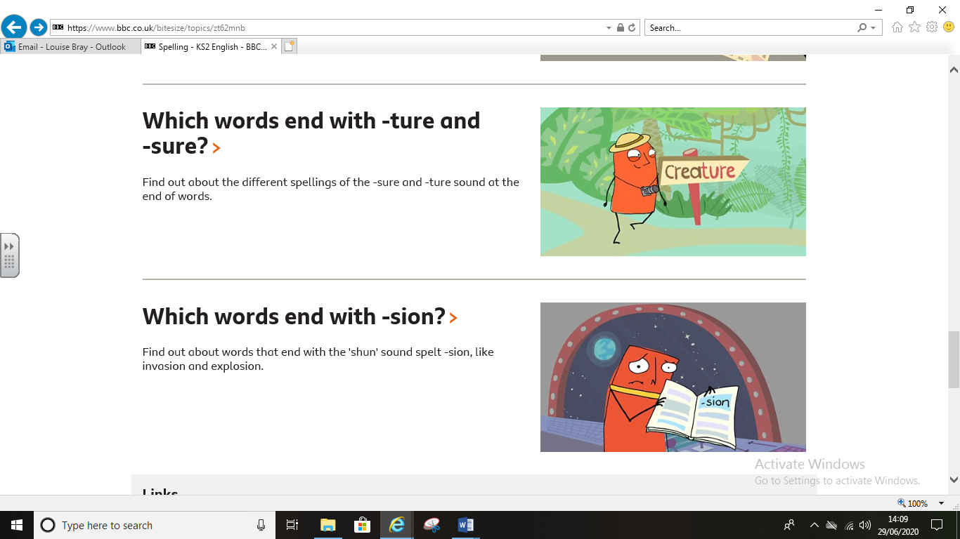

Other ideas

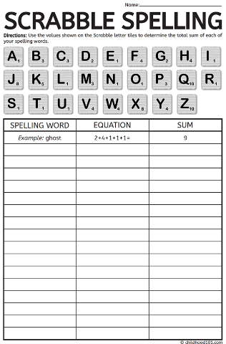
Scrabble scores – work out the Scrabble score of each of your spelling words…. When you test yourself on the spelling, how many points can you score? For example, if your word is persuade, the total number of points would be 11 (3+1+1+1+1+1+2+1). When you test yourself, score the points for the letters you got right. If you spelled it as perswade, you would score 10 out of 11 because you wouldn’t get a point for the missing u.

Have a game of Scrabble or Boggle to test your word skills – can you make any of the words from your spelling list?

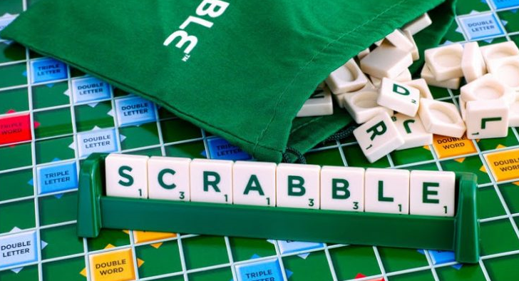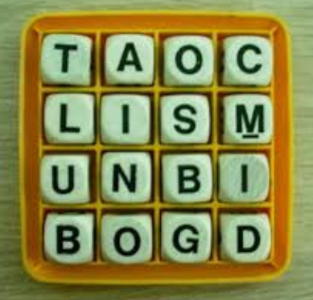

Look at the attached Spelling Challenge Activity and see how many of the strategies you can use to practise your spellings.
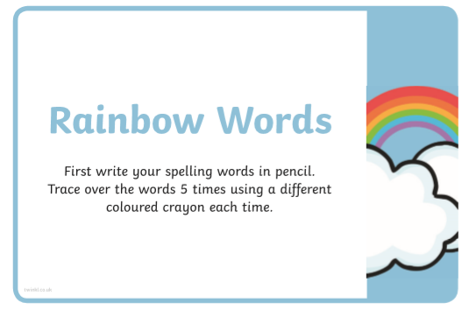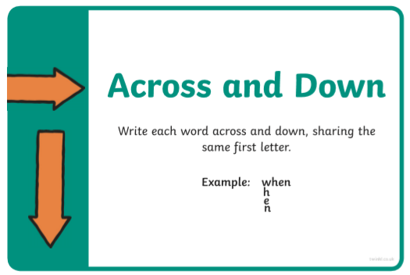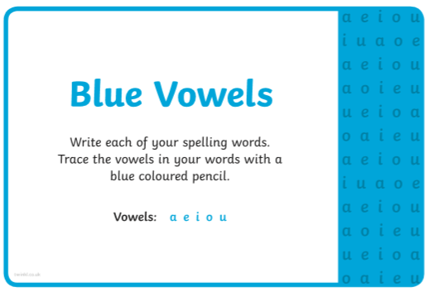

Remember to send in photos of your spelling practise!

