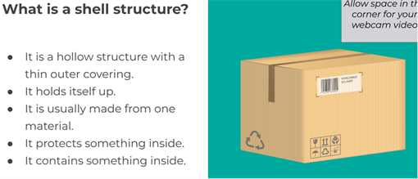

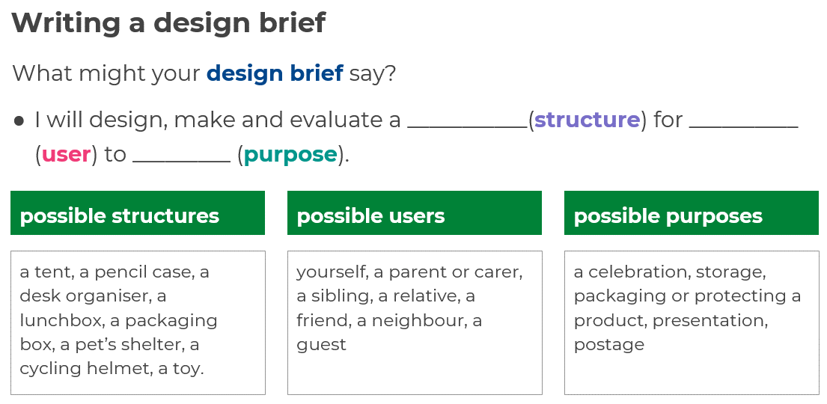

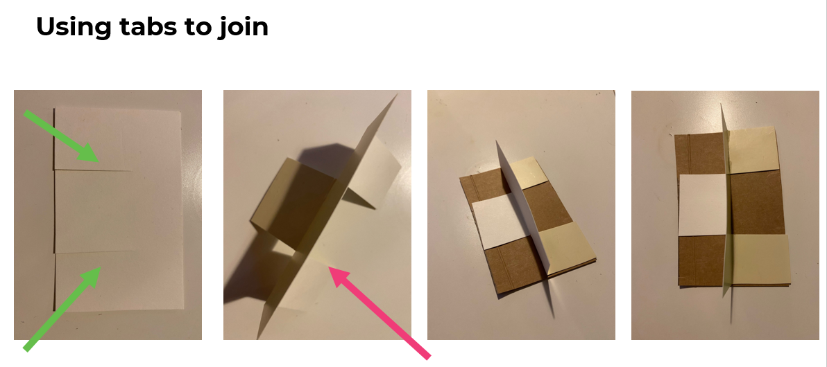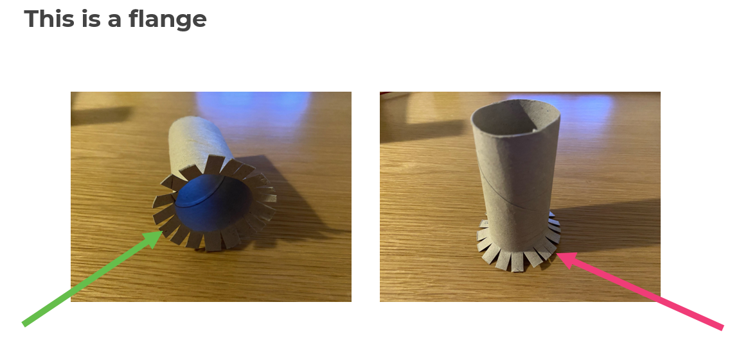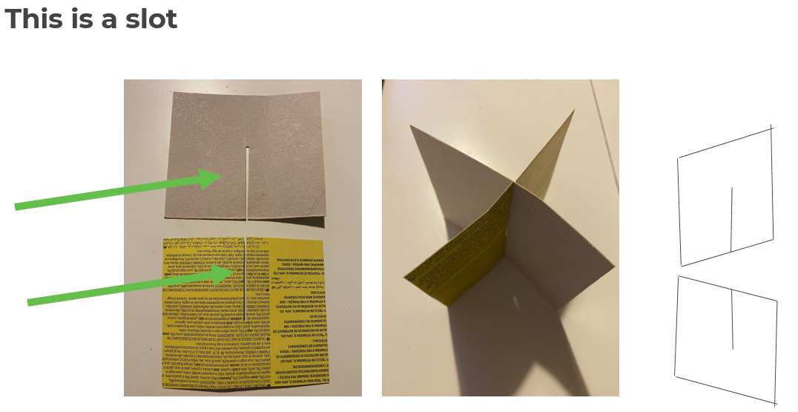

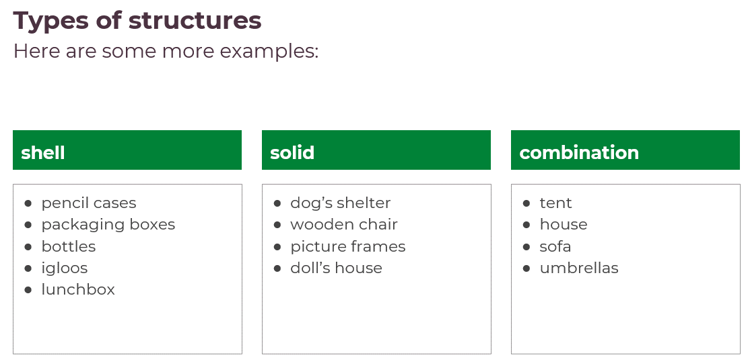

Examples of 3D nets

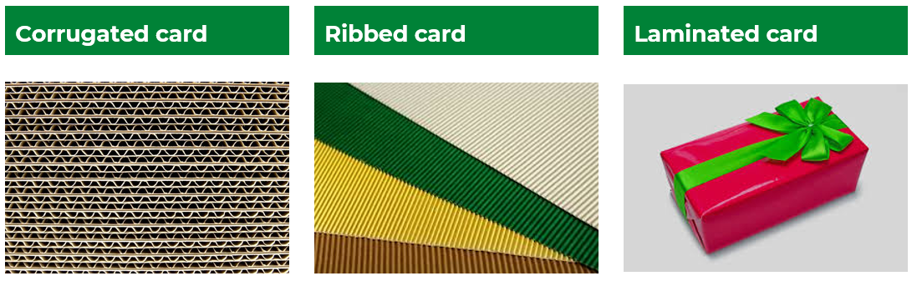



|  |  |
| --- | --- |
| **Key Vocabulary** | |
| Structure | Object constructed of several parts |
| Shell structure | Is a hollow structure with a thin, strong outer coating |
| Corrugated | Is a material shaped into a series of ridges to give extra rigidity and strength |
| Ribbed | Is a material shaped into a series of parallel ribs in order to strengthen it |
| Net | A term used to describe what a 3D shape would look like if it was opened out and laid flat. |
| Scoring | Cutting a line or mark into sheet material to make it easier to fold |
| Product analysis | To look closely and carefully at an object and find out more about it |
| Function | What a product does |
| Solid structure | Are solid material the whole way through |
| Combination structures | Are a mixture of shell, solid and frame structures |
| Design brief | A description of the product we will design. It states how a product will function to meet the needs of a user. |
| Purpose | The reason why an item is created. |
| Product | The item we will design and make. |
| User | The person who will use our product. |
| Sketch | To make a rough drawing of a product. |
| Annotate | To add notes which state opinions or make comments about the product. |
| Context | The circumstances in which a product will be used. |
| Developing | To become more advanced and elaborate. |
| A tab | A small flap attached to a structure. It is used to hold or fasten another part. |
| A flange | A projecting flat rim or collar on an object that helps to strengthen another attached part. |
| A slot | A slit in a structure where something can be inserted |

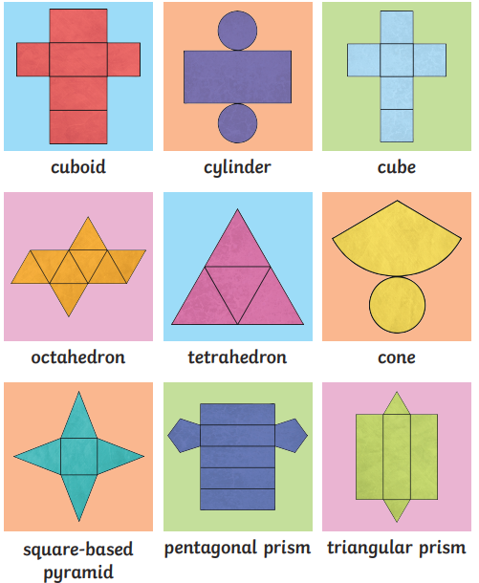

Shell, solid and combination structures