Maths Tasks – Mental subtraction
Remember I would like you to email or upload for me photos of at least 3 of these tasks. If you are doing a task on the computer you can photograph the screen you are working on!

Each day start your maths with these 10 questions
https://www.topmarks.co.uk/maths-games/daily10
Choose Level 3, subtraction. Pick one of the options and choose a time that will challenge you! You can give yourself a longer time by clicking on manual.
OR
Print out or look at the daily 10 questions in the resource section, choose the level that challenges you. Time yourself – how quickly can you answer the questions? Can you get quicker each day?

Task 1:-

Log onto this website:- https://www.topmarks.co.uk/maths-games/subtraction-grids
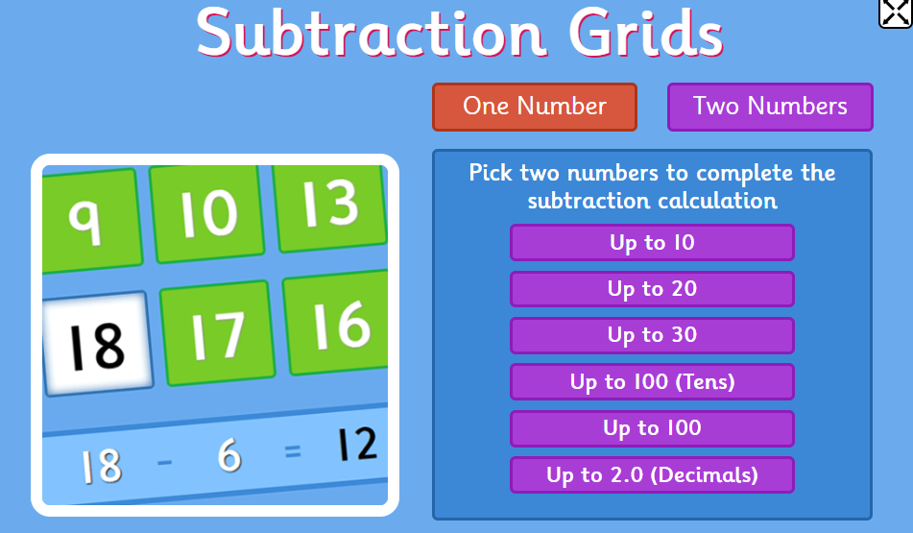
Choose 1 number and a level that challenges you. Play the game at least 5 times. (Each game is only 2 minutes!)
OR
Copy out or print out the subtraction calculations. Cut them up into single questions and put them in a pile. How many can you complete in 1 minute? Check your answers on the answer sheet.

Task 2
Race to 0!
You can play this on your own or with someone else in your house.
Start with either 50 or 100.
Roll a dice and subtract it from your start number. Keep rolling the dice and subtracting, first to 0 wins! Or if you are playing by yourself what is the smallest number of rolls to take you to 0?
To make the game more challenging – start with 200 and roll 2 dice.
If you don’t have a dice, use the interactive one in the resource section.

Task 3

https://www.topmarks.co.uk/maths-games/mental-maths-train
Choose subtraction and then choose the level to challenge yourself.
OR
Repeat task 2 again – race to 0!

Task 4
Complete the colouring sheet
OR if you can’t print out the sheet, repeat task 1

Task 5
Complete the subtraction spiders – choose a challenge level:-
Challenge 1 | Challenge 2 | Challenge 3
Use any numbers to create the calculations | Don’t use any multiples of 10 | Use 3 or 4 digit numbers and no multiples of 10 or 5 unless you have to.

