Write a subtraction calculation on each leg of the spider which has the answer in the centre of the spider.
EXAMPLE

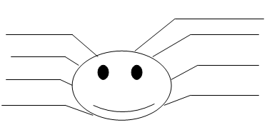
524 - 504
123 - 103
250 - 230
41- 21
126 - 106
67 - 47
45 - 25
100-80
20

Write a subtraction calculation on each leg of the spider which has the answer in the centre of the spider.
45
27
34
7
12
8
22
15

