UNICEF Children’s Rights
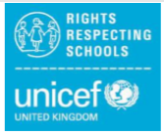
Do you think you can make some posters for me to display around the school for our UNICEF work? I have found some from other schools (see below) which you might want to use as inspiration.

I really like the idea of the parking poster for Article 14…. I could laminate them and have them pinned up in the carpark to remind drivers not to park there when they shouldn’t.

The Foodbank poster / collage is lovely too!

Articles 3, 4 and 24…. These are about our grown-ups and the Government making decisions to protect us; Article 24 is about receiving health care. Maybe you could create a poster to reflect how you are staying safe and following the Government’s advice during the COVID-19 outbreak.

Use your imaginations and whatever resources you have around the home.

