**Creating media with digital painting - Year 2**

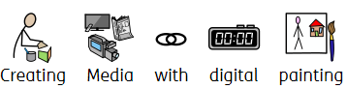

|  |  |
| --- | --- |
|  | |
|  | Electric technology. |
|  | The materials used by an artist. |
|  | Different things we can choose the computer to do – spray, fill, paintbrush or pencil tools. |
|  | Drawings and paintings made on a computer. |

**1**

How can we paint using a computer?

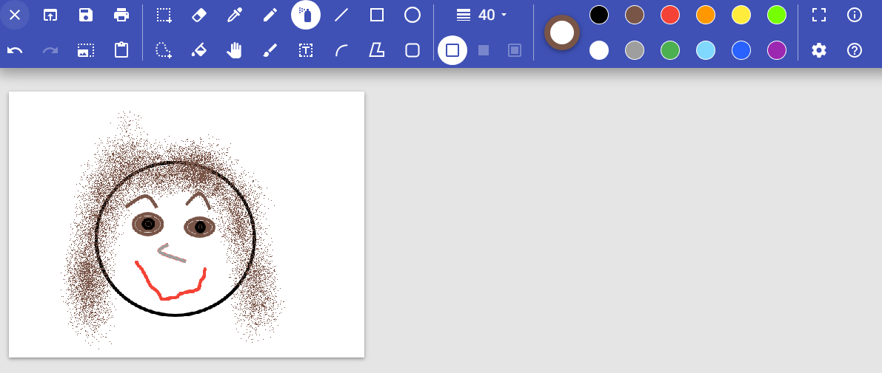

**2**

Using shapes and lines

Mondrian used lines and colours.

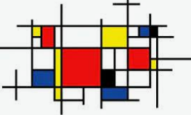

We will draw and paint our faces on the computer using shapes the paintbrush tool, the spray can and colours.

We will use squares, straight lines, red, yellow, blue and white.

Canvas

Colours

Painting tools

**4**

Why did I chose that?

**3**

Making careful choices

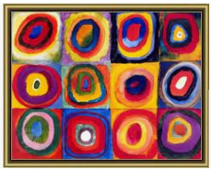

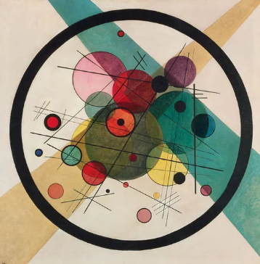 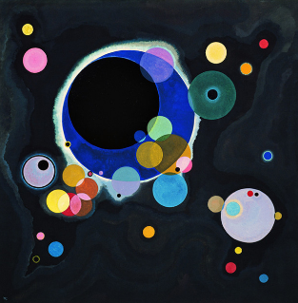

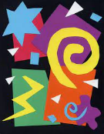 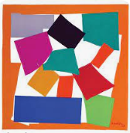

We will think about the different jobs the paint tools do and how to make the best choices when making digital art.

We will use paint and brushes to make the same type of Seurat pictures we made on the computers last week!

Seurat used lots of dots.

We will use the paintbrush to make dots of different colours and sizes.

**5**

Painting all by myself

Kandinsky loved colours and circles.

Matisse used different colours and shapes.

We will use all the shape tools and different colours to copy an artist.

**6**

Comparing computer art and painting with brushes

