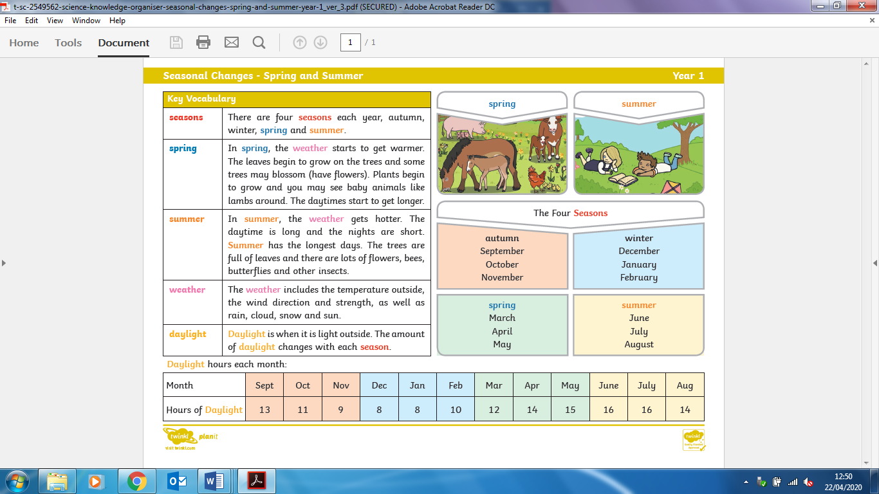

* The plants are fully blossomed with flowers and fruit on them
* The weather is mainly sunny and cloudy
* The plants begin to have buds on them
* New animals are born such as lambs
* The weather is mainly windy, cloudy, sunny and rainy
* The trees have no leaves except for evergreen trees
* Animals hibernate and birds migrate
* The weather is mainly windy, cloudy, icy, snowy and rainy
* The leaves change colour and fall off of the tree
* Animals begin to collect food for hibernation
* The weather is mainly windy, cloudy and rainy

Summer

Spring

|  |  |
| --- | --- |
| **Key Vocabulary** | |
| **Daylight-** | when it is light outside. The amount of daylight changes with each season. |
| **Seasons-** | there are 4 seasons each year: autumn, winter, spring and summer |
| **Weather-** | the temperature outside, the wind direction and strength, as well as rain, cloud, snow and sun. |
| **Month-** | One of the 12 parts of the year. |
| **Hibernation-** | when animals spend all of winter sleeping |
| **Migration-** | When animals move to another place to suit their needs (e.g. to be warmer) |

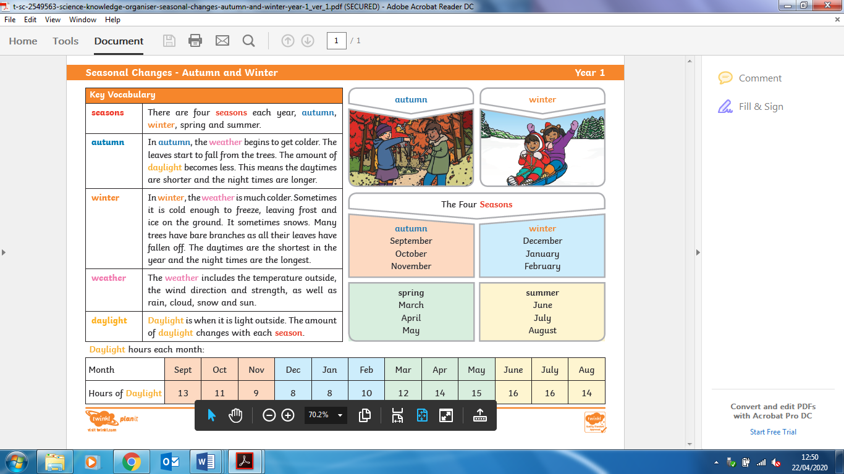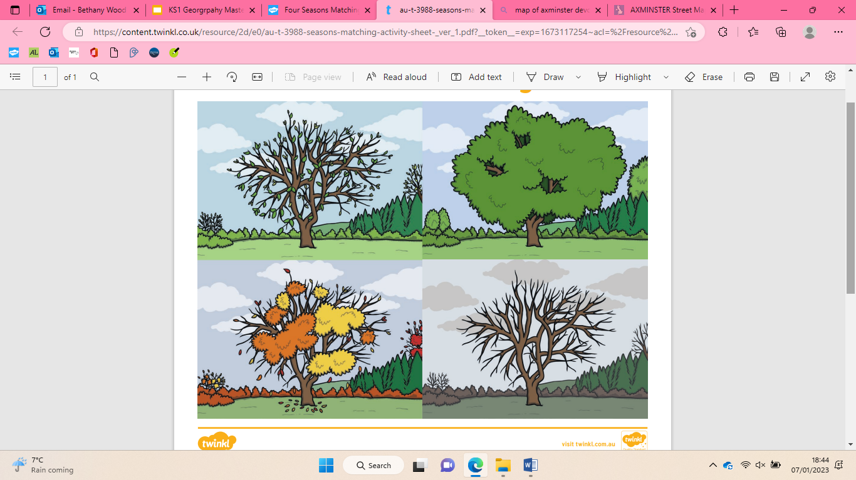

|  |
| --- |
| Winter |







Autumn

Seasons