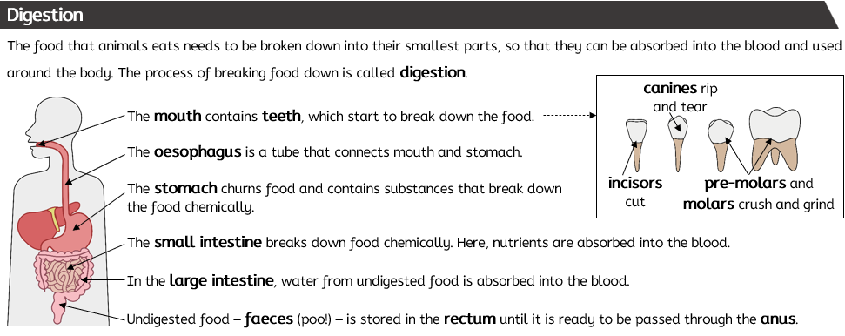
Key Vocabulary

absorb (noun): to take or soak in. After the food has been digested (broken down into tiny molecules), they move into the blood in your body – we say that the body absorbs the nutrients.
carnivore (noun): a carnivore is an animal that only eats other animals (it only eats meat).
churn (verb): to move something around with force.
chew (verb): using teeth to crush food into smaller pieces
consumer (noun): a consumer feeds on (eats) other organisms.
digestion (noun): the process where your body breaks down food into smallest parts which can be absorbed by the body.
food chain (noun): a food chain shows the feeding relationship between organisms in a habitat. The arrows show the transfer of energy.
herbivore (noun): an organism that only eat plants.
mouth (noun): we put food into our mouth to eat it. When we chew, the teeth help break the food into smaller pieces. Our tongue pushes the food around in our mouth.
nutrients (noun): nutrients are what we need to keep healthy. Carbohydrates, proteins and fats are the main nutrient groups.
omnivore (noun): an omnivore is an organism that eat both plants and animals (meat).
predator (noun): a predator is an animal that hunts, kills and eats another animals.
prey (noun): the animal that is eaten by the predator.
producer (noun): a producer is an organism that can make its own food. Plants are producers; they make their own food using sunlight.
saliva (noun): the liquid that is made in our mouth that helps break down food into smaller parts and also helps keep our teeth.
Food and digestion

