**Biodiversity**

Biodiversity is all the different living things in an area.

Biodiversity is important because:

Humans rely on biodiversity for food, medicines and other resources.

Living things rely on each other for resources – this is called interdependence.

It is important for good soil health.

It is good for our mental well-being.

Biodiversity is threatened by humans. We remove habitats, cause climate change, hunt animals and reduce biodiversity using some agricultural practices.

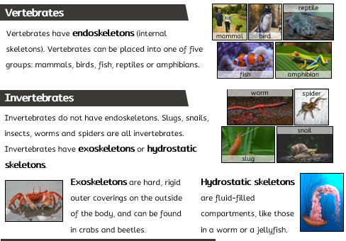

Classification describes how we can sort all organisms (living things) into groups. Animals and plants belong to different groups. Plants can be separated into two groups: flowering and nonflowering. Animals can be separated into vertebrates and invertebrates.

|  |
| --- |
| **Key Vocabulary** |

* **amphibian** (noun): Nearly all amphibians lay eggs. The eggs are covered in a jelly-like substance. Some don’t lay eggs. Amphibian young have gills so they can breathe in the water. When they grow into adults, they develop lungs and breathe air
* **biodiversity** (noun): all the different living things in an area
* **backbone** (noun): a column of bones that supports the body
* **bird** (noun): All birds lay eggs. All birds have beaks, feathers, two legs and two wings. They have lungs and breathe air. Birds are warm-blooded (they can maintain a constant body temperature). Some birds can fly and some can’t
* **characteristic** (noun): the qualities of that particular animal or plant.
* **classification** (noun): sorting or grouping things according to their characteristics.
* **climate change** (noun): any change in long-term weather patterns
* **fish** (noun): Fish have gills that allow them to breathe under water. They have fins. Most fish lay soft eggs. They have scales. They are vertebrates (have a backbone inside their body)
* **greenbelt** (noun): an area of open land that is protected from being built upon
* **habitat** (noun): where an animal, plant, or organism lives. It includes all living and non-living parts of the environment
* **interdependence** (noun): the fact that all organisms depend on (rely on) each other, for things like food and shelter.
* **mammals** (noun): mammals have hair or fur. Mammals have lungs. They breathe air. Some mammals live in the sea and some live on land. Mammals are warm-blooded (they can maintain a constant body temperature). All mammals give birth to live young, except for the duck-billed platypus and four species of spiny anteaters (these mammals lay eggs).
* **reptiles** (noun): reptiles have dry, scaly skin. Most reptiles lay eggs. Some give birth to live young (e.g. some snakes and lizards). They are cold-blooded (they need help from the environment to warm up or cool their body down). They have lungs and breathe air
* **species** (noun): a group of one type of organism, individuals in this group can breed with each other to produce offspring that can go on to reproduce

Classifying animals