Eagles SPAG task
Week commencing 11th May 2020
Task 2
Today we are going to focus on pronouns.
Pronouns – these are words we use instead of a noun to show who things belong to. We use pronouns to avoid repetition of a noun.
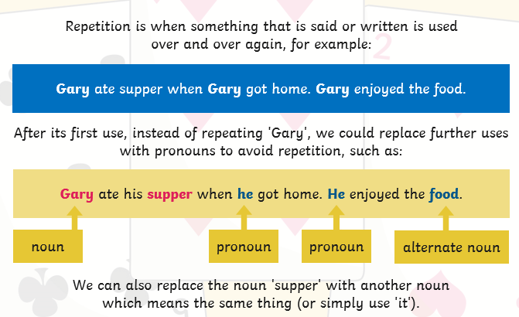

This video will help!
https://www.youtube.com/watch?v=aSwTlQNLqPA
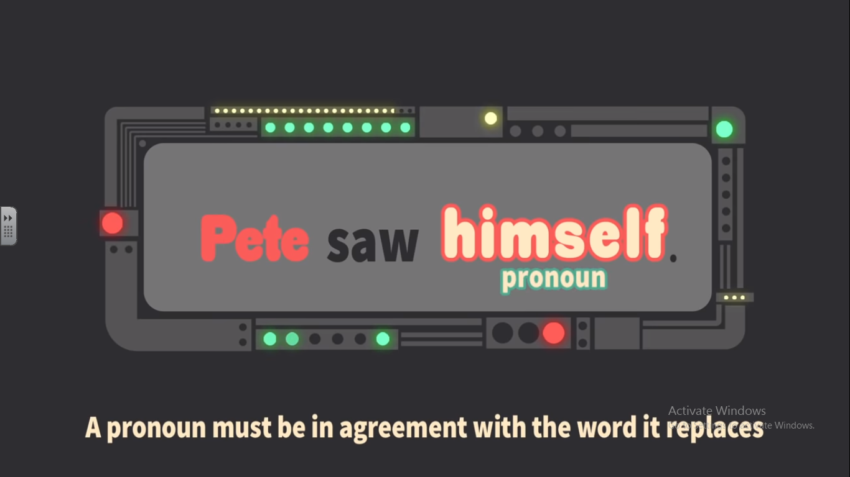

On your grammar flip chart, please complete the following table:
I | You | He | She | They | we | It
I  myself  me  my  mine | you  your  your  yourself | he  him  his  himself | she  her  hers  herself | they  them  their themselves | we  us  our  ours  ourselves | It  Its  itself

In honour of Florence Nightingale – it is Florence Nightingale Day on 12th June – read through the PowerPoint and write a paragraph about her life using some of the pronouns above!
