**Firework Poem – Crackle Spit**

Crackle! Spit!

What is this?

Orange, yellow, red.

Crackle! Spit!

Hotting up,

Flames above my head.

Frazzle! Pop!

Feel the heat

Burning up the ground.

Frazzle! Pop!

Faces glow,

Smiles all around.

Whizz! Zoom!

Up they go

High into the night.

Whizz! Zoom!

Coloured stars

Shining bold and bright.

Zap! Fizz!

Shooting out

Flying really quick.

Zap! Fizz!

See the blur

Dancing on a stick

**Water Bottles –** please bring in a named water bottle each day for your child.

**Library VISIT** – Our next visit is on Tuesday 26th November

**Have a wonderful weekend.**

**From Mrs Burrough and Mrs Slade**

**Robin Class News**

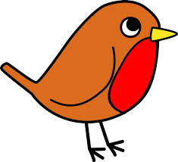

**Year Reception**

**RE -** In our RE lessons this week we have been learning that Mary and Joseph travelled to Bethlehem to add their names to a register. We thought about how Mary felt on her way to Bethlehem and what Mary and Joseph would have prayed for. In explore and learn Robins have enjoyed playing with a Nativity set in one of our tuff spots, acting out the story. As well as this, the children have enjoyed making maps of Mary and Joseph’s journey to Bethlehem and roleplaying it outside. On Thursday afternoon, we listened to the carol, O Little Town of Bethlehem and the children drew and painted a building that we will put together on our class display to represent the town of Bethlehem. In this activity the children LOVED mixing colours and painting brightly coloured buildings.

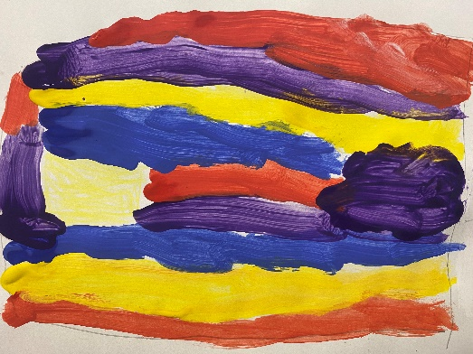 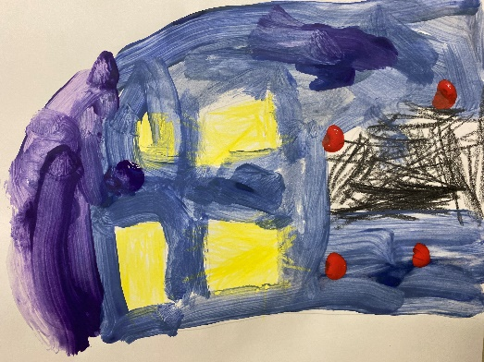 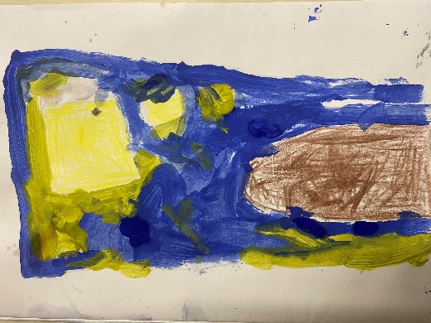 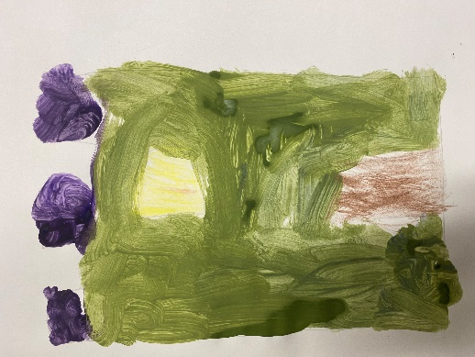

**Maths -** In maths this week we learnt about the names and properties of some 3D shapes including cone, sphere, cylinder, cube and cuboid. We explored which shapes roll and which shapes slide. As well as this we recognised that some of them had curved edges and some had straight edges. We talked about the shape of their faces. For example a cylinder has two circle faces. As well as learning about shape, we have been practising reciting numbers up to 10 and back, up to 20 and back and up to 100.

**Remembrance Day -** On Monday, we watched a video on the CBeebies website called Poppies which is a beautiful animation that sees war as experienced by animals in a WWI battlefield. Then the children made collage poppies and we talked about why we wear poppies on this day.

**Phonics - week beginning 15th November 2024**

In phonics this week, the children have learnt to read and write the words, the, no & go and to read and write the letters h and b. They have learnt their letter names and have learnt the sound they make (the phoneme). I have assigned a game with the letter sounds on Bug Club for your child to practise. Please log onto Bug Club to play some of the games with your child.

We have listened to the sounds the letters h and b make and we have practised writing the letters. I have sent home the flash cards for you to practise at home. You could stick them onto cereal box card so you can use them as flash cards. Why not rearrange the sound cards to make words and practise reading words?

**UW-** This afternoon, we continued our work on autumn. We recapped our work last week on hibernation. In class we learnt about why birds migrate and which birds migrate. We made our own bird using fallen leaves and we took part in activities to learn about the dangers of migration for different birds. The birds we mentioned were swallows, swifts, geese, redwing thrushes and garden birds robins, blue-tits and black birds.

**Drawing Club -** This week in Drawing Club, the children listened to the story Billy and the Beast by Nadia Shireen. On our first day the children drew a picture of the beast. Then we drew a picture of where we thought the beast might live. We had an opportunity to write some of our key words in our secret codes. For our adventure, the children invented a way for them to fly for Billy and the Cat to avoid the beast. The children had some wonderful ideas. The vocabulary we used for Drawing Club this week was gobsmacked, ravenous, unexpectedly, cowering, courageous, concealed and distracted. Please take the opportunity to use these words with your children in everyday contexts.