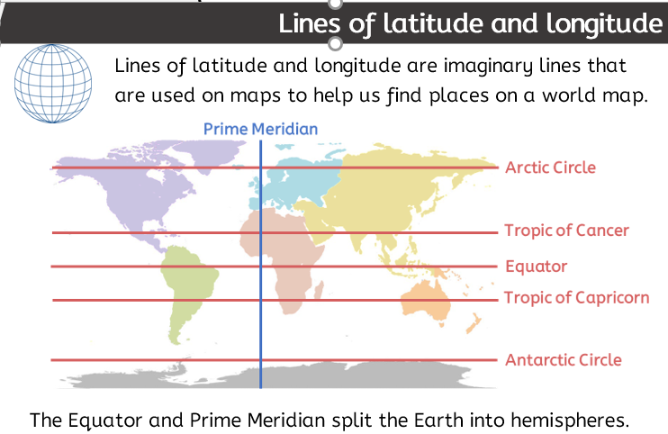 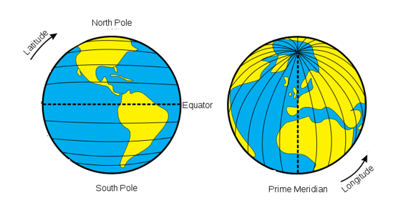

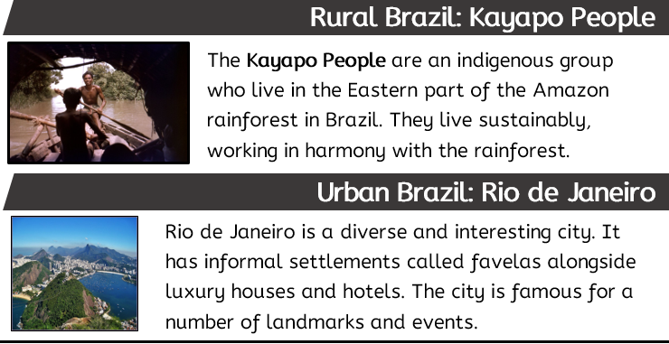

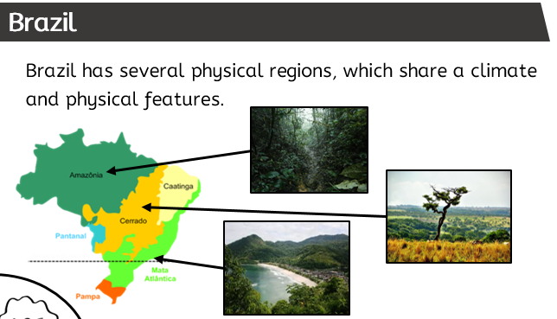

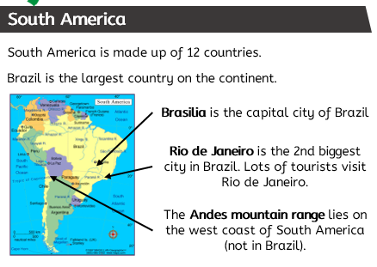

|  |
| --- |
| **Key Vocabulary** |

* **atlas: (noun) a collection of maps, usually in a book.**
* **beach: (noun) the land area that meets the sea or ocean. It can be sandy or rocky.**
* **border: (noun) a boundary between different countries.**
* **city: (noun) is the largest type of settlement, containing lots of buildings and lots of people.**
* **climate: (noun) average weather over a long period of time such as 20-30 years.**
* **coast: (noun) the stretch of land where the land meets the sea or ocean.**
* **Equator (noun): line of latitude. It is the line that divides the Northern and Southern Hemispheres.**
* **indigenous (adjective) native to a country. Can be human or plant and animal species.**
* **mountain: (noun) an area of high ground that is taller and usually steeper than a hill.**
* **rural: (noun) usual term for the countryside.**
* **tourism: (noun) the commercial organisation (makes a profit) and operation of holidays/visits to places of interest.**
* **tourist: (noun) a person who is travelling to, or visiting a place for pleasure.**
* **urban: (noun) usual term for towns, cities and conurbations.**

Brazil