Eagles English and SPAG – TASK 4
Thursday 25th June 2020

You have all made an excellent start to your myths. They are creative, interesting and fun to read so thank you to all those who have shared them. We are going to keep it very simple today - please finish writing your myth! Make sure it has a clear ending and try and include a moral if possible. Below is the boxing up structure as a reminder and the writing expectations below that. Good luck!
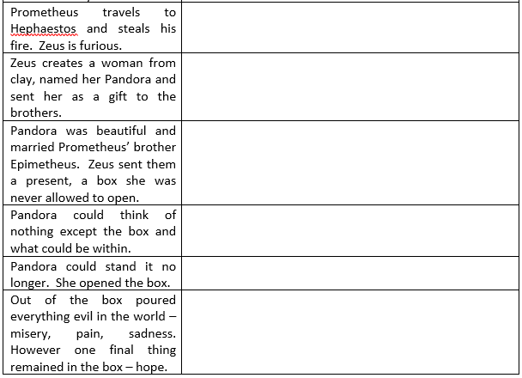
Year Five and Six Writing Expectations:
In your writing, please include the following:
- All punctuation used correctly , . ? ! “” ‘ : ; - ()
- Spell year five and six common exception words correctly
- Maintain a consistent tense (so basically keep it all past tense)
- Use figurative language (including subjunctive form and passive voice)
- Write in clear paragraphs and think carefully about how to link these
- Use speech correctly

Remember to take a photograph of your work and ask a grown-up to either email it to the office for us or upload it to the Eagles unit of the Facebook page. We really want to see your work!

