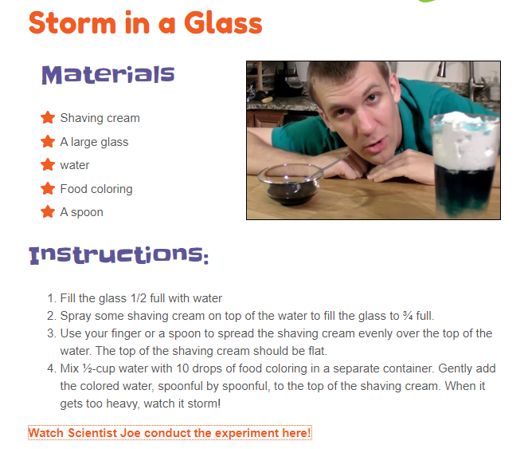
https://www.youtube.com/watch?v=GVW5OOExQxM&feature=youtu.be
