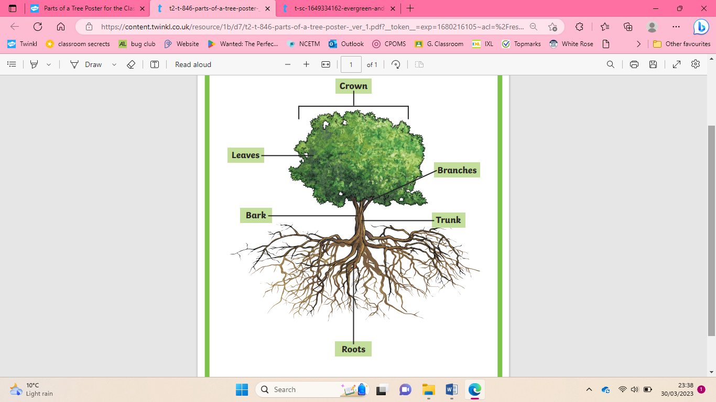

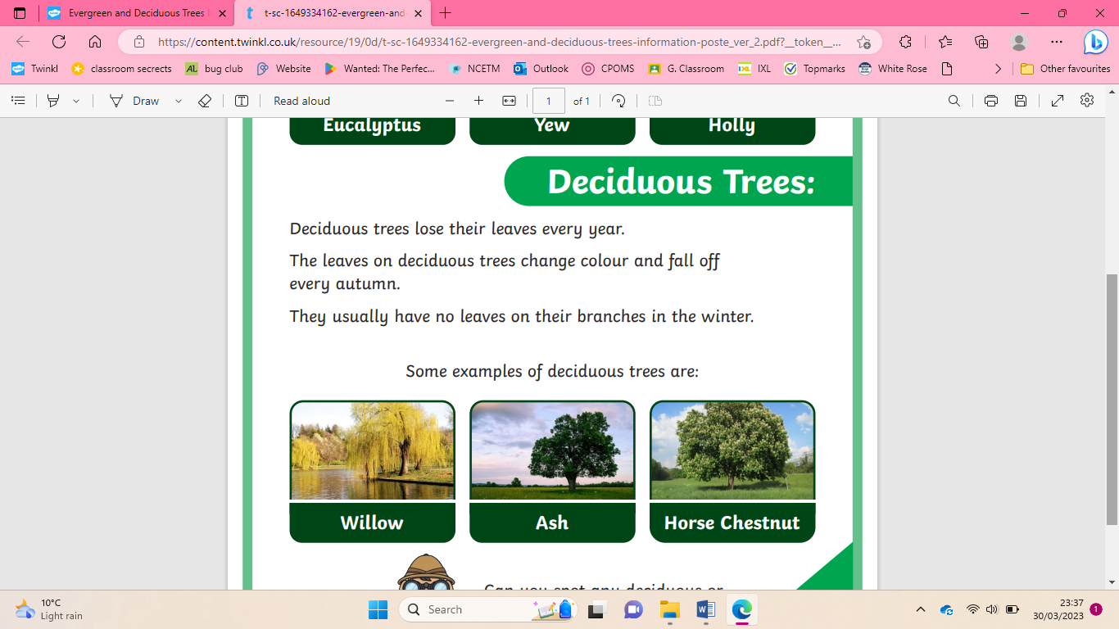

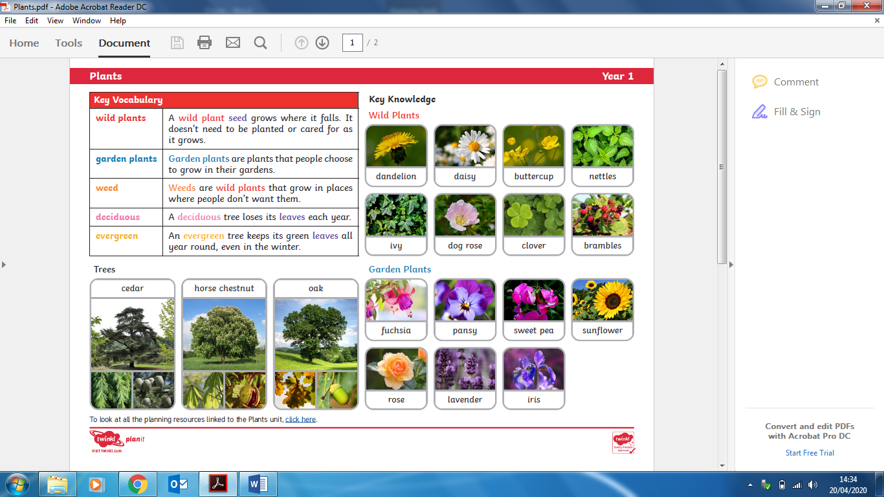

To name a variety of deciduous trees

To describe the basic structure of trees.

To name a variety of evergreen trees

To name a variety of wild plants



|  |
| --- |
| To describe the basic structure of flowering plants |

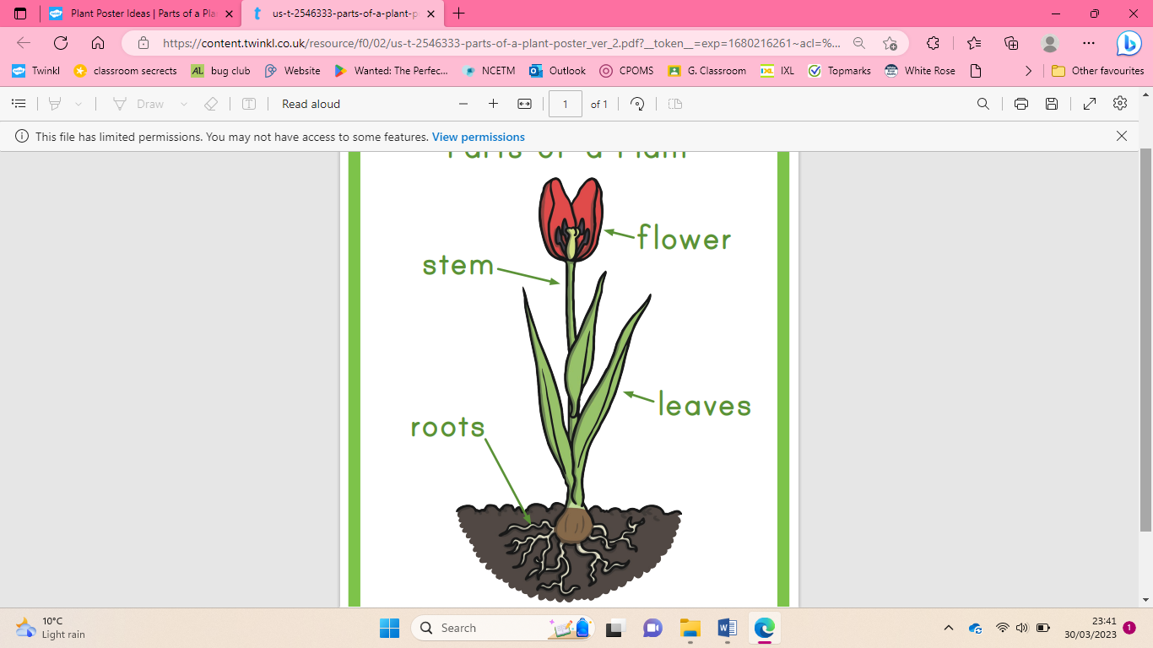

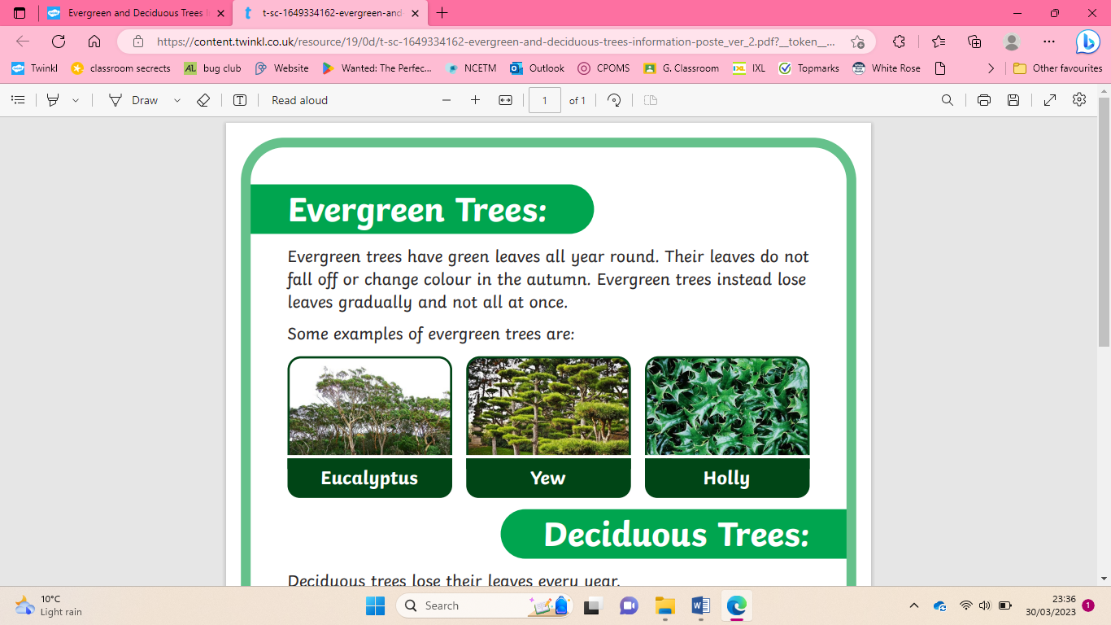

|  |
| --- |
| To name a variety of garden plants |



|  |
| --- |
| **Key Vocabulary** |

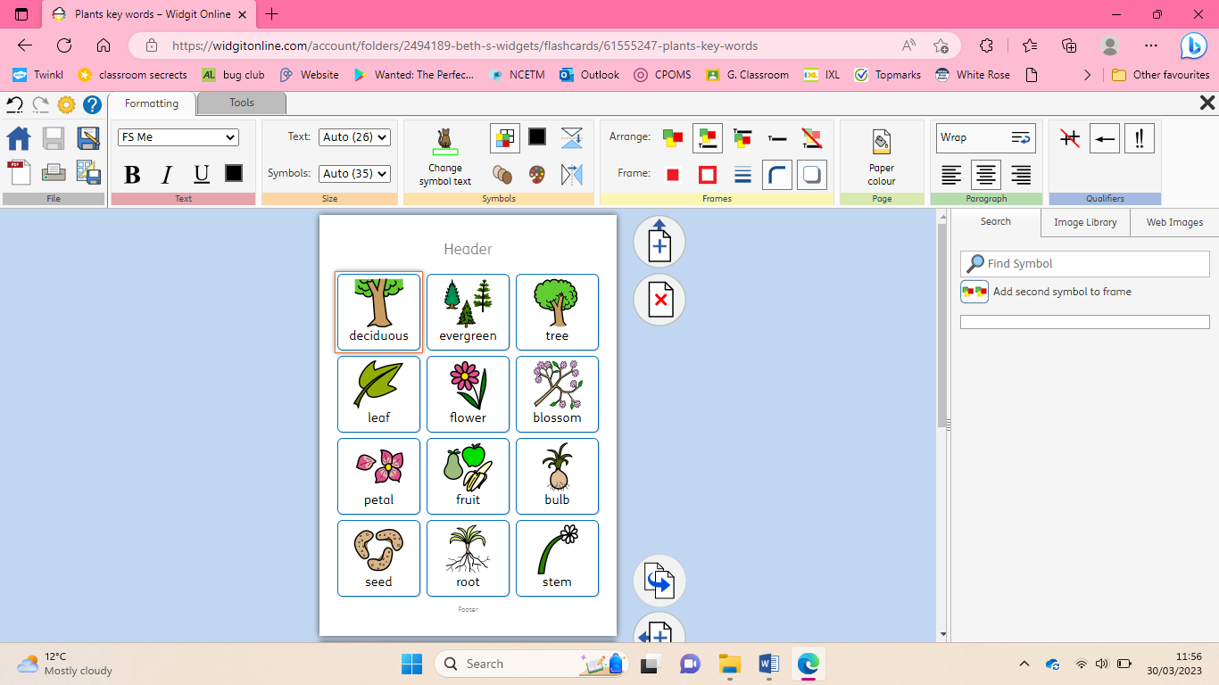 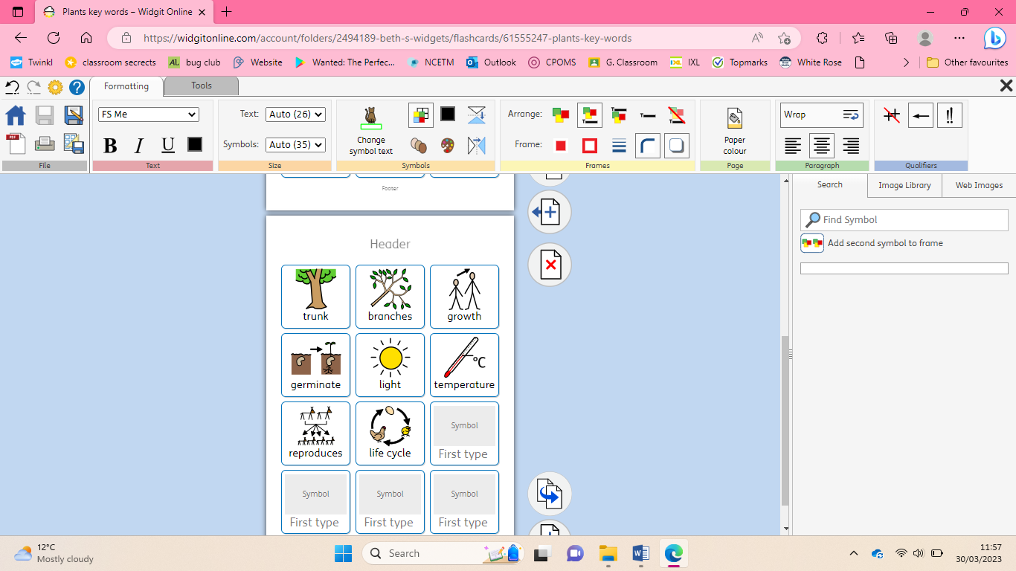

Plants