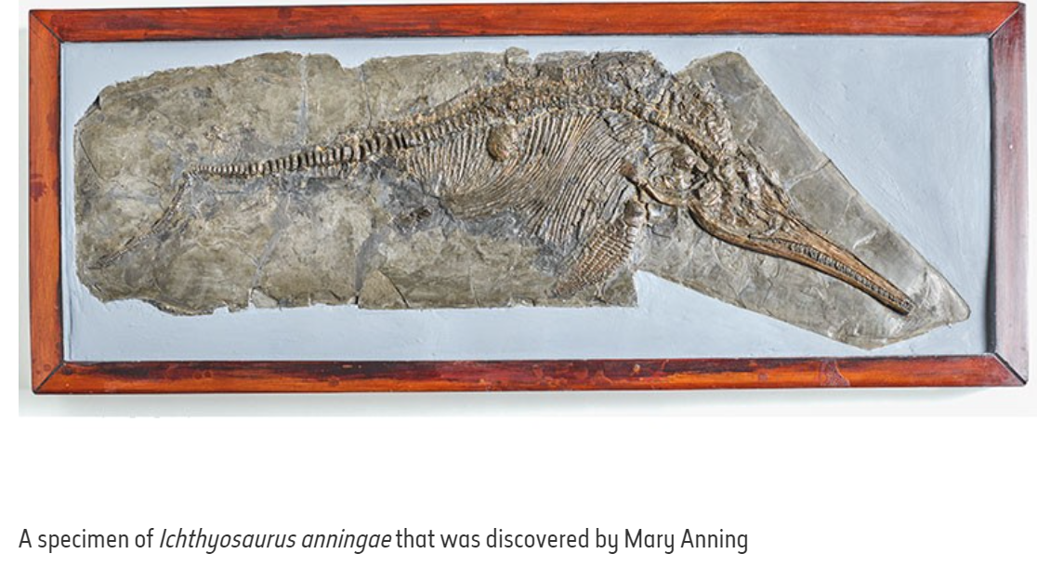

|  |
| --- |
| Why was this important? |

* She was not published or well-known because she was a woman- until after her death
* Lyme Regis beach is now a heritage site- people travel to visit it now helping the economy
* People now understand more about the world and what it was like and the creatures in it
* Helped scientists to understand ‘extinction’
* Mary Anning’s discoveries were some of the most significant geological finds of all time which she called curiosities to begin with until she realised they were fossils
* With her brother, she found the first complete Ichthyosaur in 1810-1811
* This made her famous among some of the most important scientists of the day. They would visit her for advice and to discuss scientific ideas about fossils.

What did Mary Anning do?

Who was Mary Anning?

* Mary Anning was born on 21 May 1799
* She lived in the English seaside town of Lyme Regis in Dorset.
* While Mary Anning was alive, only men were allowed to be part of the scientific community. This meant she wasn't able to publish any of her own work. However, Mary documented her findings in order to better understand the creatures she found.
* Although Mary sold some of her smaller finds, she was poor
* Mary died aged 47. After her death in 1847, Mary was forgotten about for many years. However, people started to realise how important her discoveries were. In fact, she is now remembered as one of the greatest fossil hunters ever.

What was life like when Mary Anning was alive?

Life in the 1800’s:

* Many women were domestic servants or housewives
* Women wore stays (a bodice with strips of whalebone) and hooped petticoats under their dresses.
* People’s diets were generally poor and there wasn’t a lot of variety in the food they ate.
* There was no electricity, running water or central heating.

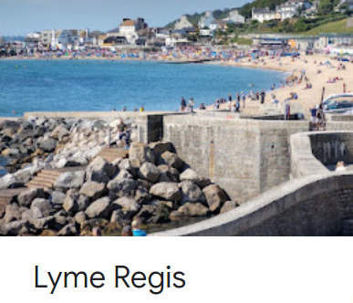

Immersing in our local history

|  |
| --- |
| **Key Vocabulary** |

**Century -** a period of a hundred years that is used when stating a date.

**Chisel** - A hand tool with a long blade.

**Coast** - an area of land that is next to the sea.

**Dinosaurs** - large reptiles which lived in prehistoric times.

**Discovery** - If someone makes a discovery, they are the first person to find or become aware of a place, substance, or scientific fact that no one knew about before.

**Extinct** - no longer has any living members, either in the world or in a particular place.

**Existed** - was present in the world as a real thing.

**Fossil** - a special rock that holds the remains of creatures that lived millions of years ago

**Influential** - a lot of importance over people or events,

**Jurassic Coast -** the name of the coast where Mary Anning made a lot of her discoveries. It is in the south of England.

**Palaeontology -** the study of fossils as a guide to the history of life on Earth.

**Prehistoric** - the time in history before any information was written down.

**Reptile -** a group of cold-blooded animals which have skins covered with small hard plates called scales and lay eggs. Snakes, lizards, and crocodiles are reptiles.

**Scientist -** someone who has studied science and whose job is to teach or do research in science.

**Search -** to try and find something by looking or otherwise seeking and carefully and thoroughly

**Skeleton -** the framework of bones in your body.

**Vertebrate -** a creature which has a spine. Mammals, birds, reptiles, and fish are vertebrates.

Local history- Mary Anning