To the

**Happy New Year**

It has been really lovely to see all the children this week. I hope you all had a joyous Christmas and that the children have had a good rest and are ready for the new term ahead.

**Balancability**

I am looking forward to using the balance bikes with the children next week.

**Slowly, Slowy**

Slowly, slowly, very slowly,

creeps the garden snail,

Slowly, slowly, very slowly,

up the garden rail.

Faster, faster, so much faster,

runs the little mouse.

Faster, faster, so much faster,

round my little house.

**Don’t forget….**

* PE will be on a Wednesday when the children do their gymnastics lesson unless notified otherwise.
* PE kit needs to be worn on a Thursday.
* To hear your child read every evening. Children who are heard read daily at home make good progress with their reading.
* To bring in any materials suited to junk modelling.

**Have a wonderful weekend.**

**Mrs Burrough**

**Robin Class News**

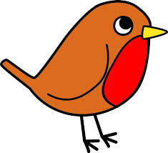

**Year Reception**

**How you can help your child with mathematics.**

**Counting, counting, counting**

Please help your child by counting lots of different objects to match numbers to 10 then numbers to 20.

**What’s in the box?**

Prepare five small boxes. Place a number of small objects in each box- between one and five, one and ten or one and twenty. Something like dry beans (magic beans) would be suitable. Ask your child to choose a box, shake it and predict how many are inside. Open the box and count to confirm. Extend the activity by putting the same number in two of the boxes and the children predict which two boxes have the same number of objects.

**How you can help your child with English.**

* Please make time every day to hear your child read. Explain the meaning of unknown words.
* Practise writing the letters learnt so far.

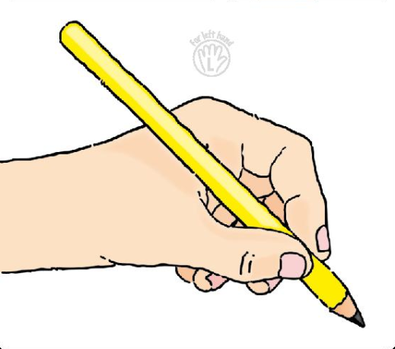 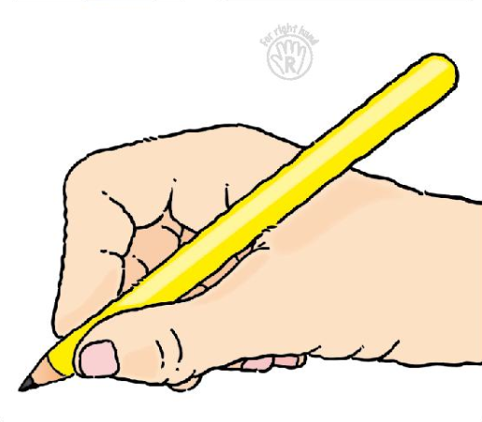

* Please help your child **practise writing their name** starting the lowercase letters from the line.
* Read a story every evening to your child.
* Visit your local library.

**Phonics work week beginning 14th January 2019.**

In phonics we have one more week of revising the sounds learnt so far at the beginning of phase 3 before moving on to learning the rest of phase three. This will give a chance for those children who are ready to start writing letters, words and captions using the letters learnt and those that have not managed to learn to read the letter sounds to catch up. Remember, repetition is the mother of all learning so the more your child reads and writes, the quicker they will learn.

y z

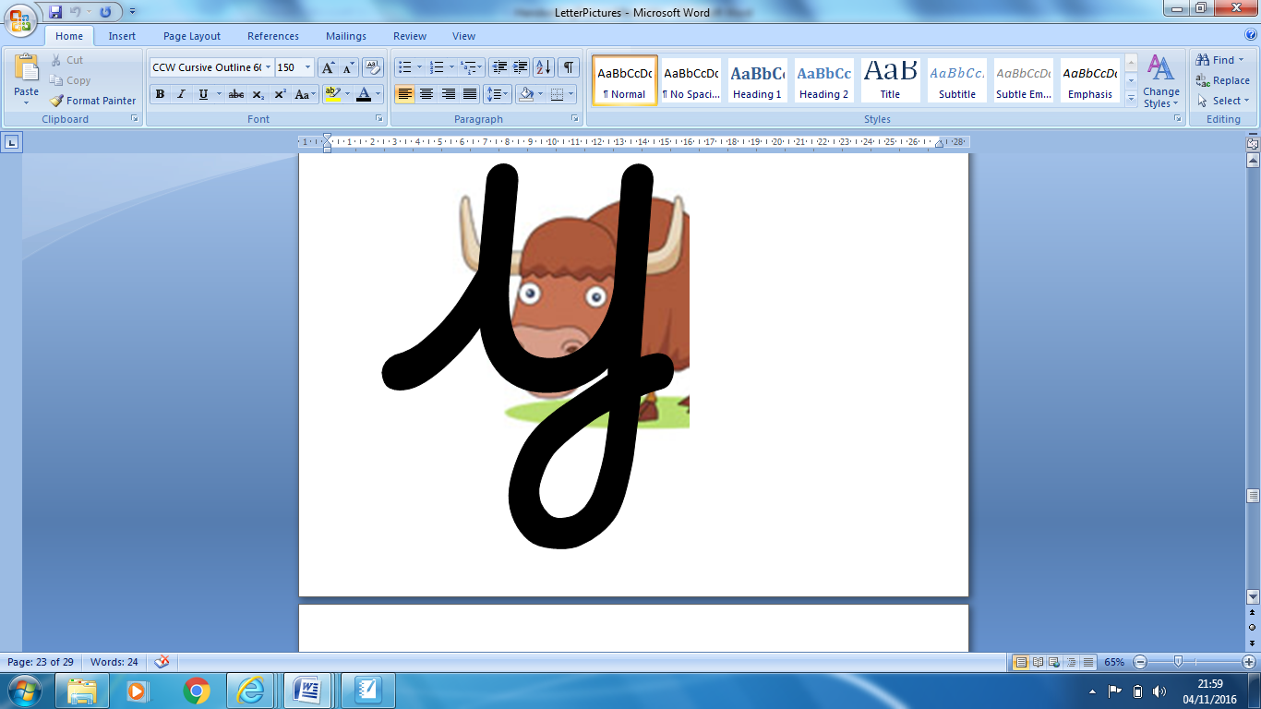 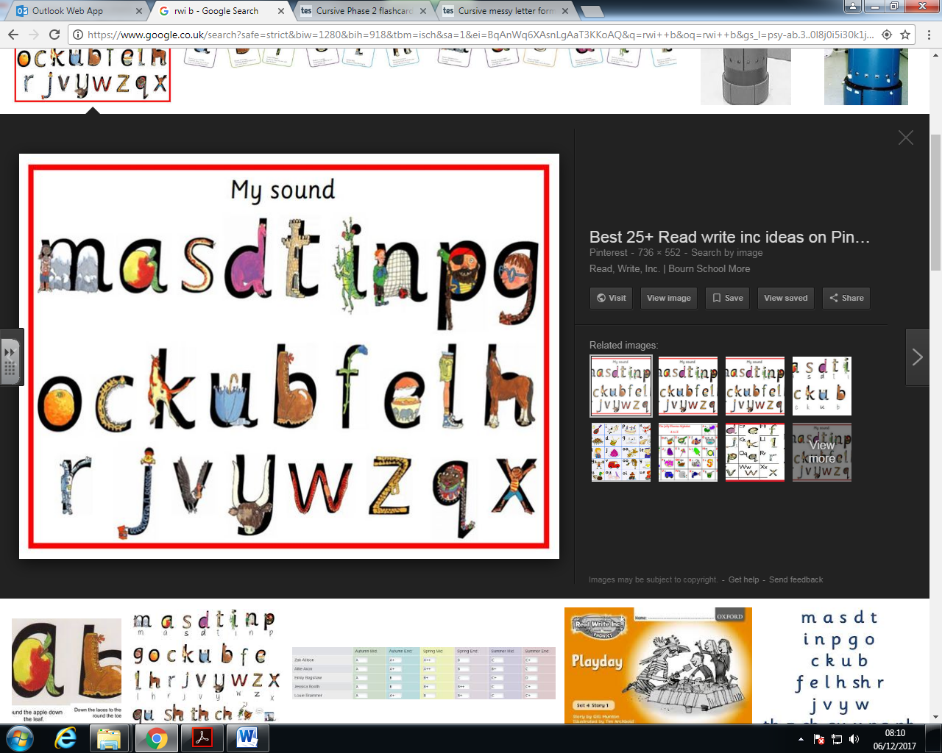

We will also be learning to recite the alphabet in the form of a rap.

We have been learning some rhymes for each letter to help with formation, they are as follows:

* **Start on the line. Up then down a horn. Up a horn. Under his head**

Reading tricky words will and was.

Writing tricky words the, and, to & I.