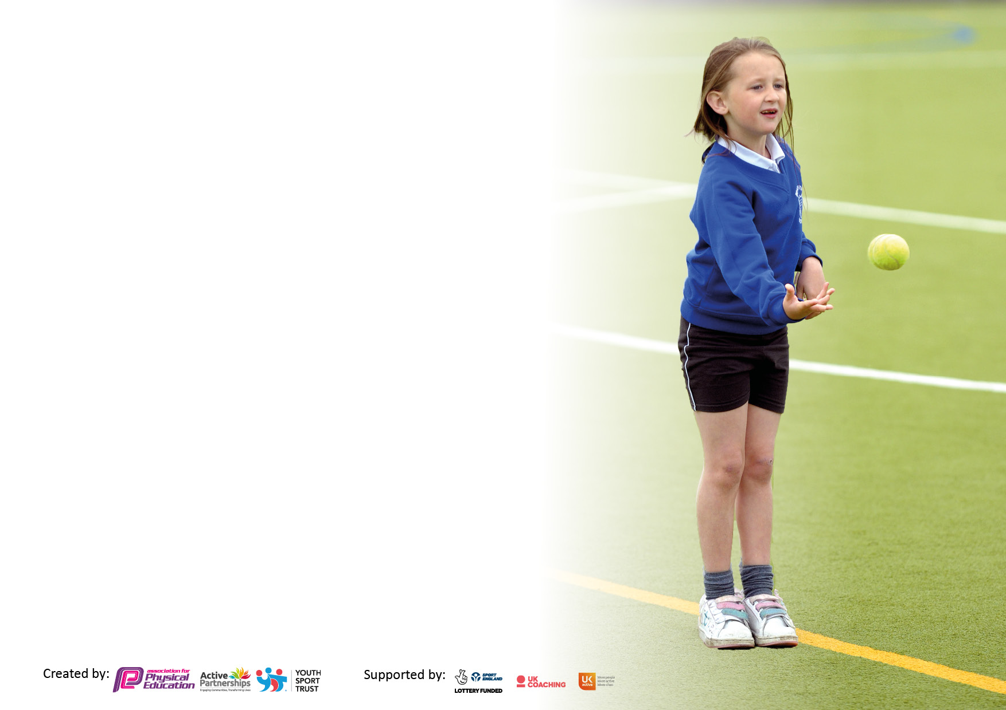

It is important that your grant is used effectively and based on school need. The [Education Inspection Framework](https://www.gov.uk/government/publications/education-inspection-framework) makes clear there will be a focus on **‘whether leaders and those responsible for governors all understand their respective roles and perform these in a way that enhances the effectiveness of the school’**.

Under the Quality of Education judgement, Ofsted inspectors consider:

**Intent** - Curriculum design, coverage and appropriateness

**Implementation** - Curriculum delivery, teaching (pedagogy) and assessment

**Impact** - Attainment and progress

To assist schools with common transferable language, this template has been developed to utilise the same three headings which should make your plans easily transferable between working documents.

Schools must use the funding to make additional and sustainable improvements to the quality of Physical Education, School Sport and Physical Activity (PESSPA) they offer. This means that you should use the Primary PE and sport premium to:

* Develop or add to the PESSPA activities that your school already offers
* Build capacity and capability within the school to ensure that improvements made now will benefit pupils joining the school in future years
* The Primary PE and sport premium should not be used to fund capital spend projects; the school’s budget should fund these.

Please visit <https://www.gov.uk/guidance/pe-and-sport-premium-for-primary-schools> for the revised DfE guidance, including the 5 key indicators across which schools should demonstrate an improvement. This document will help you to review your provision and to report your spend. DfE encourages schools to use this template as an effective way of meeting the reporting requirements of the Primary PE and Sport Premium.

We recommend you start by reflecting on the impact of current provision and reviewing the previous spend.

Schools are required to publish details of how they spend this funding, including any underspend from 2021/2022, as well as on the impact it has on pupils’ PE and sport participation and attainment.

We recommend regularly updating the table and publishing it on your website throughout the year. This evidences your ongoing self-evaluation of how you are using the funding to secure maximum, sustainable impact. Final copy must be posted on your website by the end of the academic year and no later than the 31 July 2023.

**Details with regard to funding**

Please complete the table below.

|  |  |
| --- | --- |
| Total amount carried over from 2022/23 | £0 |
| Total amount allocated for 2023/24 | £16,000 plus £10 per pupil |
| How much (if any) do you intend to carry over from this total fund into 2023/24? | £0 |
| Total amount allocated for 2023/24 | £17,370 |
| Total amount of funding for 2023/24 to be reported on by 31st July 2024 | £ 17, 370 |

**Swimming Data For Autumn 2023**

Please report on your Swimming Data below.

|  |  |
| --- | --- |
| Meeting national curriculum requirements for swimming and water safety.  **N.B.** Complete this section as best you can. For example, you might have practiced safe self-rescue techniques on dry land which you can then transfer to the pool when school swimming restarts.  **Due to exceptional circumstances priority should be given to ensuring that pupils can perform safe self-rescue even if they do not fully meet the first two requirements of the NC programme of study** |  |
| What percentage of your current Year 6 cohort swim competently, confidently and proficiently over a distance of at least 25 metres?  **N.B.** Even though your pupils may swim in another year, please report on their attainment on leaving primary school at the end of the summer term 2023.  Please see note above | 64% Out of the 36% that can’t 57% of them can swim 25m but may need to stop part way.  (4children) |
| What percentage of your current Year 6 cohort use a range of strokes effectively [for example, front crawl, backstroke and breaststroke]?  Please see note above | 35% |
| What percentage of your current Year 6 cohort perform safe self-rescue in different water-based situations? | 29%  More did the activity but would not say that they were successful! |
| Schools can choose to use the Primary PE and sport premium to provide additional provision for swimming, but this must be for activity **over and above** the national curriculum requirements. Have you used it in this way? | Yes |

**Action Plan and Budget Tracking**

Capture your intended annual spend against the 5 key indicators. Clarify the success criteria and evidence of impact that you intend to measure to evaluate for pupils today and for the future.

|  |  |  |  |  |
| --- | --- | --- | --- | --- |
| **Academic Year:** 2023/24 | **Total fund allocated:£17350** | **Date Updated:** | |  |
| **Key indicator 1:** Increase confidence, knowledge and skills of all staff in teaching PE and sport | | | | Percentage of total allocation: |
| 0% |
| **Intent** | **Implementation** | | **Impact** |  |
| Your school focus should be clear on what you want the pupils to know and be able to do. What do they need to learn and to consolidate through practice: | Make sure your actions to achieve are linked to your intentions: | Funding allocated: | Evidence of impact:  What do pupils now know and what can they now do? What has changed? | Sustainability and suggested next steps: |
| Use of Get Set 4 PE curriculum to help teachers plan well structured, focused lessons.  CPD for staff through the primary school sports partnership with Colyton Grammar School | Teachers to deliver lessons where all staff have high expectations, enough time on each activity (20% teacher talk and 80% activity time), checking understanding and progression  Teachers to attend festivals to help develop teaching ideas and content for lessons.  Lauren to come into school for CPD according to teacher’s needs. | £0 (paid for three years last year)  See Colyton Grammar School Cost | Children knowledgeable about what they are learning in their PE lessons.  At least 80% of children are at age related expectation at the end of each unit.  Children with SEND well supported in their physical development. |  |
| **Key indicator 2:** The engagement of all pupils in regular physical activity – Chief Medical Officers’ guidelines recommend that  primary school pupils undertake at least 30 minutes of physical activity a day in school | | | | Percentage of total allocation: |
| 28% |
| **Intent** | **Implementation** | | **Impact** |  |
| Your school focus should be clear on what you want the pupils to know and be able to do. What do they need to learn and to consolidate through practice: | Make sure your actions to achieve are linked to your intentions: | Funding allocated: | Evidence of impact:  What do pupils now know and what can they now do? What has changed? | Sustainability and suggested next steps: |
| Each class to complete the daily mile.  Active Playtimes  Sports mentoring  Teachers to complete a heat map for their classes.  Whole school dancersize to continue.  To improve physical literacy in identified group of children (SEMH) To increase the confidence and self-esteem for pupils who are less active in school. To improve their self-esteem and confidence to improve their resilience through PE.  All children in year six meet the national requirements for swimming through catch up swimming lessons.  Forest School Provision | Teachers responsible for making sure target records are maintained for each child.  School to implement an in year fundraiser in the summer term linked to a sporting event for example run to the Euros in Germany and run to the Olympics in Paris  Mr Murnane to work with play leaders in two half hour sessions per week to plan and evaluate activities for KS1 children and KS2 children  Mr Munane to work with reluctant children and children with SEND to engage in physical activity and to mentor around over coming barriers.  They then see where the children are inactive for too long and implement a 5 min go noodle or just dance activity for increased activity  Sports leaders lead the dances with Mrs Burrough once a week, replacing the daily mile.  Leisure East Devon (LED)will be working alongside heads up mental health charity and RD (SMHL) to lead physical activities and monitor children’s sense of esteem before and after activities to inform them how physical health and mental health are related.  Catch up swimming lessons for children in year 6.  Opportunities for children to be active outside in a forest school setting. | £0  £881  £2645  £289 for speaker  £40 for mp3 Player  £0  East Devon County Council Funding  Up to 12 extra lessons at £23  £276  3 x 5 afternoons a term  £814 | Children have a good attitude towards the daily mile. Children are fitter and healthier and concentrate better in class due to the daily mile.  Children enjoy their playtimes. They have good relations with each other and are more physically active.  Children will develop better resilience and physical fitness. They will see the positive impact of sport and link it to improved mental health  Children are not inactive for longer than an hour.  Children’s physical literacy will be improved. Children will have a knowledge of how physical activity improves their mental health and general well-being. Improved awareness and access to local sports facility – LED Hanger. Children will have a range of skills an strategies to support them when dealing with social situations during sporting activities.  Children experience physical activities in different settings and engage with further physical activity outside of school understanding that it does not have to be traditional supporting activities. | 4%  15%  2%  2%  5% |

|  |  |  |  |  |
| --- | --- | --- | --- | --- |
| **Key indicator 3:** The profile of PE and sport is raised across the school as a tool for whole school improvement | | | | Percentage of total allocation: |
| 0% |
| **Intent** | **Implementation** | | **Impact** |  |
| Your school focus should be clear on what you want the pupils to know and be able to do. What do they need to learn and to consolidate through practice: | Make sure your actions to achieve are linked to your intentions: | Funding allocated: | Evidence of impact:  What do pupils now know and what can they now do? What has  changed? | Sustainability and suggested next steps: |
|  |  |  |  |  |
|  |  |  |  |  |
|  |  |  |  |  |
|  |  |  |  |  |
| Children have access to at least two hours of physical activity each week in the form of their PE lessons.  End of unit inter house activities to raise the profile of PE. | Children receive two one hour PE sessions a week.  Inter-house competition in Kestrels and Eagle class | £0  £0 |  |  |
| **Key indicator 4:** Broader experience of a range of sports and physical activities offered to all pupils | | | | Percentage of total allocation: |
|  |
| **Intent** | **Implementation** | | **Impact** | 71% |
| Your school focus should be clear on what you want the pupils to know and be able to do. What do they need to learn and to consolidate through practice: | Make sure your actions to achieve are linked to your intentions: | Funding allocated: | Evidence of impact:  What do pupils now know and what can they now do? What has  changed? | Sustainability and suggested next steps: |
|  |  |  |  |  |
|  |  |  |  |  |
|  |  |  |  |  |
|  |  |  |  |  |
| Continue to take part in the CCSSP and the EDSG pathway.  Children take part in a kick boxing and golf club for identified children.  To improve physical literacy in identified group of children (SEMH) To increase the confidence and self-esteem for pupils who are less active in school. To improve their self-esteem and confidence to improve their resilience through PE. | Children from year 1 to year 6 take part in whole class festivals or workshops e.g. dance workshops, gymnastics festivals, orienteering, basketball, ability counts, multiskills, dance showcase events  Children in KS2 take part in competitive sports, e.g. cross country, girls football, trigolf, cricket, SEND swim gala,  Coach from local kick boxing club to come into school and run a club  Sports teacher to provide new Golf club  Leisure East Devon (LED)will be working alongside heads up mental health charity and RD (SMHL) to lead physical activities and monitor children’s sense of esteem before and after activities to inform them how physical health and mental health are related. | Colyton Grammar School Partnership  £4000  Transport to events  £3000  Axminster gymnastics £164  Cost of staff to cover events up to £5000  Kick Boxing  £160  £0 | Children will engage in a range of sporting activities and develop an increased awareness of different sporting opportunities available to them. | 23%  17%  1%  29%  1% |

|  |  |  |  |  |
| --- | --- | --- | --- | --- |
| **Key indicator 5:** Increased participation in competitive sport | | | | Percentage of total allocation: |
| 0% |
| **Intent** | **Implementation** | | **Impact** |  |
| Your school focus should be clear on what you want the pupils to know and be able to do. What do they need to learn and to consolidate through practice: | Make sure your actions to achieve are linked to your intentions: | Funding allocated: | Evidence of impact:  What do pupils now know and what can they now do? What has  changed? | Sustainability and suggested next steps: |
|  |  |  |  |  |
|  |  |  |  |  |
|  |  |  |  |  |
|  |  |  |  |  |
| Continue to take part in the CCSSP and the EDSG pathway.  Interhouse competition | Children from year 1 to year 6 take part in whole class festivals or workshops e.g. dance workshops, gymnastics festivals, orienteering, basketball, ability counts, multiskills, dance showcase events  Children in KS2 take part in competitive sports, e.g. cross country, girls football, trigolf, cricket, SEND swim gala,  KS2 pupils to compete in interhouse competition at the end of each unit. | See Colyton Grammar School Partnership  £0 | Enhanced physical competence enabling the children to participate in competitive sports. Increased confidence in their own ability to compete. |  |

|  |  |
| --- | --- |
| Signed off by | |
| Head Teacher: |  |
| Date: |  |
| Subject Leader: |  |
| Date: |  |
| Governor: |  |
| Date: |  |