|  |
| --- |
| I can explain how the internet allows us to view the World Wide Web  I can recognise that the World Wide Web is the part of the internet that contains websites and web pages |

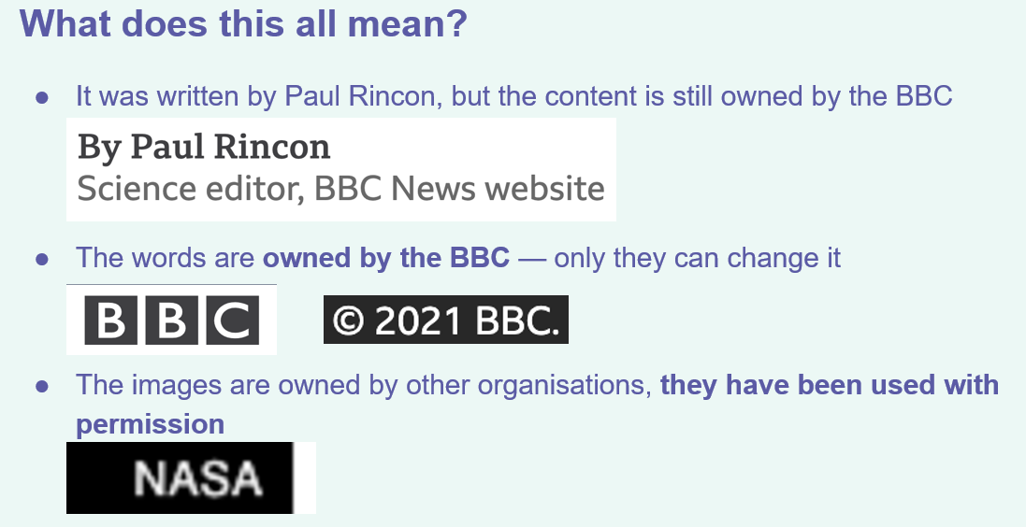

I can describe the different networked devices and how they connect

I can recognise that the World Wide Web is the part of the internet that contains websites and web pages

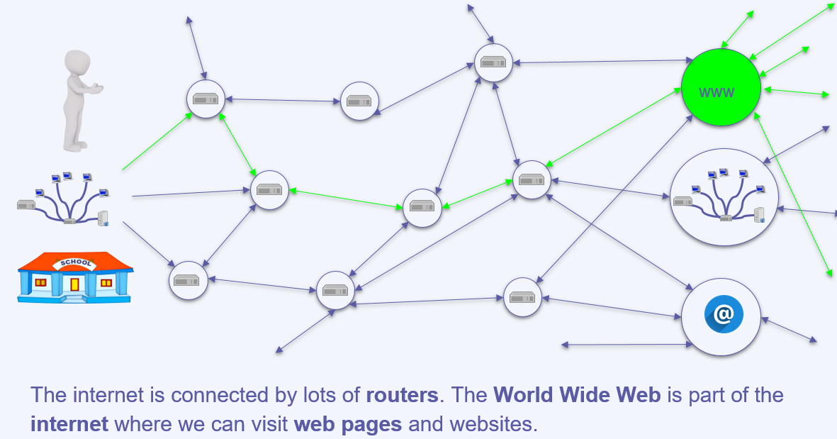

|  |  |
| --- | --- |
| **Key Vocabulary** | |
| Browser | A software used to search the world wide web. |
| Elements | The parts that make something up. |
| Internet | A network, or system, that connects millions of computers worldwide. |
| Network | A group or system of [interconnected](https://www.google.com/search?sca_esv=559959589&q=interconnected&si=ACFMAn8Oh0NPLPMUUCFo6ECuri0W9ACPD770T2AJKDkpBx5qudgH6u35f8Zq0xGx_45EWqbAJlfs6s8SThA1I-H7yyq8ZisfSZfE2bmwGatW9DSvAN7xOLo%3D&expnd=1) people or things |
| Network Security | Is a set of rules and configurations designed to protect the integrity, confidentiality and accessibility of computer networks and data using both software and hardware technologies. |
| Network Switch | A device that enables multiple devices on a network to be connected with each other. |
| Router | A device that passes information between two computer networks. |
| Server | A computer that manages the network and stores files. |
| Wireless access point / WAP | A device, connected to a wired network, that sends and receives wireless signals for/from devices with wifi connectivity. |
| Website | A collection of many web pages. |
| Web Address | Contains information about the location of the webpage |
| Web page | A document for the world wide web |

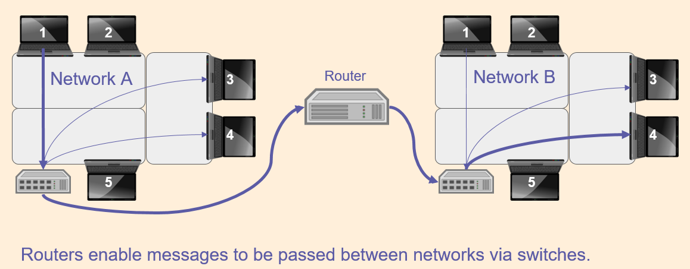

I can describe the internet as a network of networks

I can demonstrate how information is shared across the internet

**Computer systems and networks – the internet**