Tuesday 30th June
Please find attached the work for today with all of the extra activities we will be doing in school.
After we have registered we are going to be looking at our phonics sounds. We will practice all of phase 3 and 5 sounds using Flashcard speed trial. Then we will be looking at our tricky words using trick word trucks for phase 4. Below are then the worksheets we will be working through as a class or doing similar activities.
After phonics we will be going out and doing 15 minutes of exercise either playing a game like simon says outside or super movers.
In maths we will be starting each lesson with using our number square to practice counting forwards and backwards in 2,5 and 10 up to 100. We will then play a game involving finding and making 2digit numbers. We will also practice writing our number digits from 10-20 correctly. After this we will be working through the sheets below or doing similar activities using resources. Today we are focussing on half past the house
We will then have half an hour to eat a piece of fruit and have some fresh air outside.
After break it will be literacy. This week we are focussing on The ugly duckling. We will then create a story map. This is when the children draw pictures to help them remember what happens in the story. They may choose to write key words but they do not have to. In-between the pictures they draw an arrow to show which direction the pictures go in. it would look something like this:
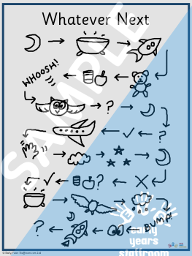
We will then put a post-it-note on the mind map showing what animal you will exchange the duckling for.
Following this we will do a go noodle or some super movers.
The children will then work through the following sheets so that we can prepare the classroom for lunch.
We will now have our lunch and fresh air outside.
After lunch the children will have handwriting practice. Today the children will be practicing: October November December
Then they will have PE. In PE today we will be learning how to throw and catch a ball independently.
After this we will have our creative lesson which today is continuous provision which is where the children choose objects to create something on their own table. We have a wide range of different materials for the children to choose from and they enjoy creating their own buildings, gardens, and stories with them.
Finally we will end the day with a story.

