



The Roman world changed over time:

* Its **government** changed. Kings was replaced by a republic, which was replaced by a dictatorship, which became an empire.
* Its **religious beliefs** changed. Early Roman religion drew on ancient Greek gods. Later, Christianity became the official religion of the empire.
* It developed ideas in **science and technology**, like roads and medicine – but Romans often borrowed and built upon the ideas of other civilisations!
* The Roman empire covered a large area of land, which included lots of people. Many languages were spoken.
* The ‘Romans’ includes different groups of people, who would have all had different experiences:
* **Citizens**, including **patricians** (richer), **plebeians** (poorer) and **legionary** soldiers
* **Non-citizens**, including **auxiliary** soldiers and **slaves**, and other people who lived in lands taken over by the Romans.

**The ‘Romans’ were a diverse group**

Ancient Rome

**How did ancient Rome change over time?**

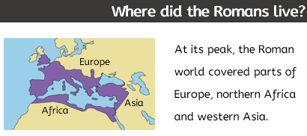

|  |
| --- |
| **Key Vocabulary** |

* aqueducts (noun): man-made structures that transport water from one place to another, often using gravity
* autocracy (noun): a system of government where one person has absolute power
* citizen (noun): someone who has certain rights and freedoms in Rome (a patrician or plebeian)
* cult (noun): a system of religious worship that is directed to a particular object or individual
* dictator (noun): a ruler who has got absolute power, usually obtained by force
* democracy (noun): a place where all people are involved in governing the country (e.g. through elections)
* emperor (noun): the leader of an empire
* empire (noun): a large group of countries or places ruled over by one person
* imperial (adjective): describing or relating to an empire
* persecution (noun): cruel treatment of people based on their (religious) beliefs
* republic (noun): a system of government where power is held by a group of representatives
* slave (noun): someone who is owned by someone else, who is forced to work without pay